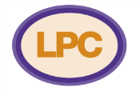
Community Pharmacy
Briefing Document
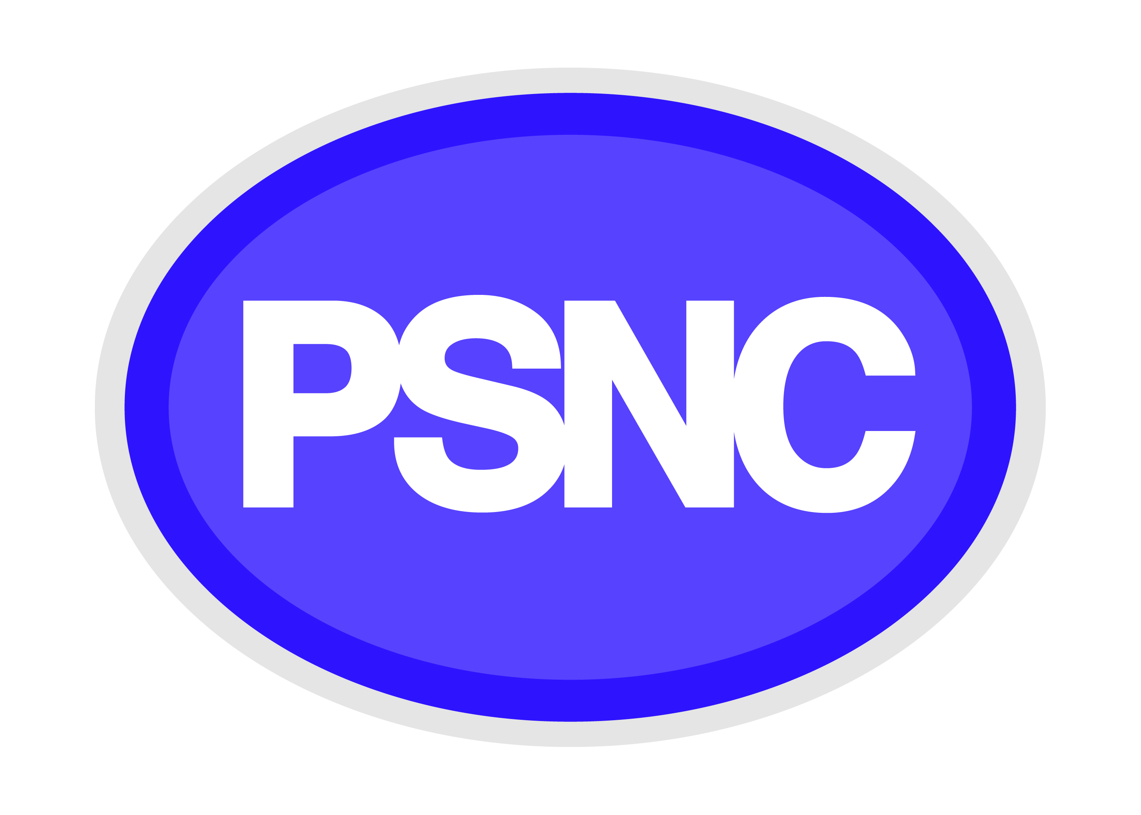

NB. – LPCs and pharmacy contractors should try to tailor this document to local circumstances, including examples of how pharmacies have made a difference to patient care and how local services are helping communities, before printing!

Introduction

On 17th December 2015 the Government announced a number of plans for community pharmacy. The proposals included a £170m reduction in funding for community pharmacy in 2016/17. Since publication of the letter it has also become clear that as many as 3,000 pharmacies may close, that key payments for pharmacies will be phased out, and that there may be a drive towards a commoditised medicines supply service with an increased focus on warehouse dispensing and online services.

The national pharmacy organisations believe the proposals pose significant threats to both the community pharmacy network and patient care, and we are working together to seek support.

Pharmacies are a valuable and valued resource
- People in England make 1.6 million visits to community pharmacies every day.
- As well as dispensing medicines community pharmacy teams help people to stay well and out of the GP’s surgery, to get the most benefit from their medicines, and to manage their health conditions.
- Pharmacies are easy to access and form part of the fabric of local communities. Pharmacy teams regularly go the extra mile for patients, the public and the NHS (utilise local anecdotes*).
- The NHS spends £2bn per year on GP consultations for conditions which pharmacy teams could treat.
- 96% of the population can reach a pharmacy within 20 minutes by walking or using public transport.
- More than 1 billion prescription items are dispensed by community pharmacies every year.
- Pharmacies delivered more than 3.17 million medicines use reviews to help people to understand and take their medicines correctly in 2014/15.
- Community pharmacies help us to stay well and prevent unnecessary visit to the GP’s surgery and A&E. For example, pharmacy services supporting frail elderly people after hospital discharge have reduced re-admittance by 63%.
- Community pharmacy can and should do much more. A community pharmacy minor ailments service could save the NHS £1bn per year through reduced GP appointments.

The Government’s plans threaten patients’ access to pharmacies and pharmacy services
- The Government wants pharmacies to close. The Health Minister has suggested that up to 3,000 pharmacies – a quarter of pharmacies in England – could be forced to close under its plans.
- The Government says it wants a ‘clinically-focused’ community pharmacy service and to optimise the use of medicines. Community pharmacy is always open to discussions on changes that demonstrably support these objectives.
- The network underpinning the supply of medicines is complex and fragile. The Government has proposed a blanket cut in funding that will have unpredictable consequences. It has not yet confirmed the full extent of the cuts for future years.

The implications for patient care have not been properly considered and may be damaging
- The Government has not conducted an assessment of the impact of its proposals on patient safety, or on the quality of care and must commit to doing so. None of the detailed information required for a constructive discussion has been published.
- The Government must explain how proposed changes will deliver a clinically-focused community pharmacy service and optimise the use of medicines.
- There is strong evidence that pharmacy can relieve the considerable pressure on GP surgeries and A&E. Trials of a community pharmacy discharge service saw a 63% drop in hospital re-admissions for frail patients. The Government must demonstrate how changes will help to relieve those pressures.
- The Government must provide detail on how it will ensure access to pharmacy services in remote or deprived communities. Central funding for ‘Essential Pharmacies’ was ended in 2015.
- We do not yet understand the implications of hub and spoke dispensing models. It is too early to quantify any potential efficiency savings. Any changes designed to facilitate hub and spoke models must safeguard the quality, efficiency and accessibility of pharmacy services.
- GPs have expressed concerns about the plans – the NHS Alliance has called them ‘astonishing’ and ‘extremely short sighted’.

See over for next steps and actions for MPs and other stakeholders
Next steps
To protect patient care, community pharmacy organisations would like to see the following things happening.

- The Government must provide more detail
Community pharmacy is happy to discuss changes to the network that will improve patient care. Pharmacies can do more for patients and save money for the NHS. That discussion must be based on a clearer picture of the Government’s plans, and a mutual commitment to changes that will deliver a clinically-focused community pharmacy service and optimise the use of medicines in the best interest of patients.

- We must prevent disruption to patient care
The plans have created huge uncertainty and anxiety, which puts patient care at risk. The consequences are unpredictable. The Government must commit to explaining fully how its proposed changes will deliver a clinically-focused community pharmacy service and optimise the use of medicines in the best interests of patients.

- The Government must then entre constructive discussions
Community pharmacy continues to talk to the Government about its plans, and welcomes a collaborative discussions in the best interests of patients – but this must be based on full disclosure and a mutual commitment to changes that will deliver a clinically-focused community pharmacy service and optimise the sue of medicines in the best interests of patients.

How can you help?
Here are some practical steps that you can take now to help. As negotiations develop over the coming months, pharmacies may continue to ask for your support.

Everyone can help by following us online and on social media – visit supportyourlocalpharmacy.org and look out for #lovemypharmacy updates or share stories of how your local pharmacy has helped you. You can also sign the e-petition at: https://petition.parliament.uk/petitions/116943

Members of Parliament
MPs can help local pharmacies by encouraging the Government to be clearer about its plans. MPs could write to the Secretary of State, or table Parliamentary Questions, asking about the impact in their constituency. Specifically, MPs should ask about the impact of the changes laid out in the letter from the Department of Health and NHS England of 17th December 2015, titled ‘Community pharmacy in 2016/17 and beyond’. MPs should ask how the plans will affect community pharmacies in their constituency. MPs can also sign the following EDM: http://www.parliament.uk/business/publications/business-papers/commons/early-day-motions/edm-detail1/?session=2015-16&edmnumber=1072

Patients and representative groups
Patients and others can help by visiting the website supportyourlocalpharmacy.org. Here you can find out more information, links to petitions, and details on how to write a letter to your MP telling him or her that you want them to back your local pharmacies.

Local authorities, commissioners and health professionals
Commissioners and providers of local health services can help by considering the impact of the proposals on their local health network and patients. The Local Pharmaceutical Committee may be able to help in these discussions. Health providers and commissioners could then ask NHS England to explain the plans to them in more detail, and to outline what impact they think they will have.

COI on behalf of Department of Health, Community pharmacy use - quantitative and qualitative research: market research report, 2008, http://www.dh.gov.uk/en/Publicationsandstatistics/Publications/PublicationsPolicyAndGuidance/DH_083815
IMS Health Dec. 2007 study, http://www.selfcareforum.org/wp-content/uploads/2011/07/Minorailmentsresearch09.pdf
Hodson et al. Evaluation of the Discharge Medicines Review Service, Welsh Institute for Health and Social Care, 2014
Watson MC, Holland R, Ferguson J, et al. Community Pharmacy Management of Minor Illness (The MINA Study). London: Pharmacy Research UK, 2014
Hodson et al. Evaluation of the Discharge Medicines Review Service, Welsh Institute for Health and Social Care, 2014
Press release, New NHS Alliance responds to predicted pharmacy closures, January 2016, www.nhsalliance.org/mediacentre/new-nhs-alliance-responds-to-predicted-pharmacy-closures/

