Pharmacy logo

Pharmacy Name
Address 1
Address 2
Address 3
Postcode

Telephone number
Email
Website

Information for patients on the
NHS Electronic Prescription Service

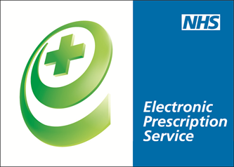

Pharmacy logo

NHS Electronic Prescription Service - a new way to get your medicines and appliances

The Electronic Prescription Service (EPS) is an NHS service. It gives you the chance to change how your GP sends your prescription to the place you choose to get your medicines or appliances from.

What does this mean for you?
- If you collect your repeat prescriptions from your GP you will not have to visit your GP practice to pick up your paper prescription. Instead, your GP will send it electronically to the place you choose, saving you time;
- You will have more choice about where to get your medicines from because they can be collected from a pharmacy near to where you live, work or shop;
- You may not have to wait as long at the pharmacy as there will be time for your repeat prescriptions to be ready before you arrive.

Is this service right for you?
Yes, if you have a stable condition and you:
- don’t want to go to your GP practice every time to collect your repeat prescription; or
- collect your medicines from the same place most of the time or use a prescription collection service now.

It may not be if you:
- don’t get prescriptions very often; or
- pick up your medicines from different places.

How can you use EPS?
You need to choose a place for your GP practice to electronically send your prescription to. This is called nomination.
You can choose:
- a pharmacy;
- a dispensing appliance contractor (if you use one);
- your dispensing GP practice (if you are eligible).

Ask any pharmacy or dispensing appliance contractor that offers EPS, or your GP practice, to add your nomination for you. You don’t need a computer to do this.

Can I change my nomination or cancel it and get a paper prescription?
Yes you can. If you don’t want your prescription to be sent electronically tell your GP. If you want to change or cancel your nomination speak to any pharmacist or dispensing appliance contractor that offers EPS, or your GP practice. Tell them before your next prescription is due or your prescription may be sent to the wrong place.

Is EPS reliable, secure and confidential?
Yes. Your electronic prescription will be seen by the same people in GP practices, pharmacies and NHS prescription payment and fraud agencies that see your paper prescription now.

Sometimes dispensers may see that you have nominated another dispenser. For example, if you forget who you have nominated and ask them to check or, if you have nominated more than one dispenser.

For more information talk to a member of the pharmacy team, staff at your GP practice or visit www.hscic.gov.uk/epspatients.

