Sexual Health

The health profile of Hertfordshire, produced by Public Health England on 2 June 2015, noted that the number of under 18s conception was 342. The UK has the highest teenage pregnancy and abortion rates in Western Europe. Public Health activity and engagement in sexual health Services are well established community pharmacy roles. The key attributes of community pharmacies for service delivery include easy access without an appointment, convenient locations, extended opening hours and private consulting areas.
Pharmacy Support for Sexual Health

Community pharmacies and their teams support sexual health in the community in a broad range of services. In Hertfordshire locally commissioned services relating to sexual health include:

- Emergency Hormonal Contraception (EHC) Service
- Chlamydia Screening
- Chlamydia Treatment

Community pharmacies providing emergency contraception free of charge in Hertfordshire can be accessed below: http://www.hertsdirect.org/docs/pdf/e/epharmacies.pdf

During April 2014 to July 2015 community pharmacies in Hertfordshire have screened a total of 190 people for chlamydia. Community pharmacists offer a confidential discreet service which is particularly useful at targeting hard to reach population groups who may not access other sexual health providers.

In addition to the locally commissioned service community pharmacies and their teams play a vital role in health promotion, providing health advice and signposting patients to other sexual health providers. Pharmacists providing sexual health services must undergo safeguarding training keeping children and young people safe from sexual violence and abuse.

C-Card Services in Community Pharmacy Pilot

C-Card is an initiative to provide information about contraception and sexually transmitted infections and issue patients with the C-Card and condoms. The pilot was implemented in the localities of Broxbourne, Stevenage and Watford and aimed at the target group of young men and women aged between 13 to 24. During the period of 1 November 2014 – 31 March 2015 a total of 39 young people benefitted from the project through accessing these services from six community pharmacies. Whilst initial indications of the project were for these outlets to reach young people through easy access to condom distribution what the pilot has shown is that community pharmacy can reach new young people to register them on this service.

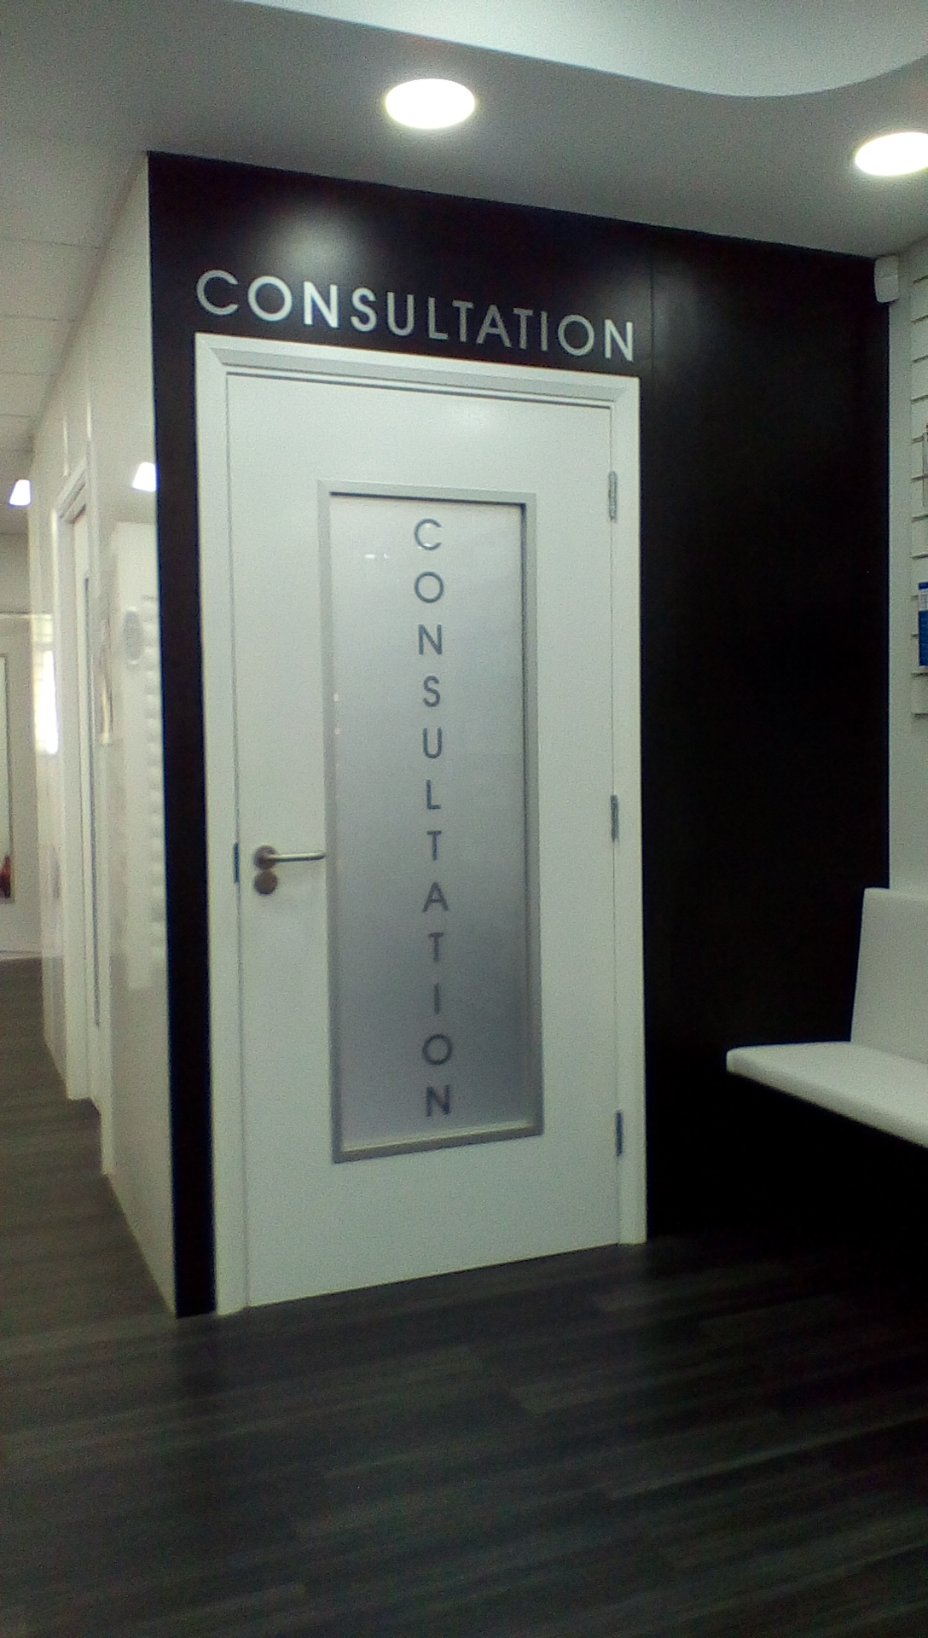
Local example of Sexual Health

“In my practice we aim to consistently engage for chlamydia testing from prescription age information. The engagement is to create a proactive awareness of a non-symptomatic condition.” Girish, Chemilab Pharmacy, Watford

“We generally offer a test to every EHC request. We have displayed a chlamydia test card dispenser next to pregnancy tests and have kept two test kits there for people to take.” Hitesh, Parade Pharmacy, Chorleywood.

