Example of Claiming a Top-up Payment
The following three examples have been calculated using the payment thresholds in this table:
Number of items per month | Practice Payments for 6 month period
Up to 1,099 | £300
1,100 – 1,599 | £2,673
1,600 – 2,499 | £3,742
2,500+ | 52.2p per item

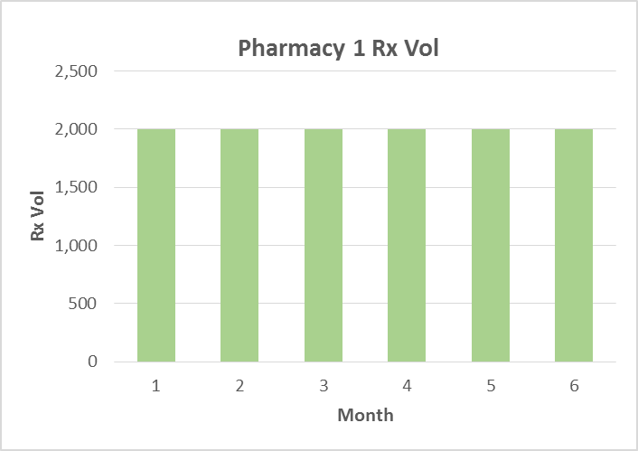
Pharmacy 1: No top-up can be claimed
Month | Rx Vol
1 | 2,000
2 | 2,000
3 | 2,000
4 | 2,000
5 | 2,000
6 | 2,000
Avg. | 2,000

The pharmacy prescription volume is flat. The pharmacy dispensed 2000 prescriptions each month, and the calculated average across the 6 month period is 2000. The pharmacy fell into the same payment band each month and there is no entitlement to a top up payment.

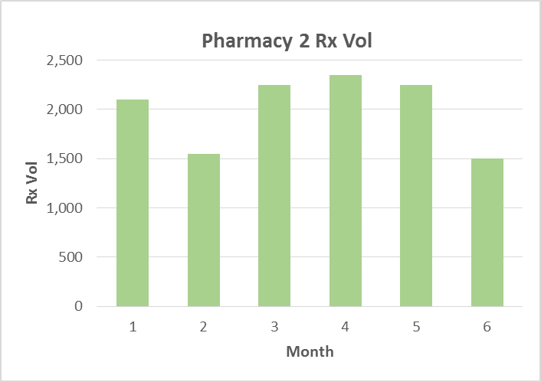
Pharmacy 2: Top up can be claimed
Month | Rx Vol
1 | 2,100
2 | 1,550
3 | 2,250
4 | 2,350
5 | 2,250
6 | 1,500
Avg. | 2,000

The pharmacy prescription volume fluctuates. In month 2 and month 6, the pharmacy dropped into a lower payment band, and the pharmacies total payment was (4 x £623.66) + (2 x £445.50) = £3,385.64
The calculated average prescription volume across the 6 month period is 2,000. If the pharmacy had been paid on the basis of their average prescription volume, they would have received (6 x £623.66) = £3,741.96. As such the pharmacy is entitled to claim a top up payment of (£3,741.96 - £3,385.64) = £356.32
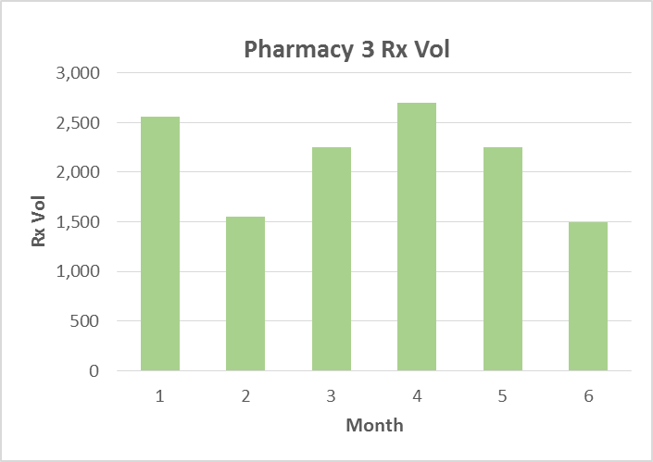
Pharmacy 3: No top up can be claimed
Month | Rx Vol
1 | 2,560
2 | 1,550
3 | 2,250
4 | 2,700
5 | 2,250
6 | 1,500
Avg. | 2,135

The pharmacy prescription volume fluctuates. In months 2 and 6 the pharmacy has dropped to a lower payment band, and in months 1 and 4 the pharmacy has climbed to a higher payment band. The pharmacies total payment was (2 x £623.67) + (2 x £445.50) + (2,560 x 0.522) + (2,700 x 0.522) = £4,884.05
The calculated average prescription volume across the 6 month period is 2,135. If the pharmacy had been paid on the basis of their average prescription volume, they would have received (6 x £623.67) = £3,742, which is lower than the amount they actually received. As such the pharmacy is not entitled to claim a top up payment.

