Tweet templates following funding imposition

@MP/councillor Pharmacy funding imposition: “We are very concerned about the impact that this will have on patients.” http://psnc.org.uk/our-news/government-imposes-community-pharmacy-funding-reduction/

@MP/councillor Pharmacy imposition: “NHS must recognise this as winter pressures set in & it turns to pharmacy for help.” http://psnc.org.uk/our-news/government-imposes-community-pharmacy-funding-reduction/

@MP/councillor Pharmacy imposition: “Removal of Establishment Payments targets those in areas with highest health needs.” http://psnc.org.uk/our-news/government-imposes-community-pharmacy-funding-reduction/

@MP/councillor Pharmacy imposition: “This is a short-sighted approach when constructive alternatives have been put forward.” http://psnc.org.uk/our-news/government-imposes-community-pharmacy-funding-reduction/

@MP/councillor DH cuts to funding mean pharmacies in [location] will have to reduce staff, services & opening hours http://psnc.org.uk/our-news/government-imposes-community-pharmacy-funding-reduction/

@MP/councillor Pharmacy funding package from DH will put more pressure on GPs & hospitals in [location] http://psnc.org.uk/our-news/government-imposes-community-pharmacy-funding-reduction/

@MP/councillor If you #lovemypharmacy in [location], ask the Government to rethink the funding imposition http://psnc.org.uk/our-news/government-imposes-community-pharmacy-funding-reduction/

@MP/councillor If you know #valueofpharmacy in [location], ask the Government to rethink the funding imposition http://psnc.org.uk/our-news/government-imposes-community-pharmacy-funding-reduction/

@MP/councillor If you care about #futureofpharmacy in [location], ask the Government to rethink the funding imposition http://psnc.org.uk/our-news/government-imposes-community-pharmacy-funding-reduction/

@MP/councillor Discuss the implications of DH funding imposition in your constituency by arranging a pharmacy visit through us #lovemypharmacy

@MP/councillor Since 2005 effective medicines purchasing by pharmacies has saved the NHS £10bn – so why has DH cut funding? http://psnc.org.uk/our-news/government-imposes-community-pharmacy-funding-reduction/

@MP/councillor Developing pharmacy services could prevent hospital visits & reduce GP pressures – so why has DH cut funding? http://psnc.org.uk/our-news/government-imposes-community-pharmacy-funding-reduction/

@MP/councillor Through [number] local services pharmacies improve health & support people in [location] – so why has DH cut funding? http://psnc.org.uk/our-news/government-imposes-community-pharmacy-funding-reduction/

@MP/councillor Every day [location] pharmacies help patients who want face-to-face health advice – so why has DH cut funding? http://psnc.org.uk/our-news/government-imposes-community-pharmacy-funding-reduction/

@MP/councillor Every day [location] pharmacies help patients who can’t get appointments with their GP – so why has DH cut funding? http://psnc.org.uk/our-news/government-imposes-community-pharmacy-funding-reduction/

@MP/councillor Pharmacies offer vital services to help people in [location] every day. Please ask Government ministers to rethink #lovemypharmacy

@MP/councillor Pharmacies offer vital services to vulnerable patients in [location]. Please ask Government ministers to rethink #lovemypharmacy

@MP/councillor Pharmacy urgent care proposal is a long way from services needed to improve patient care in [location] http://psnc.org.uk/our-news/psnc-statement-response-to-ministers-announcement-on-urgent-care-role/

@MP/councillor Evidence from @PwC_UK gives clear picture of #valueofpharmacy – so why has DH cut funding? http://psnc.org.uk/our-news/government-imposes-community-pharmacy-funding-reduction/ [include one of the following images]

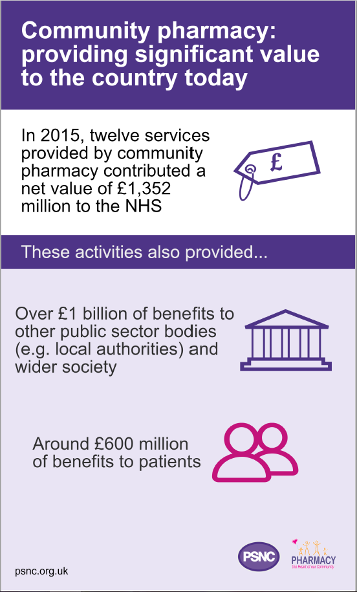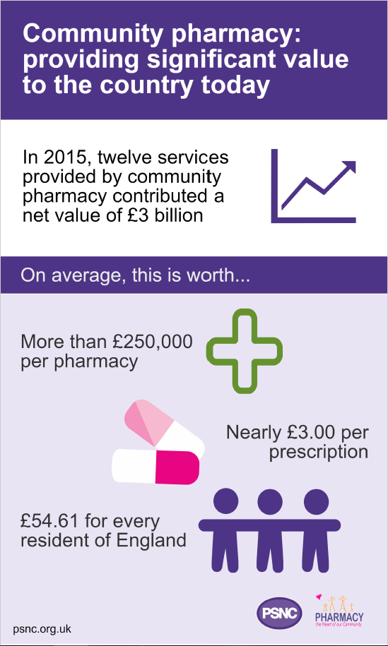

@MP/councillor 12 services provided by community pharmacy contributed a net value of £3bn in 2015 – so why has DH cut funding? http://psnc.org.uk/our-news/government-imposes-community-pharmacy-funding-reduction/ #valueofpharmacy

@MP/councillor 12 services provided a net value of >£250,000 per pharmacy in 2015 – so why has DH cut funding? http://psnc.org.uk/our-news/government-imposes-community-pharmacy-funding-reduction/ #valueofpharmacy

@MP/councillor 12 services provided a net value of £54.61 for every resident of England in 2015 – so why has DH cut funding? http://psnc.org.uk/our-news/government-imposes-community-pharmacy-funding-reduction/ #valueofpharmacy

@MP/councillor Pharmacies made >150m interventions through 12 services in 2015 – so why has DH cut funding? http://psnc.org.uk/our-news/government-imposes-community-pharmacy-funding-reduction/ #valueofpharmacy

@MP/councillor The NHS benefitted from £1,352m from pharmacy in 2015 – so why has DH cut funding? http://psnc.org.uk/our-news/government-imposes-community-pharmacy-funding-reduction/ #valueofpharmacy

@MP/councillor Pharmacies deliver more in benefits than they get in funding – so why has DH cut funding? http://psnc.org.uk/our-news/government-imposes-community-pharmacy-funding-reduction/ #valueofpharmacy

