Templates for Minor Ailments services are available in the PharmOutcomes library and can be easily imported into a commissioning area and edited to exactly match the requirements of local Patient Group Directions (PGDs) and Service Level Agreements.
Access to the service template can be restricted to those practitioners who are able to demonstrate that the appropriate training and premises requirements have been met:
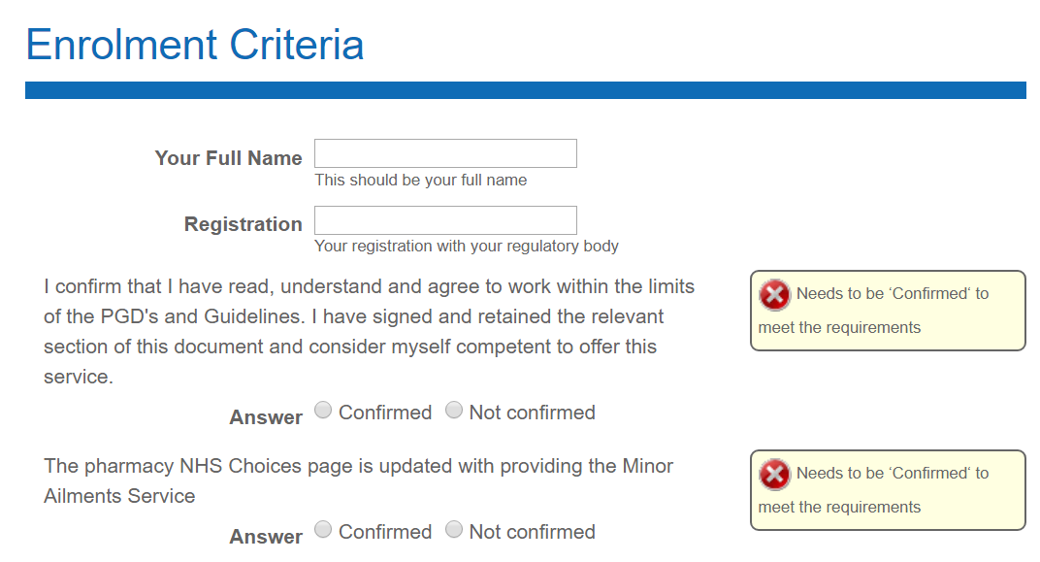
PharmOutcomes can also refer directly to a practitioner’s CPPE Declaration of Competence status to check self-declarations of competence to provide a Minor Ailments service: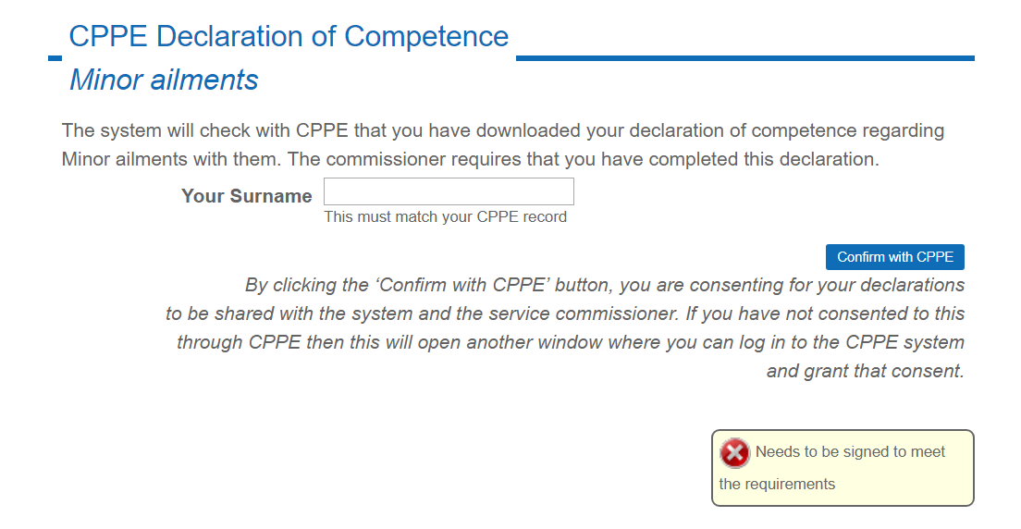
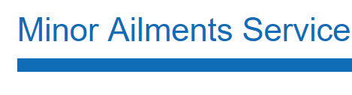
The platform can collect and store the appropriate Patient Identifiable Data as adequate security exists to allow this. Patient data is automatically anonymised for commissioner reports.
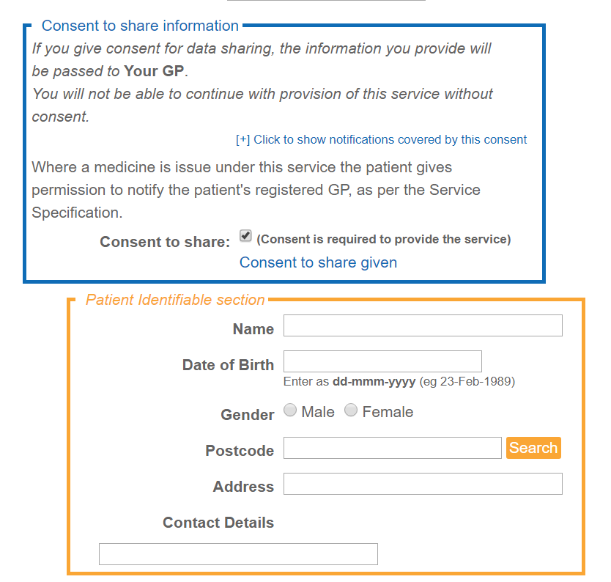
GP Practice details can be recorded by reference to the national dataset. This enables GP notifications to be configured to automatically send my secure email when data is saved.
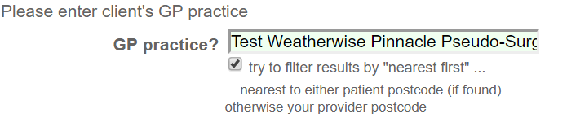
Consultation information can then be captured to exactly match the service specification. For example, choosing a presenting condition from a list will prompt inclusion and exclusion criteria for the associated PGD(s) to appear:
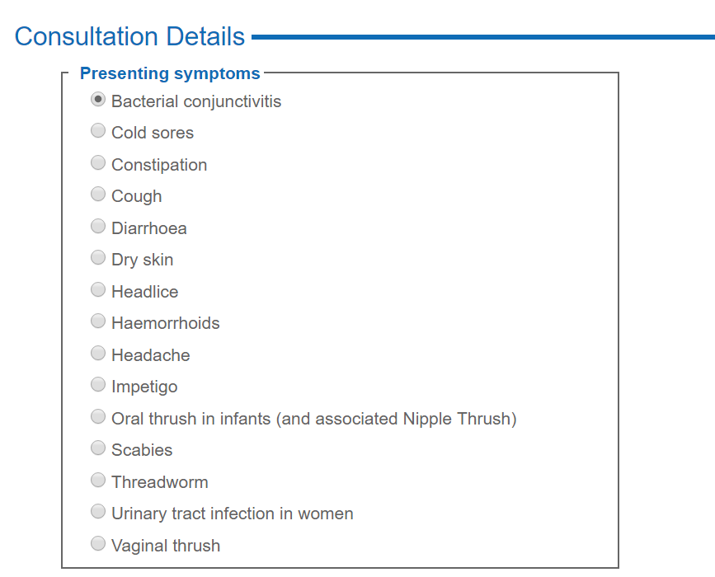

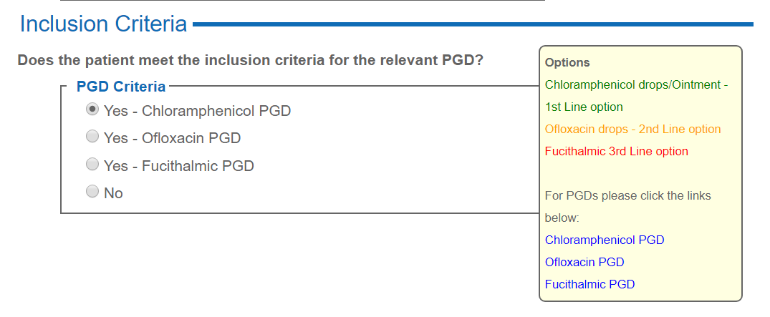
Specific warnings can be configured to prevent inappropriate medicine supply. In the example below, a warning appears when an exclusion is ticked; this warning will prevent medicine supply fields appearing.
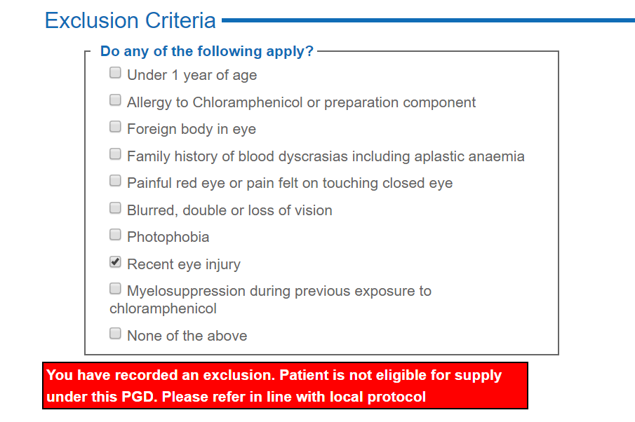
If medicine supply is appropriate, a link to the Dictionary of Medicines and Devices (DM&D) can be used to obtain up to date prices for products supplied. This can then be used to automatically generate invoices for product reimbursement at current prices with no updates necessary by the commissioner.
