Profile Updater User Guide

Published 18 October 2018
1 Introduction 3
1.1 About Profile Updater 3
1.2 Quality Payments Scheme 3
1.3 What happens to the data you submit 3
1.4 Key Points 4
1.4.1 Errors, crashes, outages 4
1.4.2 DoS Services 4
1.4.3 Browser requirements 5
2 Step by step guidance 6
2.1 Cookie consent 6
2.2 Home page 6
2.3 NHSmail email address 7
2.4 Verification code 7
2.5 Your contact details 9
2.6 Find your pharmacy 10
2.7 Check your services 11
2.8 Checking and correcting your services 13
2.8.1 Check your service details 14
2.8.2 Check your address 16
2.8.3 Check your opening hours 17
2.8.4 Check your holiday dates 19
2.9 Review your changes and submit 21
2.10 Final page 22
2.11 Missing service report 23
3 Contact Information 24
3.1 Profile Updater helpdesk 24
3.2 NHSmail 24
3.3 Quality Payments Scheme 24
4 Appendices 25
4.1 DoS Regions 25
4.2 Regional DoS pharmacy profiling 26

Introduction
The purpose of this document is to help users understand Profile Updater.

About Profile Updater
The NHS Directory of Services (DoS) is a national database that is used to direct patients to appropriate healthcare services. When patients call NHS 111, for example, they depend on the accuracy of DoS data. Service providers need to be involved and supported in keeping the DoS up to date.
Profile Updater allows pharmacists to check and update information about their services, so patients keep receiving the best care. The service information includes location and contact details, opening times, holiday closures and the range of services being offered.
It is important to understand how the DoS stores information about a pharmacy. See the DoS Services section in this document.
The process should take 5 to 10 minutes but may take longer if you have several DoS services to check.

Quality Payments Scheme
You may have been asked to use Profile Updater as part of the Quality Payment Scheme (QPS). For up-to-date information on QPS, please see:
- www.england.nhs.uk/commissioning/primary-care/pharmacy/framework/pqp/
- psnc.org.uk/services-commissioning/essential-services/quality-payments/

What happens to the data you submit
- Once you have reviewed your DoS services, any corrections are sent to your local DoS Team and NHS England Contract team. They will review and, if approved,
- If you make a correction to your opening hours, the Contract team will check it against your contractual opening times. The opening times in the DoS should reflect your actual business hours, so that patients visit you at the right times. Your actual business hours should not breach your current contract with NHS England. You cannot use Profile Updater to change your contracted hours, instead you must follow the contractual process.
- If your DoS service details are already correct, you can still complete the review process to let us know.
- In all cases, you will receive an email to confirm that you have successfully submitted your review. Remember to check your junk mail folder if it doesn’t arrive in your inbox.
When will my pharmacy’s services be updated on the DoS?
If your corrections are approved, the DoS will be updated within 7calendar days.
The Contract teams and DoS teams will check your corrections. They will contact you if they have any questions.

Key Points

Errors, crashes, outages
If there is a mandatory field you need to fill in before you can move on, the ‘next step’ button will be disabled. If you are not sure how to complete a step:
- Check the page title, which tells you the purpose of each step.
- Check for instructions or explanations, which are included on some pages.
- Check for error messages, which might tell you exactly where the problem is.
If there is a problem with Profile Updater, your computer or your internet connection, you may see a message reading, ‘something went wrong’. Try the following:
- Check you have a connection to the internet.
- Close the browser and start again.
- Try a different browser or a different computer.
- Wait a while and try again – it may be a temporary problem.
- If problems persist, please let us know.
I’m stuck! How do I contact someone?
Contact details for the helpdesk are on the home page and on the ‘Help’ link at the bottom of every page. They are also in the Contact Information section of this document.

DoS Services
It is important to understand how the DoS stores information about a pharmacy:
- The DoS stores 'services'.
- A DoS ‘service’ represents a healthcare service, with a location, opening times, contact details, etc.
- A single pharmacy is represented by one or more separate DoS services.
  - Normally, one of the DoS service records is a simple pharmacist service, indicating that a dispensary exists.
  - Many pharmacies also offer some additional services (such as 'emergency supply', ‘NUMSAS’, etc.). These are recorded as separate DoS services.
DoS services should have the pharmacy’s ODS code. Profile Updater groups the services by ODS code, so you can check and update all of your pharmacy’s services together.
Please review every DoS service belonging to your pharmacy and complete a ‘missing service report’ to notify your DoS team if you think services are missing. To check which DoS services you should expect to see, see the ‘Regional DoS pharmacy profiling’ table in the appendices of this document.
Why can’t I see my clinical details?
Currently, Profile Updater only shows your contact details, address, opening times and holiday dates. Detailed clinical information (like specific clinical services offered) is held on the DoS, but you cannot review this on the Profile Updater tool.

Browser requirements
Profile Updater works best on Windows or Mac desktop computers. Most Android and Apple devices are fine too. We recommend that you use one of the following internet browsers:
- Chrome
- Firefox
- Safari
- Edge
- Internet Explorer 10 or higher

Step by step guidance

Cookie consent
If you have not visited the website recently, we will ask for your consent to use cookies.
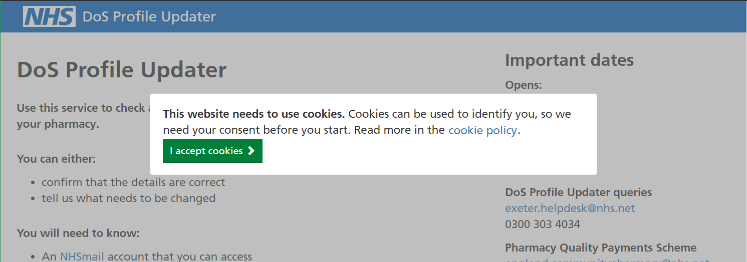
Cookies are necessary for the website to work. You can find out how and why we use cookies by following the link to the cookie policy.

Home page
The home page provides some useful information before you begin the process.

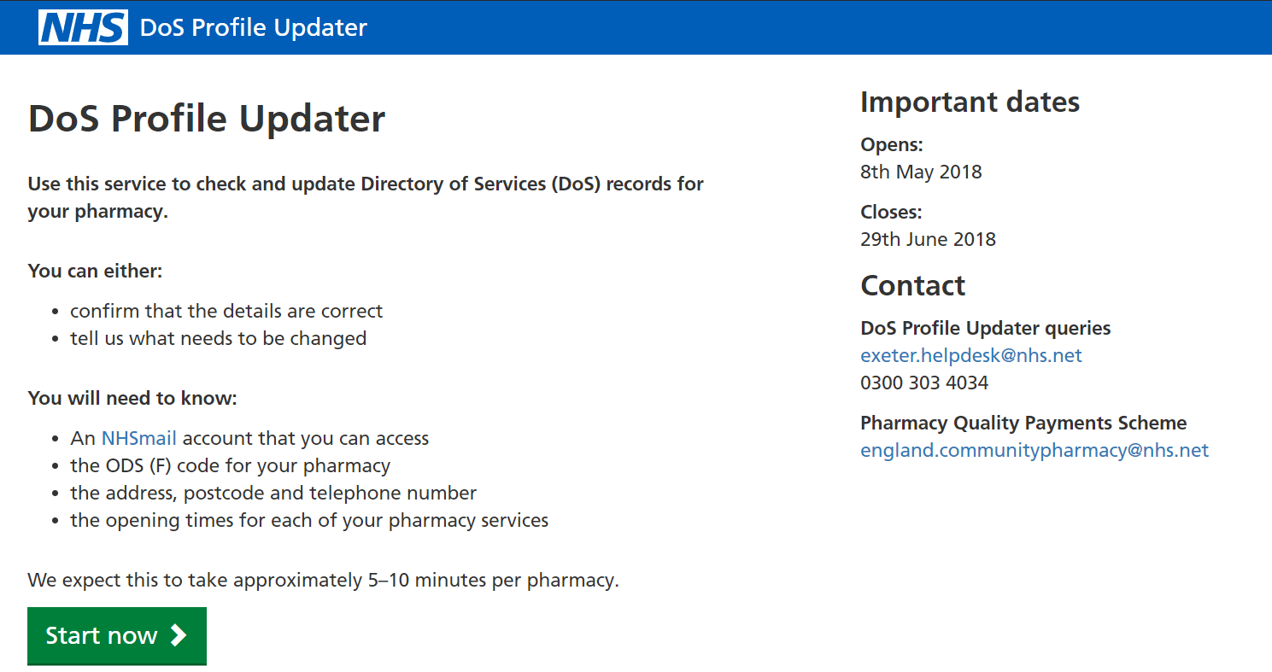
The Profile Updater home page

- Read the instructions and check you have the necessary information to hand.
- Click “Start now”.

NHSmail email address
You must verify that you have access to an NHSmail account. This step lets us know who is using the tool and ensures that we can contact you if necessary.
The NHSmail email address field

- Enter your email address, ending with ‘@nhs.net’. You can use your pharmacy’s address or your personal NHSmail address. Click ‘Next’.

Verification code
- Check your email. You will receive a message containing instructions and a verification code. This code can only be used once.
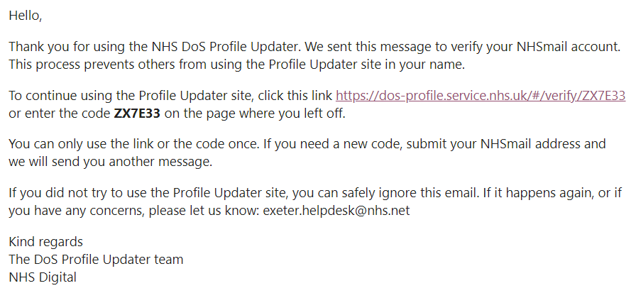
Example of the email with the verification code

Entering a verification code

- To complete this step, enter the verification code and click ‘next’.
- You can skip this step by clicking the link in the email.
If you need help with NHSmail, visit https://portal.nhs.net/ where you can sign up, sign in or contact the NHSmail helpdesk.
If your verification email does not arrive within a few minutes, try submitting your email address again. If you receive more than one verification code, only the most recent will work. If you still have problems, contact exeter.helpdesk@nhs.net
Once you have verified your NHSmail address, you will be ‘signed in’. If someone else is likely to use Profile Updater on the same computer, you should sign out when you leave. You can sign out at any time using the ‘sign out’ link at the top of every page. You will automatically be signed out after one week.

Your contact details
This information is being collected so that Contract and DoS teams can contact you directly if they have questions about your correction requests. You can read more about how your information is used in our privacy policy. Find a link to the policy at the bottom of every page on the website.
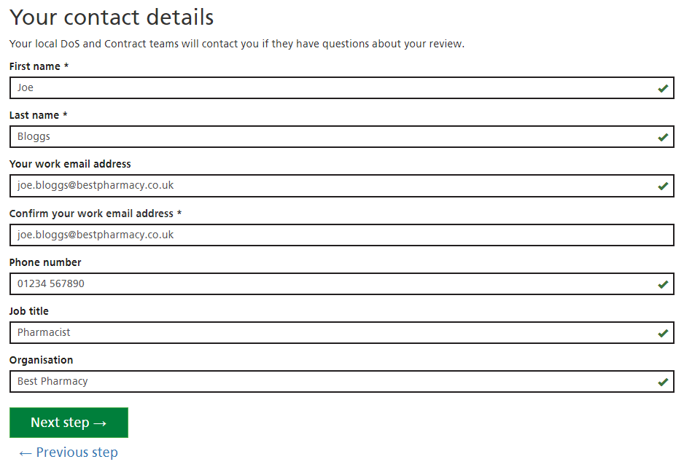
Entering contact details
- Enter your name
- Your work email address: if you have a different email address that you normally use for work (other than your NHS email address), enter it here. At the end of the process, we will send a confirmation email to both your NHS email address and your work email address. This field is optional.
- Confirm your work email address: if you entered a work email address, type it again. If it does not match, you will see a warning message.
- Phone number: enter a work phone number that can be used to contact you about your correction requests.
- Job title: this helps us to understand who is requesting corrections.
- Organisation: Enter the name of the business or organisation that you work for. This helps us understand who is requesting corrections.

Find your pharmacy
On this step you will search for your pharmacy and select it.
Searching with an ODS code

- Enter your ODS code and click ‘Search’.
- If you do not see any results, try searching for your postcode, or the first part of your postcode.
- Select your pharmacy using the checkbox.
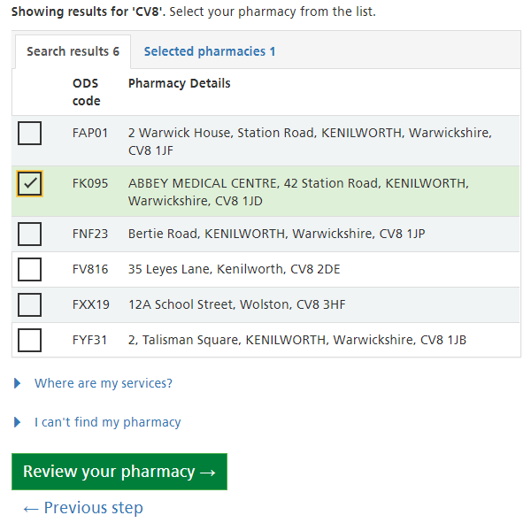
Selecting a pharmacy after searching with the first part of a postcode

- Once you have selected a pharmacy, proceed by clicking ‘Review your pharmacy’.

I can’t find my pharmacy
Click the ‘I can’t find my pharmacy’ button and follow the instructions.
Where are my DoS services?
In the past, you had to search and select all your DoS services. Now, you only have to search and select your pharmacy. In the next step, you will see all the DoS services that belong to your pharmacy.

Check your services
On this page, you will see all the DoS services that have your pharmacy’s ODS code. You need to confirm whether they belong to your pharmacy. If you tell us that a service is no longer offered, or does not belong to your pharmacy, the DoS team will fix the problem.
- For every DoS service, use the checkboxes to answer the question ‘Is this your service?’. The options are:
  - Yes
  - No, it is no longer offered
  - No, it belongs to a different pharmacy
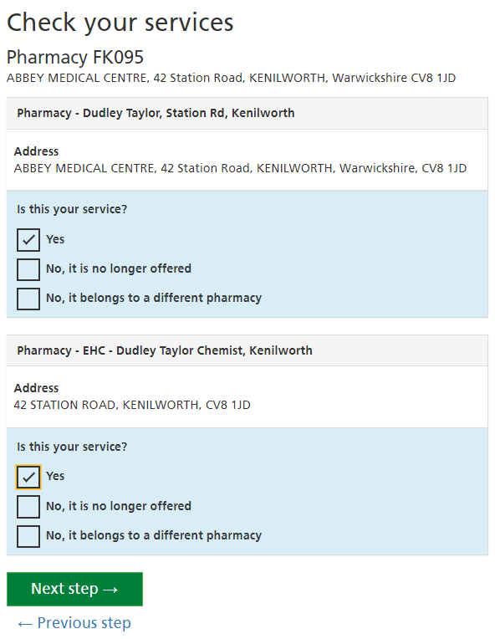
Answering ‘Is this your service?’ for every DoS service.
In this example, there is one pharmacy service and an additional EHC service.

What is a DoS service?
See the DoS Services section in this document.
How do I know if a DoS Service is mine?
The name and address of each DoS Service are shown. If the name and address look like they refer to your pharmacy, choose ‘Yes’.
If the address looks very different to yours, the service probably belongs to a different pharmacy. The service name normally states the type of service. If you no longer offer that service, the DoS needs to be updated. Choose the ‘No…’ option that seems most appropriate
The service names are long and confusing
NHS staff, including 111 operators, need to see certain information in the service names. Normally, the service name includes your pharmacy’s name and the type of service being offered. Sometimes, they also include parts of the address.
The services are mine, but some of the information is wrong
Later in the process, you can make corrections to your services.

Checking and correcting your services
In the next four steps, you will check and update the information about your DoS services. The four steps are:
- Basic service details
This step asks for some simple information about the pharmacy. Normally, these details should be the same for all of your pharmacy’s DoS services.
- Address details
The address allows patients to find you when the need to use your services. Normally, the address should be the same for all of your pharmacy’s DoS services.
- Opening times
These are your normal opening hours – the times at which your services are available to patients. You may have services that are available at different times, so they may need different opening hours.
- Bank holidays and other dates
You need to specify whether you are open or closed on upcoming bank holidays. If you are planning any other closures or temporary changes to your opening hours, you can enter them here too.
On each step, you can edit the details of all the services in your pharmacy (except ones you removed on the Check your services step). To make this easier, Profile Updater automatically chooses a ‘main service’.
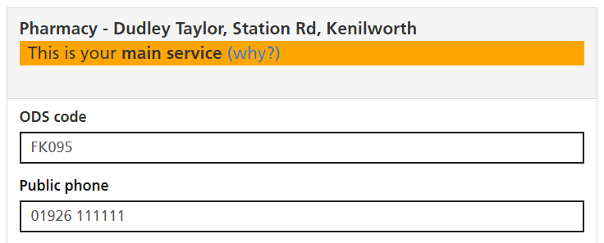
A pharmacy’s main service

Other services are shown below the main service.
If a service has the same details as the main service, they do not need to be shown again. Instead, there is a message: ‘This service uses the same details as your main service.’
If you make a change to the main service, other services are automatically changed too, as long as they are set to use the same details as the main service.
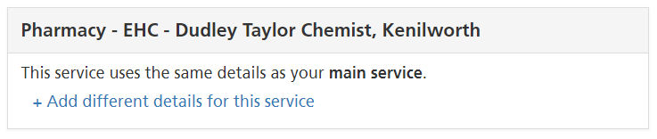
A service with the same details as the main service

You can click ‘Add different details for this service’ if you want to change the details for a service that is not the main service.
If a service has different details to your main service, the details are shown and you can edit them. You can easily make them match the main service by clicking ‘Use the main service details instead’.

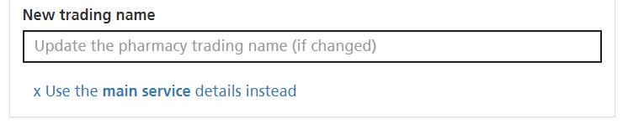
A service that can be set to use the main service details instead

How is the ‘main service’ chosen?
In the DoS, there is no concept of a ‘main’ service. Profile Updater chooses a main service so that it is easier for you to make corrections to all of your services at once. The main service is chosen automatically. Normally it will be your basic pharmacy service (See DoS Services). Don’t worry if a different service was chosen, it won’t have any effect on the DoS. You can still make changes to your services so that they all have the correct details.
I can’t see a ‘main service’.
If your pharmacy only has one DoS service, there is no need for a main service.

Check your service details
On this page, you will check and correct some basic information about your pharmacy.
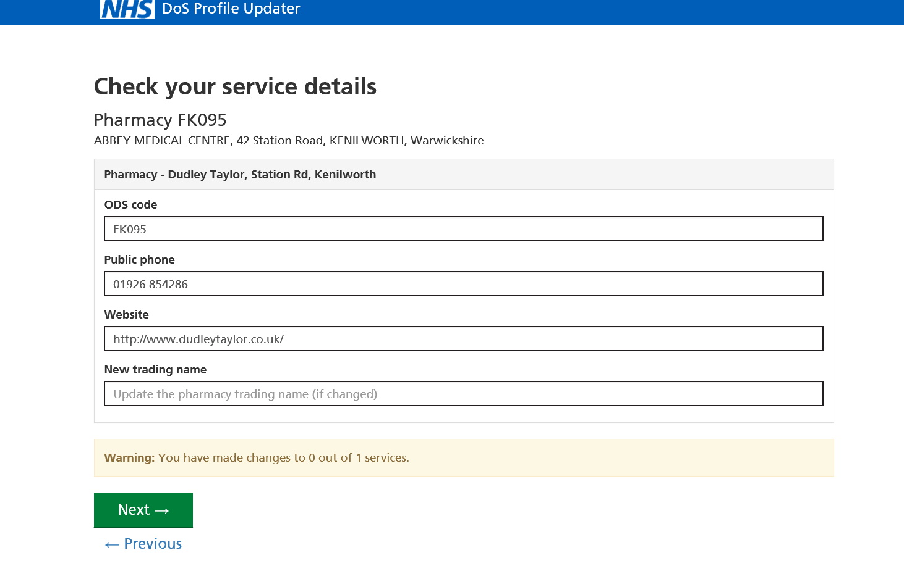
Making corrections to the basic details

- ODS code: if your ODS code is wrong (and you found your pharmacy with a postcode search) you can correct it here.
- Public phone: this is the phone number that can be used by the public to reach your pharmacy.
- Website: if your pharmacy has a website, enter it here.
- New trading name: If your pharmacy’s trading name has changed, but the DoS service names have not been updated, enter the new name here.

Check your address
On this page, you will check and correct the address and postcode of your pharmacy.
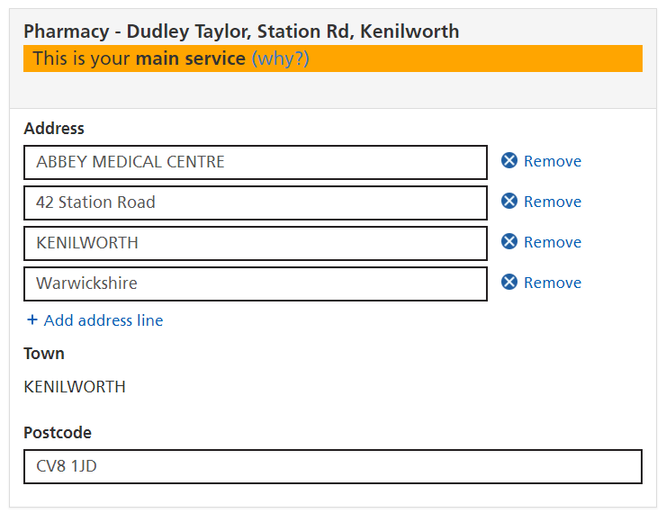
Making corrections to the address

- Check and correct the address lines.
  - To remove an address line, click the blue ‘Remove’ button next to the line.
  - To add a new address line, click the blue ‘Add address line’ button.
- Check and correct the postcode.

Check your opening hours
On this page, you will check and correct the normal opening hours for your pharmacy’s services.
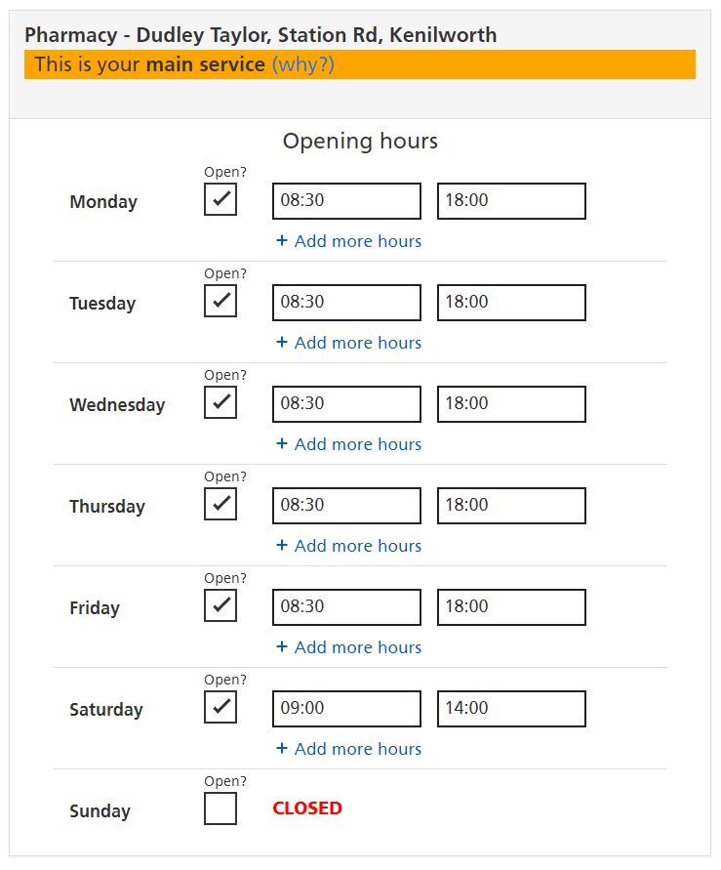
Checking the opening hours

- Click the ‘Open?’ checkbox to change a day from open to closed, or vice versa.
- To change an opening or closing time, click it. A drop-down menu will appear. You can either select the correct time from the menu or type it in.
Changing an opening time

- To add additional opening periods to a day, click ‘Add more hours’. (This allows you to create a lunch break, for example.)
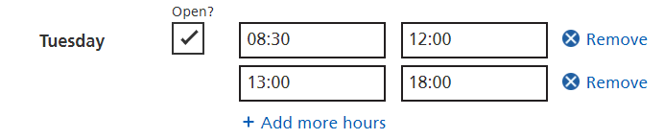
Using two opening periods to show a closure between 12:00 and 13:00

- To remove an opening period, click the ‘Remove’ button next to that period.
- If you have DoS services that are available at different times, remember to check and correct them too. You may need to click ‘Add different details for this service’.

Check your holiday dates
On this step, you will check and update:
- Planned closures or opening hours on upcoming bank holidays.
- Other dates on which your services will not be available at the usual times.
The opening times settings work in the same way as on the previous step (Check your opening hours)
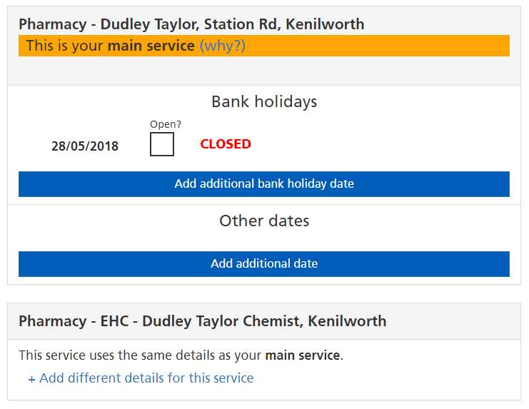
The bank holiday page before adding all upcoming bank holidays

- Click the ‘Add additional bank holiday date’ button to add an extra bank holiday.
- The next bank holiday date is selected automatically, but you can use the drop-down menu to change it if you need to.
- Click a ‘Remove date’ button if you need to delete one of the bank holidays.
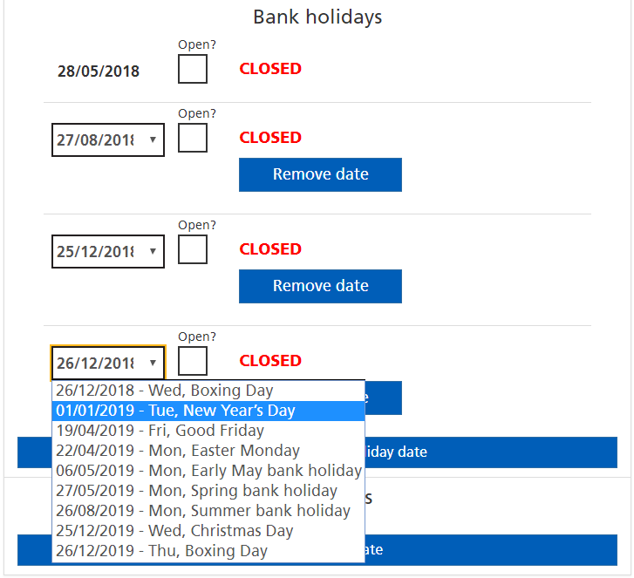
Adding future bank holidays

- If necessary, set dates to open using the checkbox, then enter the opening times. This works in the same way as the previous step.
- ‘Other dates’ work in the same way as bank holidays, but you need to type the date (DD/MM/YYYY).
Adding a date that is not a bank holiday

Openings and closures on bank holidays and other dates must not breach your contract with NHS England.

Review your changes and submit
On this page, you will see all the details of all your DoS services. The details you have corrected are highlighted in orange. You should review your corrections before submitting.
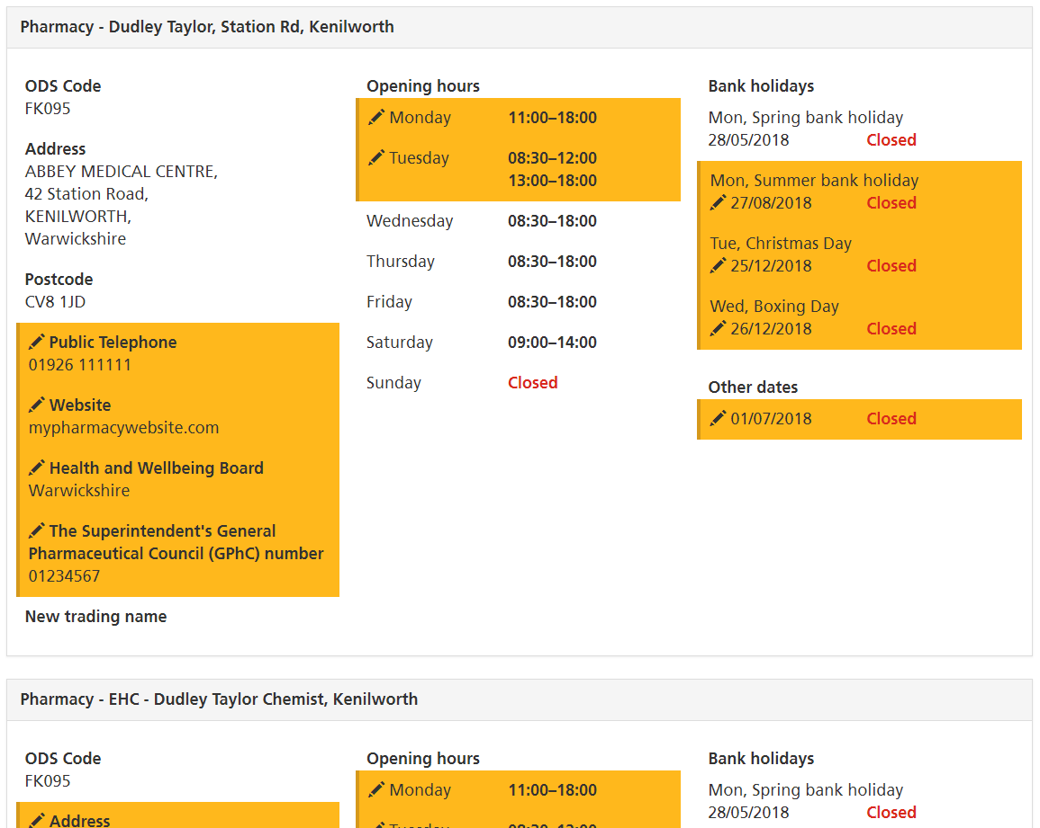
Reviewing corrections to the service details

Services that you removed on the Check your services step are shown here, with a comment highlighted in orange. (You may have removed them by clicking ‘No, it is not my service’ or ‘No, it is no longer offered’)
A comment on a service, indicating that it was removed on the ‘Check your services’ step

- Check the details carefully
- If you see something that isn’t right, use the ‘previous step’ button to go back and correct it.
- When you are ready to complete the process, click ‘Submit changes’. The Contract team will be notified. You will receive a confirmation email.

Final page
This page is displayed after you submit a review.
- Check your email. Keep a copy of the confirmation email as evidence for the QPS. If the email does not arrive, contact exeter.helpdesk@nhs.net.
From the final page, you can:
- Submit your feedback about Profile Updater.
- Go to the ‘missing service report’ page to tell us if you expected to see more DoS services.
- Go back to the ‘find your pharmacy’ page and review another pharmacy.
- Go back to the home page.

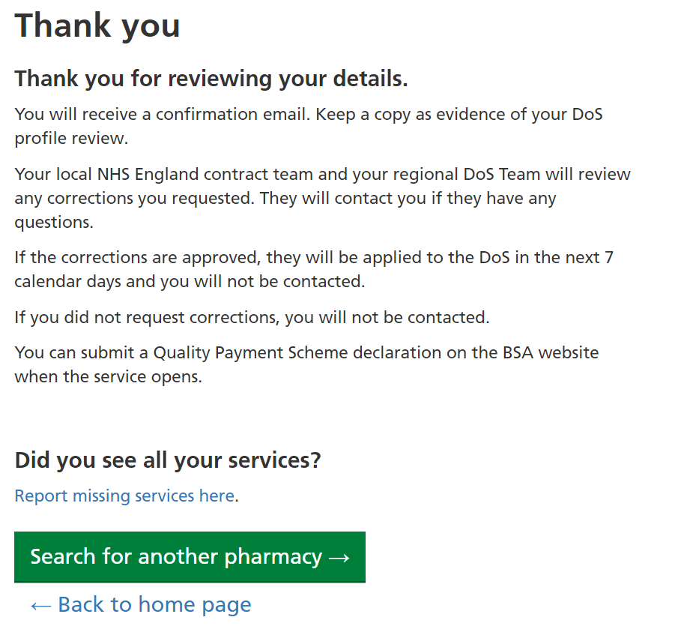
The page displayed when the process is complete

Missing service report
The ‘missing service report’ should be submitted if:
- You cannot find your pharmacy after searching by ODS code, postcode and the first part of your postcode.
- You found your pharmacy, but you did not see all the DoS services that you expected.
The report will be sent to a DoS administrator, who will resolve the problem.
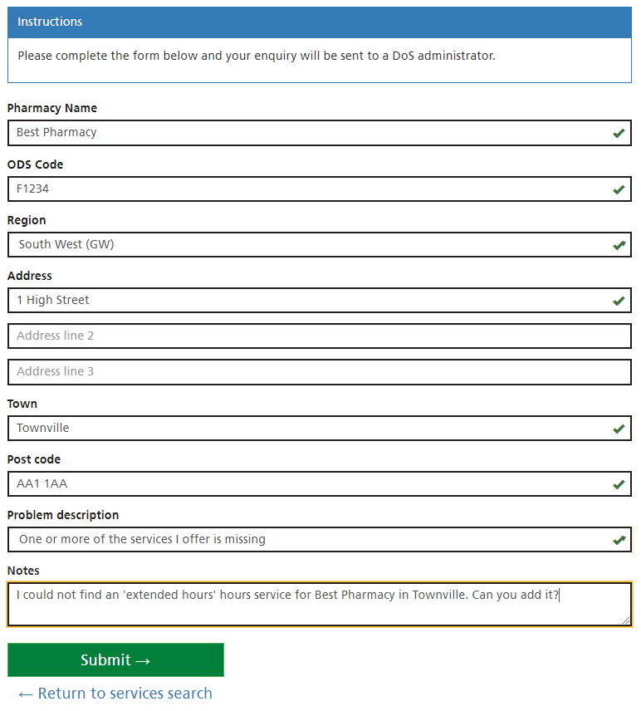
Filling in a ‘missing services report’

- Fill in every section of the form, giving as much information as you can in the notes.
- Click ‘Submit’.

Contact Information

Profile Updater helpdesk
If you have any further questions about Profile Updater, please contact:
- Helpdesk email: exeter.helpdesk@nhs.net
- Helpdesk telephone number: 0300 303 4034

NHSmail
Sign up, check your email or resolve problems at: https://portal.nhs.net

Quality Payments Scheme
More information can found here: https://psnc.org.uk/services-commissioning/essential-services/quality-payments/

Appendices

DoS Regions
DoS Region | Example Areas
East Midlands | Derbyshire; Leicester; Lincolnshire; Milton Keynes; Northamptonshire
East of England | Cambridgeshire; Peterborough; Norfolk; Suffolk
Isle of Wight
London Region
North East | Darlington; Durham; Hartlepool; Stockton-on-Tees; Newcastle; Northumberland; Sunderland;
North West Region | Blackburn; Blackpool; Bolton; Bury; Cheshire; Lancashire; Fylde & Wyre; Preston; Halton; Liverpool; Manchester; North Cumbria; Oldham; Salford; Southport; Wigan; Wirral
South Central | Berkshire; Buckinghamshire; Hampshire; Oxfordshire; Thames Valley; Wessex
South East Coast | Brighton & Hove; Kent; Sussex; Surrey;
South West (GW)
South West (SW) | Devon; Dorset; Kernow; Somerset;
West Midlands | Birmingham; Staffordshire
Yorkshire & the Humber | Airedale; Barnsley; Bradford; Doncaster; Harrogate; Leeds; Lincolnshire; Scarborough; York; Wakefield

Regional DoS pharmacy profiling
A pharmacy is represented by one or more different DoS services. In different regions, different types of DoS services are used. In some places, it varies by CCG too. Use this table to check which DoS services should exist for your pharmacy.
DoS Region | Areas and CCGs | Types of DoS Services used
East Midlands
East of England |  | Pharmacy or Pharmacy Extended Hours  NUMSAS
Isle of Wight |  | Pharmacy  Pharmacy First Enhanced service  Local PURM (not Numsas)  Extended Hours Pharmacy
London | South London | Pharmacy  NUMSAS  Minor Ailments
London
North East |  | Pharmacy ('minor ailments' added to this service)  CPRS  NUMSAS
North West | NHS Blackburn with Darwen CCG, NHS East Lancashire CCG, NHS South Sefton CCG, NHS Southport and Formby CCG | Pharmacist  Distance Selling  NUMSAS
North West | NHS Blackpool CCG, NHS Morecambe Bay CCG, NHS North Cumbria CCG, NHS West Lancashire CCG | Pharmacist  NUMSAS
North West | NHS Bolton CCG, NHS Bury CCG, NHS Chorley and South Ribble CCG, NHS Eastern Cheshire CCG, NHS Greater Preston CCG, NHS Heywood Middleton and Rochdale CCG, NHS Manchester CCG, NHS Oldham CCG, NHS Salford CCG, NHS South Cheshire CCG, NHS Tameside And Glossop CCG, NHS West Cheshire CCG, NHS Warrington CCG, NHS Trafford CCG, NHS Vale Royal CCG, NHS Wigan Borough CCG | Pharmacist  Pharmacist Ext Hrs  NUMSAS
North West | NHS Halton CCG | Pharmacist  Pharmacist Ext Hrs  Distance selling  NUMSAS
North West | NHS Liverpool CCG, NHS St Helens CCG | Pharmacist  Pharmacist enhanced  Distance selling  NUMSAS
North West | NHS Wirral CCG | Pharmacist  Pharmacist Ext Hrs  Pharmacist enhanced  NUMSAS
North West |  | Pharmacist  Pharmacist Enhanced  NUMSAS
South Central | Hampshire, Berkshire East & West, Buckinghamshire | Pharmacy or Enhanced Pharmacy  NUMSAS where in operation
South Central | Oxfordshire | Pharmacy or Extended Hours Pharmacy  NUMSAS (where in operation)  Pharmacy Enhanced Service (if able to deal with Minor Eye Conditions)
South East Coast | Eastern Kent | Pharmacist  Pharmacist - Extended Hours  Pharmacist Urgent Prescription
South East Coast | North and West Kent CCGs | Pharmacist  Pharmacy first  NUMSAS
South East Coast | Sussex
South East Coast |  | Pharmacist  Pharmacist Urgent Prescription  Pharmacist - Extended Hours  Pharmacist Enhanced Service
South West (GW)
South West (SW) | Dorset | Pharmacy  Enhanced pharmacy (PURMS) (urgent prescription type)  NUMSAS (urgent prescription type)
South West (SW) | Somerset CCG | Pharmacy or Enhanced Pharmacy  NUMSAS where in operation
South West (SW)
West Midlands |  | Pharmacy  PURM: ESS and/or NUMSAS  Pharmacy First/Common Ailments (in some areas)  EHC (in some areas)
Yorkshire and the Humber |  | Pharmacist  Pharmacist – extended hours  Pharmacists distance selling  Pharmacist Enhanced Service (Minor Ailments)  Pharmacist Urgent Prescription (NUMSAS and PURM)

