30 August Bank Holiday 2021
Opening Hours

This pharmacy will open the following hours over the May Bank Holiday:

Friday 27 August 2021 | -  -
Saturday 28 August 2021 | -  -
Sunday 29 August 2021 | -  -
Bank Holiday Monday 30 August 2021 | -  -

Please be aware that, due to limited staff on bank holidays, waiting times may be longer or some services restricted. Thank you for your understanding and patience while we serve you.

The following pharmacies in this locality are also opening over the Bank Holiday (please telephone ahead to check):
Date | Times | Pharmacy Name | Address | Postcode | Tel Number
27/8/21
28/8/21
29/8/21
30/8/21

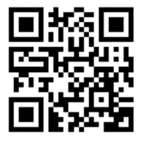
Local pharmacy details
can also be found by
scanning this code or
by visiting www.nhs.uk

Worried you have an urgent medical concern? Call 111 or visit 111.nhs.uk.
NHS 111 is available 24 hours a day, 365 days a year.
Calls are free from landlines and mobile phones.

