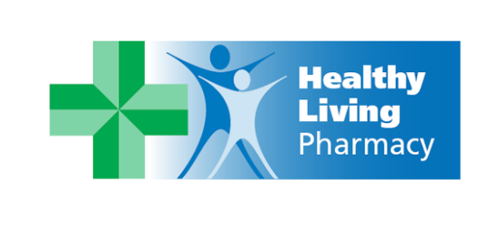

Hertfordshire LPC is committed to the concept of developing as many Healthy Living Pharmacies within its locality. There are currently 19 healthy living pharmacies within Hertfordshire. In order to achieve HLP accreditation in Hertfordshire, community pharmacies must meet the requirements of an accreditation process outlined here: http://www.hertslpc.org.uk/wp-content/uploads/sites/66/2013/10/Appendix-One-Accreditation-Process.pdf

Healthy Living Pharmacy

Healthy living Pharmacy (HLP) is a new concept of community pharmacies where the health and well-being of the local community is at the heart of everything the team does. The Healthy Living Pharmacy Framework aims to reduce health inequalities and prevent poor health by using community pharmacy staff to promote healthy living, provide wellbeing advice and services, and support people to self‐care and manage long‐term conditions.

A portfolio of services is now provided under a single, recognisable brand – Healthy Living Pharmacy. They promote a healthy living ethos which allows community pharmacy to extend beyond traditional pharmacy services to focus on a spectrum of needs relating to healthy living and lifestyles, through direct provision of advice and interventions and sign-posting to other services.

Before a pharmacy can be considered as a HLP, it must already be achieving the standards required within the contractual framework for Essential Services. In addition pharmacy teams must be able to demonstrate and apply a healthy living ethos with a proactive approach to service delivery. The pharmacy will be aware of service protocols, how services work and know when and where to signpost patients. A national evaluation of HLP of 1034 patients showed that 60 percent of patients who accessed HLP services would have visited their GP if the pharmacy service was not available. The national evaluation of HLP’s is available here: http://psnc.org.uk/wp-content/uploads/2013/08/HLP-evaluation.pdf

What distinguishes a healthy living pharmacy?

Chlamydia Screening (Apr 14 – Mar 15)
- HLPs 157 screens = 9.8 per pharmacy
- Non-HLPs 682 screens = 2.8 per pharmacy

An evaluation of healthy living pharmacies in Hertfordshire showed a more successful chlamydia screening service. Becoming a Healthy Living Pharmacy requires more than just providing services. It requires demonstration of consistent high quality service delivery, appropriate premises, trained and skilled staff and engagement with other healthcare professionals and the public. These pharmacies are making a significant contribution to supporting health improvement in their local communities. Their opening hours (evenings and weekends), localities and investment in staff training enables these premises to be an invaluable component of healthy lifestyle services offered within their practices. The Healthy Living Pharmacy programme has strengthened both the quality and quantity of local services delivered by local pharmacies.

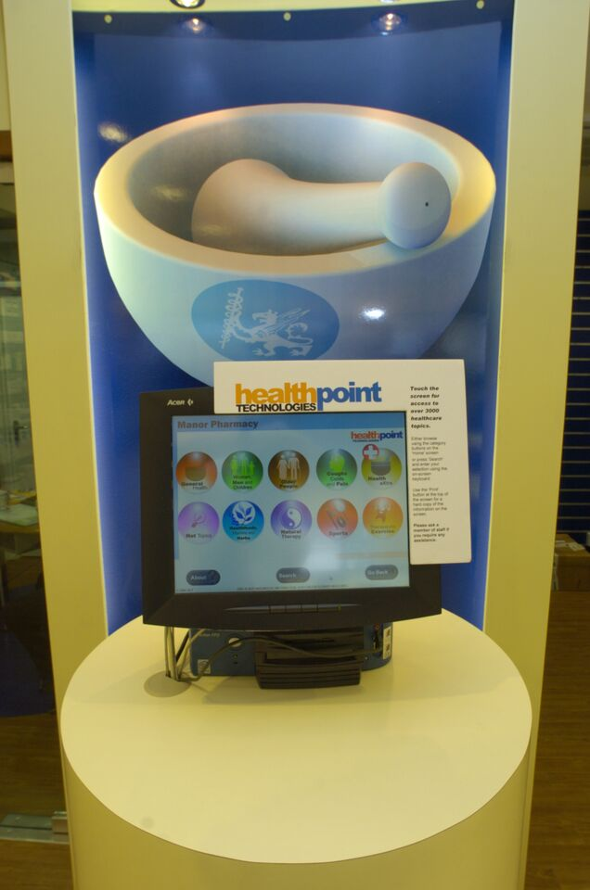

A local example of an HLP
Jackie Sayer is the HLP champion at Manor Pharmacy in Letchworth. Jackie has been involved in organising health promotions both inside and outside the pharmacy. Jackie helped organise a men’s health awareness day with a local group of men with low self-esteem which included blood pressure testing. Since organising the events Jackie has found that feedback from patients about HLP has been mainly positive. She also feels the HLP quality mark has helped to improve the team’s ability to work well together and be good team players.

