Alcohol IBA pilot in Hertfordshire

Hertfordshire County Council Public Health Department is running a pilot for the Alcohol Intervention & Brief Advice (IBA) service of which 25 pharmacies are signed up to. From September 2014 to March 2015 244 IBA’s were completed in community pharmacy. A dashboard summary highlighting the key performance indicators and key trends of the IBA service pilot in Hertfordshire is available here: http://www.hertslpc.org.uk/wp-content/uploads/sites/66/2013/10/Dashboard-Summary-of-Alcohol-IBA-March-20151.pdf

Alcohol Identification and Brief Advice (IBA)
More than 9 million people in England drink more than the recommended daily limits. In England, in 2012 there were 6,490 alcohol-related deaths, a 19% increase compared to 2001 (www.alcoholconcern.org.uk). According to the health profile of Hertfordshire (Public Health England 2 June 2015) the number of hospital stays for alcohol related harm in Hertfordshire is 5,233 people per year. Alcohol is 10% of the UK burden of disease and death, making alcohol one of the three biggest lifestyle risk factors for disease and death in the UK, after smoking and obesity. The alcohol IBA allows selected pharmacies to offer alcohol interventions and screening services using accredited tools such as AUDIT-C and CRAFFT to assess drinking in a wide range of patient and demographic groups. Alcohol messages, assessment of harmful or hazardous levels of alcohol consumption and appropriate referral to specialist services are an essential part of improving the health and wellbeing of the population of Hertfordshire. Evidence shows that this will contribute to the multi-agency approach that will help to reduce the rate of higher and increasing risk of alcohol use.
Benefits of a community pharmacy alcohol intervention service

- Reduce harmful drinking in your local population
Pharmacy alcohol campaigns have been shown to lead to behaviour changes in some people accessing them with reductions in drinking seen. This would have health benefits, and may lead to fewer people living with preventable ill health or dying prematurely from alcohol-related conditions.

- Reduce pressure on GPs, A&E and other healthcare providers.
Sometimes people who are worried about their alcohol consumption visit their GPs; so if receptionists could refer them to local pharmacists this may ease pressure on practices. Perhaps more importantly, with a plan in place to manage their alcohol intake, fewer people will end up with alcohol-related complications and health problems, reducing both pressures on practices and on A&E and hospital services.

- Save NHS money and resources
If alcohol dependence and harmful drinking can be reduced in people accessing this service then those people are likely to have fewer alcohol-related complications which reduces future NHS spend on services. Fact: for every £1 invested in specialist alcohol treatment, £5 is saved on health, welfare and crime costs.

- Target hard-to-reach drinking groups
Community pharmacies are accessible to vulnerable patients and populations, with many located in deprived areas and communities. This means they can more easily access some groups of people. Pharmacy teams may also come into contact with people who are not registered with GP practices or accessing other health services.

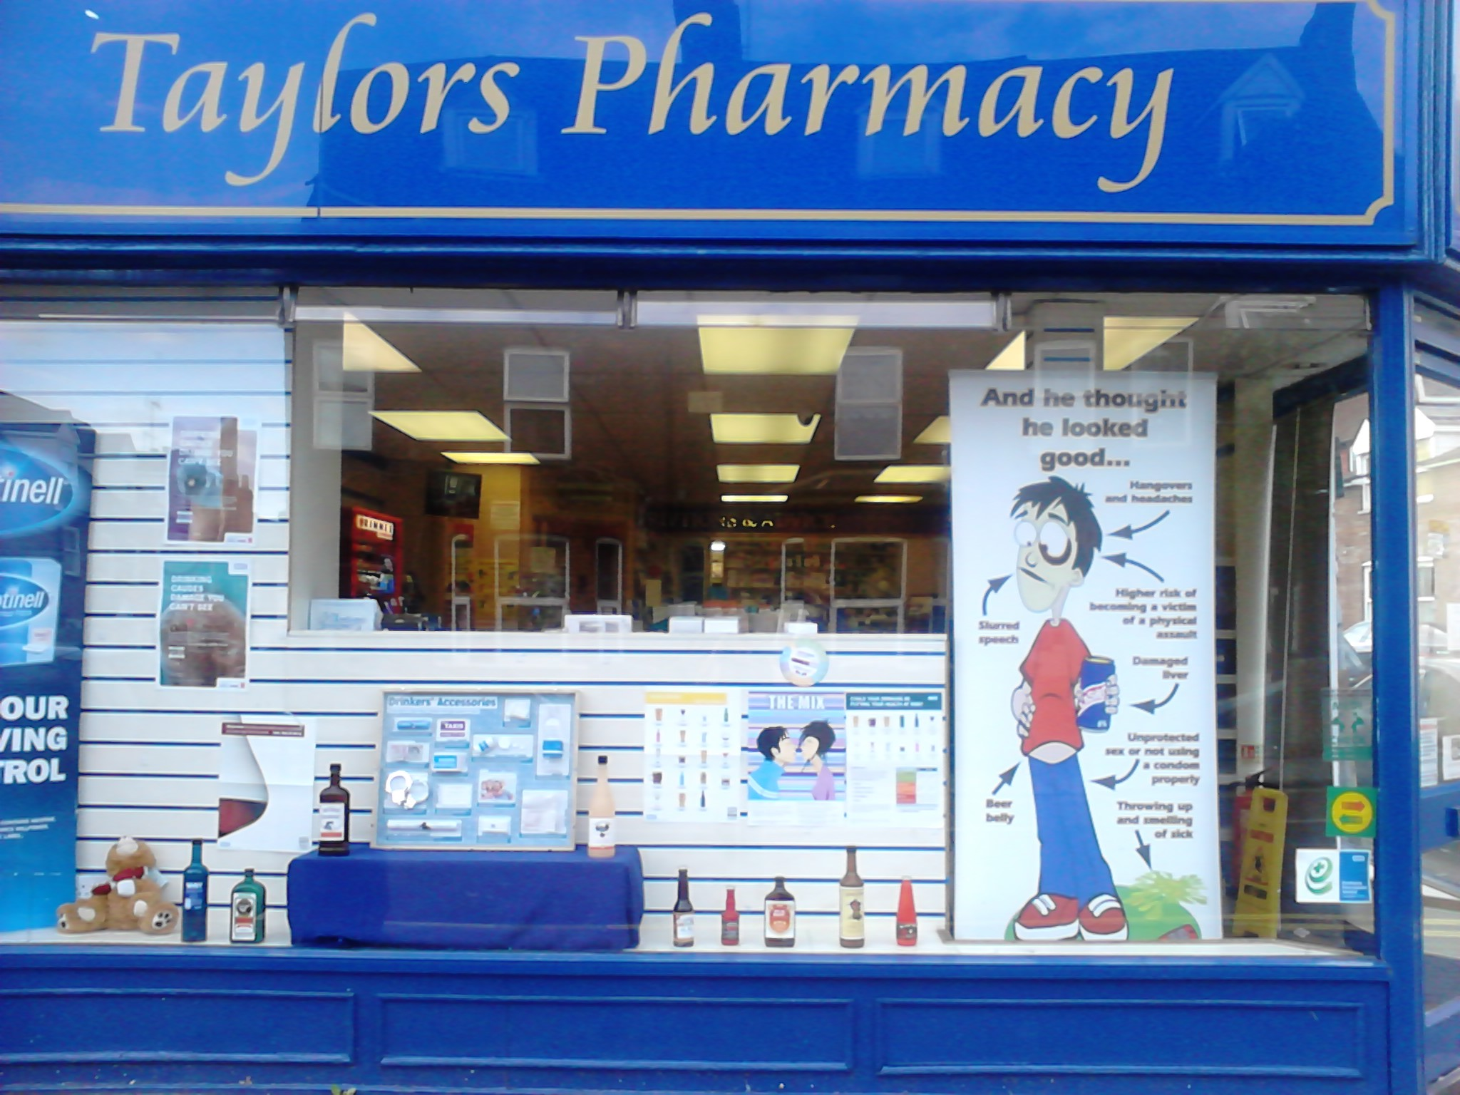

Local example of alcohol IBA service

“Our pharmacy participated in a local alcohol awareness campaign. Patients were asked to guess the alcohol units in different glasses. The campaign was good way of approaching patients on a sensitive subject matter. It also allowed us to proactively target patients drinking excessively for the alcohol IBA service.” Mitesh, St Albans Pharmacy, St Albans

