Stop Smoking

Smoking remains the leading cause of preventable morbidity and premature death in England today, and is estimated to be responsible for up to 86,500 deaths per year. Reducing smoking rates represents a huge opportunity for public health as 1 in 5 adults still smoke. According to NICE public health guidance on tobacco harm reduction, two thirds of people want to quit smoking

According to the health profile of Hertfordshire (Public Health England, 2 June 2015) the number of smoking related deaths in Hertfordshire is 1,507 people per year. Although most people in Hertfordshire experience good levels of health and wellbeing there are areas of health inequalities. Tackling and addressing health inequalities in the most socially deprived areas of Hertfordshire is a local priority. Community pharmacies and their teams in Hertfordshire provide a stop smoking service to patients under a locally enhanced scheme. The Stop Smoking service is one in which pharmacies will provide one to one support and advice to people who want to give up smoking. It takes most smokers many attempts before they finally quit for good. When smokers use the NHS Stop Smoking Service together with approved stop smoking medicines, they will be up to four times more likely to quit successfully. Community pharmacies and their teams in Hertfordshire have helped 1074 people in Hertfordshire quit smoking in 2014 - 15.

Advantages of pharmacy stop smoking service

- Community pharmacies are often open weekends and evenings when other health care professionals are unavailable. Community pharmacies are well placed to improve choice and access to the NHS stop smoking service.
- Community pharmacies are ideally placed to target hard to reach groups such as pregnant women and people from ethnic minorities such as Pakistani people and Bangladeshi people in which there is a high prevalence of smoking.
- It is recognised that many people may be reluctant to talk about health problems in a GP setting. Pharmacies can be seen as a more informal and friendly setting.
- Community pharmacies are well placed to provide opportunistic brief interventions to people repeatedly buying cough products and smokers toothpaste.
- Signposting is an essential service in the community pharmacy contractual framework. Pharmacy teams must inform or advise people who require assistance, which cannot be provided by the pharmacy, of other appropriate health and social care providers or support organisations. Pharmacy teams can help patients access additional treatment by offering referral to specialist services where appropriate for example pregnant smokers and smokers with mental health issues.
- Each year pharmacies are required to participate in up to six campaigns at the request of NHS England. This involves the display and distribution of leaflets provided by NHS England. NHS England (Central Midlands Area Team) announced the Health promotion programme for 2015-16. This includes a smoking cessation campaign in March 2016 coinciding with no smoking day. Further information is available here: http://www.hertslpc.org.uk/community-pharmacy-contract/essential-services/public-health-health-promotion-campaigns/

- Community pharmacies are well placed to offer

  - To help service users access additional treatment by offering referral to specialist services where appropriate.

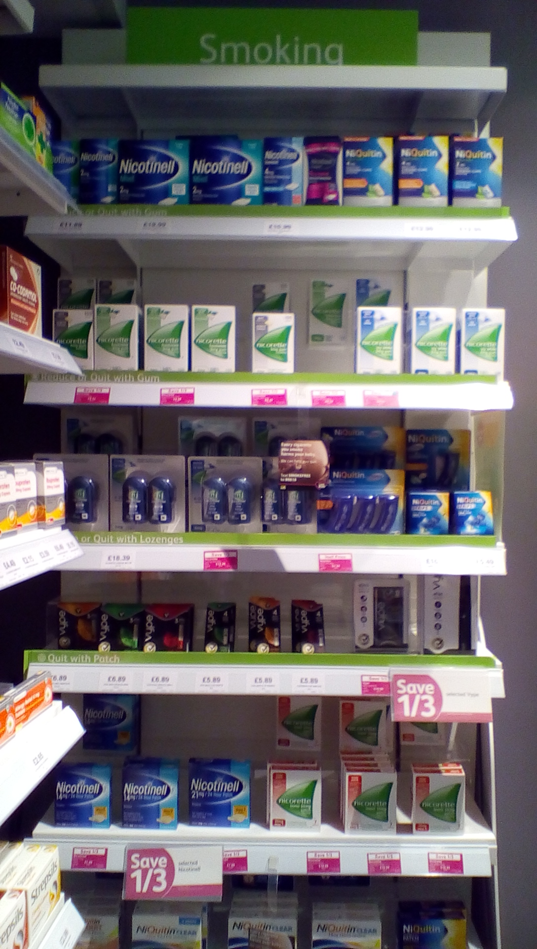
Local example of stop smoking service

“We spotted a pregnant lady viewing our range of stop smoking products. Often patients who are pregnant would like to give up smoking but are worried about seeking help due to fear of being judged and the social stigma attached to them. We tried to approach the patient with sensitivity and in a friendly manner. A member of the team spoke to the lady about the stop smoking services we offer in the pharmacy. The lady signed up to the service and was able to quit smoking after ten weeks of joining the service” Diviya, Tesco Pharmacy, Cheshunt.

