Substance Misuse
CRI Spectrum is commissioned to provide drugs and alcohol services by Hertfordshire County Council and they subcontract the following services from some community pharmacies in Hertfordshire:
- Supervised consumption of medication (methadone and buprenorphine) service to ensure substance users are supported in complying with their prescribed regime and
- Needle exchange services for provision to substance users of a distribution and disposal service for injecting equipment.

According to the current health profile of Hertfordshire (Public Health England, 2 June 2015) the prevalence of opiate and crack use is 3,355 people locally per year.

Pharmacy teams offer a non-judgmental, confidential service and are able to provide support and advice, including referral to specialist centres if appropriate. Substance misuse is also associated with mental health issues. Community pharmacy teams are well placed to proactively signpost patients to local community organisations for support.
Benefits of a community pharmacy supervised consumption service

- Reducing the burden on other NHS providers
Supervision of consumption by an appropriate professional provides the best guarantee that a medicine is being taken as directed. Using a community pharmacy service can help ensure that regular contact with a healthcare professional is maintained whilst taking the burden off GPs

- Prevent prescribed medicines entering the illegal drugs market
Some patients receiving treatment for drug dependence may attempt to sell their prescribed medicine on the illegal drugs market; a supervised consumption service can reduce this risk as the patient must consume their medicine in the pharmacy. Not only will this support the patient’s treatment plan and reduce diversion onto the illegal drugs market, it will also help reduce wastage by ensuring NHS providers are not prescribing medicines which are not being used by the patient.

- Reducing the risk of accidental overdose, including by children
The risk of accidental overdose is a concern, particularly for children living with rehabilitating drug users, and services like supervised consumption can help support the rehabilitation process by helping users to stick with their treatment plan whilst keeping dangerous drugs outside the home.

- More accessibility in socially disadvantaged areas
Community pharmacies are accessible to vulnerable patients and populations, with many located in socially disadvantaged areas (over 99% of people living in areas of the highest deprivation are within a 20 minute walk of a community pharmacy). This means they can more easily provide support for some groups of people who are unable to access, or uncomfortable accessing, other health services.

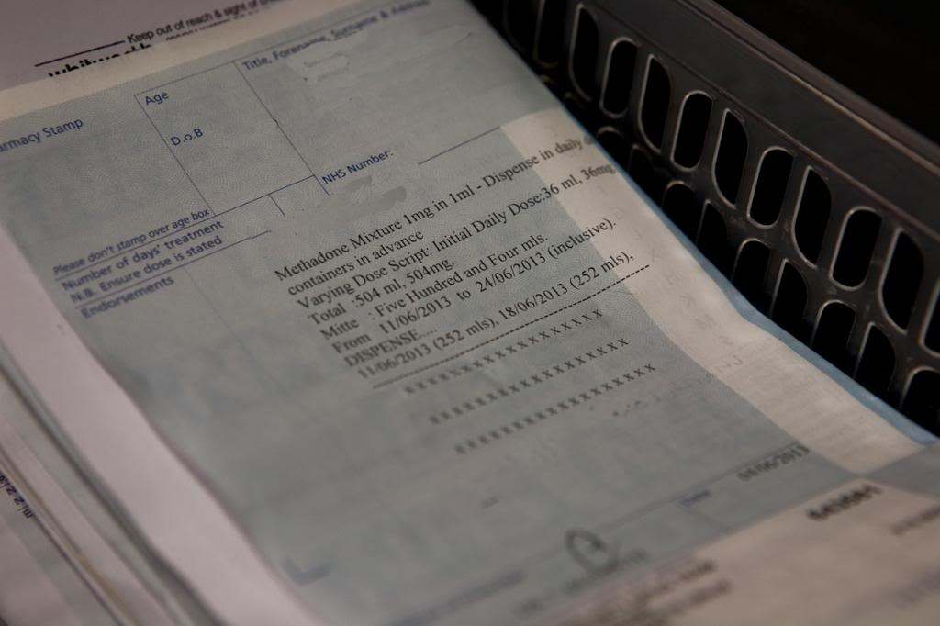
Local example of substance misuse

“Our pharmacy offers a user friendly, non-judgemental service for supervised consumption. Supervision takes place in the consultation room offering the patient privacy and an opportunity for the pharmacist to monitor and advise the patient on their health and wellbeing” Roy, Pharmacist, Superdrug Pharmacy

