Flu Vaccination Service promotion: Tweet templates

The following tweets can be used by LPCs or community pharmacy teams to help promote the availability of NHS flu jabs from local pharmacies. The highlighted sections should be amended as appropriate before use.

Pharmacies in [local area] will be giving NHS #flujabs to eligible people aged 18 & over. Ask your local pharmacist for details #thinkpharmacy

Did you know free NHS #flujabs are available from your/our pharmacy? Pop in and ask your local pharmacy team/us about eligibility #thinkpharmacy

18 or over with a long term medical condition? You may be eligible for a free NHS #flujab from a local/our pharmacy. Pop in today #thinkpharmacy

Do you look after a friend or relative who can’t get by without your help? You may be eligible for a free NHS #flujab from a local/our pharmacy

When flu strikes it can make you very ill, particularly if you are 65 or over. Ask your local pharmacist/us about #flujabs #thinkpharmacy

When flu strikes it can make you very ill, particularly if you have a long term health condition. Ask your local pharmacist/us about #flujabs

We all know winter’s on the way, but what have you done to make sure you stay healthy this year? Ask your local pharmacist/us about #flujabs

It couldn’t be easier to get the NHS #flujab – just pop in to your local/our pharmacy. You may not even need an appointment #thinkpharmacy

Worried about flu? Your local/our pharmacy can help you avoid getting it with an NHS #flujab. Speak to your local pharmacy team/us for details

No-one has the time to be ill so protect yourself from flu by getting a #flujab from your pharmacist/us at a time to suit you #thinkpharmacy

Want the NHS #flujab but not keen on waiting for an appointment? Most pharmacies/we will be able to give the jab there & then #thinkpharmacy

Flu season is upon us. To help make sure you don’t get it, ask your local pharmacy/us about your eligibility for the NHS #flujab #thinkpharmacy

If you fall into one of the high-risk groups, you may be eligible to get an NHS #flujab for free. Pop in to your local/our pharmacy to get yours

Nearly one million patients received an NHS #flujab at their local pharmacy last year – where are you getting yours? #thinkpharmacy

[Number] patients received an NHS #flujab at a [local area] pharmacy last year – where are you getting yours? #thinkpharmacy

98% of patients who had their NHS #flujab at a pharmacy in 2016/17 were very satisfied with the service. Learn more: http://ow.ly/4hyD30foG5i

99% of patients who had their NHS #flujab at a pharmacy in 2016/17 would have it at a pharmacy again. Learn more: http://ow.ly/4hyD30foG5i

99% of patients who had their NHS #flujab at a pharmacy in 2016/17 would recommend it to others. Learn more: http://ow.ly/4hyD30foG5i

15% of patients who had their #flujab at a pharmacy in 2016/17 said they may not otherwise have had it. Learn more: http://ow.ly/4hyD30foG5i

One in ten patients who had their NHS #flujab at a pharmacy in 2016/17 didn’t have it the previous year. Learn more: http://ow.ly/4hyD30foG5i

64% of patients who had their NHS #flujab at a pharmacy in 2016/17 previously had it in other settings. Learn more: http://ow.ly/4hyD30foG5i

Patients gave thumbs up to pharmacy’s 2016/17 NHS #flujabs service – why not experience it for yourself? Learn more: http://ow.ly/4hyD30foG5i [add below image]
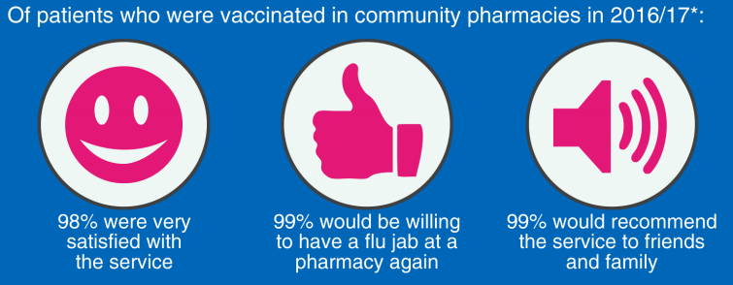

Pharmacy’s NHS #flujabs service was highly valued by patients in 2016/17 – why not try it for yourself? Learn more: http://ow.ly/4hyD30foG5i [add below image]

