PwC report tweets

The tweet templates below have been designed to help LPCs and community pharmacy contractors highlight the value of pharmacy to local stakeholders.

PwC report quantifies #valueofpharmacy psnc.org.uk/valueofpharmacy [include one of the following images]

New evidence from @PwC_UK gives clear picture of #valueofpharmacy psnc.org.uk/valueofpharmacy [include one of the following images]

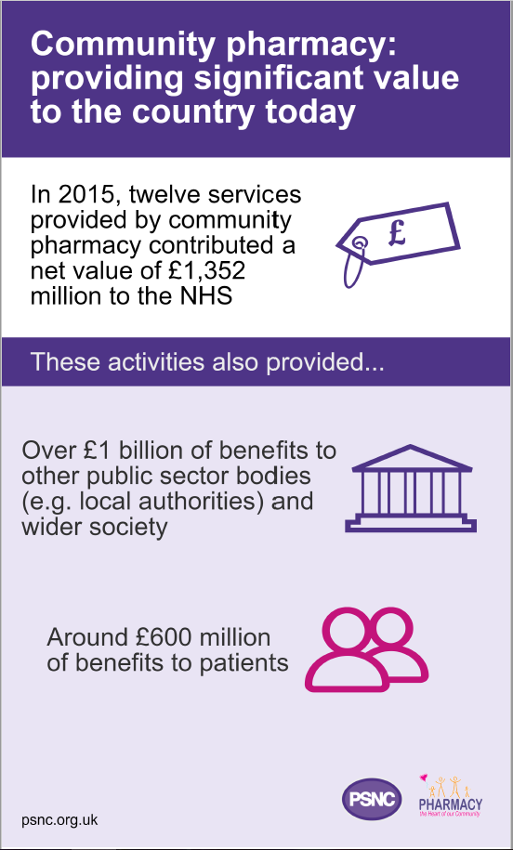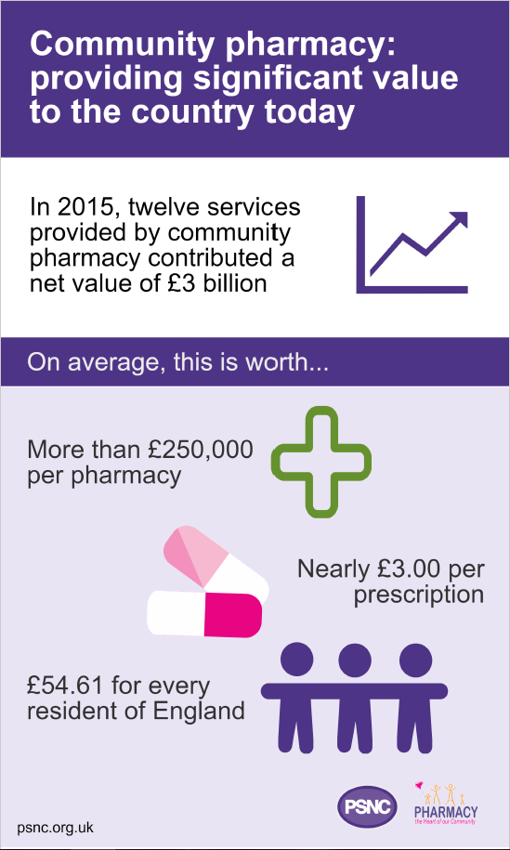

Evidence from @PwC_UK gives clear picture of the value pharmacies provide to their communities #valueofpharmacy psnc.org.uk/valueofpharmacy

#valueofpharmacy In 2015, twelve services provided by community pharmacy contributed a net value of £3 billion psnc.org.uk/valueofpharmacy

#valueofpharmacy In 2015, twelve services provided a net value of more than £250,000 per pharmacy psnc.org.uk/valueofpharmacy

#valueofpharmacy In 2015, twelve services provided a net value of £54.61 for every resident of England psnc.org.uk/valueofpharmacy

Community pharmacies made more than 150 million interventions through 12 services provided in 2015 #valueofpharmacy psnc.org.uk/valueofpharmacy

Community pharmacies supported 800,000 public health users through 12 services provided in 2015 #valueofpharmacy psnc.org.uk/valueofpharmacy

#valueofpharmacy In 2015, the NHS benefitted from £1,352m from pharmacy inc. savings from avoided treatment psnc.org.uk/valueofpharmacy

Pharmacies deliver more in benefits than they get in funding, providing excellent value #valueofpharmacy psnc.org.uk/valueofpharmacy

New #valueofpharmacy report shows importance of robustly assessing any proposed changes to comm pharmacy services psnc.org.uk/valueofpharmacy

Don’t let Government proposal undermine the #valueofpharmacy as evidenced in this @PwC_UK report psnc.org.uk/valueofpharmacy

Pharmacies provide significant value – how would your community be affected if a quarter closed? #valueofpharmacy psnc.org.uk/valueofpharmacy

@MP/other stakeholder Have you read the #valueofpharmacy report? Why not arrange to see it for yourself at a [local area/ constituency] pharmacy? psnc.org.uk/valueofpharmacy

@MP/other stakeholder Find out about the #valueofpharmacy in [local area/ constituency] by speaking to us and arranging a pharmacy visit psnc.org.uk/valueofpharmacy

@MP/other stakeholder Pharmacies offer valuable services to help people in [local area/ constituency] every day. Please support them #valueofpharmacy psnc.org.uk/valueofpharmacy

@MP/other stakeholder Pharmacies offer valuable services to vulnerable patients in [local area/ constituency]. Help save them #valueofpharmacy psnc.org.uk/valueofpharmacy

