#pharmacywinter tweet templates for LPCs
The following tweets can be used by LPCs to help support the #pharmacywinter campaign. The highlighted sections should be amended as appropriate before use.
Promoting to community pharmacy teams
Please support the #pharmacywinter campaign by adding a Twibbon to your social media profile http://ow.ly/aIDn30gakFT
Join @PSNCNews and @WePharmacists for a #pharmacywinter Twitter chat on 21st November at 8-9pm http://ow.ly/8MHm30gakKU
We’re supporting the #pharmacywinter campaign – find out how your pharmacy team can get involved at http://psnc.org.uk/campaign
Don’t forget it’s #pharmacywinter action day next week/tomorrow – find out how your pharmacy team can get involved at http://psnc.org.uk/campaign
Feel free to add the below image to any of your tweets about the #pharmacywinter campaign
Promoting to politicians and other stakeholders
Please support the #pharmacywinter campaign by adding a Twibbon to your social media profile http://ow.ly/aIDn30gakFT
@MP #pharmacywinter action day is 21st November – please attend the Parliamentary reception (12.30-2pm, Committee Room 18, Palace of Westminster)
@councillor/MP Why not visit a local pharmacy to see how they support patients at this time of year? #pharmacywinter
@councillor/MP Find out about #pharmacywinter services in [local area/ constituency] by speaking to us and arranging a pharmacy visit
@MP/other stakeholder Pharmacies offer vital services to vulnerable people in [local area/ constituency]. Please pledge your support #pharmacywinter http://ow.ly/aIDn30gakFT
@MP/councillor Pharmacies vaccinated nearly 1 million NHS patients against flu last year – why not visit one to see them in action? #pharmacywinter
@MP/councillor 99% of patients would recommend the NHS pharmacy flu jab service to others – why not visit one to see them in action? #pharmacywinter
xx prescription items were dispensed in [LPC AREA] pharmacies last year #pharmacywinter
Through xx local services pharmacies improve public health and support people in [LPC AREA] #pharmacywinter
Every day [LPC AREA] pharmacies help patients worried about their health who want face-to-face advice #pharmacywinter
[LPC AREA] pharmacies gave xx Medicines Use Reviews last year/month to help patients get the most out of their medicines #pharmacywinter
[LPC AREA] pharmacies gave xx New Medicine Service consultations last year/month to help patients understand their new medicines #pharmacywinter
[LPC AREA] pharmacies gave xxx [NAME OF LOCAL SERVICE] consultations last year/month to help patients [AIM OF SERVICE] #pharmacywinter
Pharmacies in [local area] are giving NHS #flujabs to eligible people aged 18 & over. Ask your local pharmacist for details # pharmacywinter
Worried about flu? Your local pharmacy can help you avoid getting it with an NHS #flujab. Speak to your local pharmacy team for details #pharmacywinter
Flu season is upon us. To help make sure you don’t get it, ask your local pharmacy about your eligibility for the NHS #flujab #pharmacywinter
Nearly one million patients received an NHS #flujab at their local pharmacy last year – where are you getting yours? #pharmacywinter
[Number] patients received an NHS #flujab at a [local area] pharmacy last year – where are you getting yours? #pharmacywinter
#pharmacywinter Pharmacy’s NHS #flujabs service was highly valued by patients in 2016/17 – why not try it for yourself? Learn more: http://ow.ly/4hyD30foG5i [add below image]
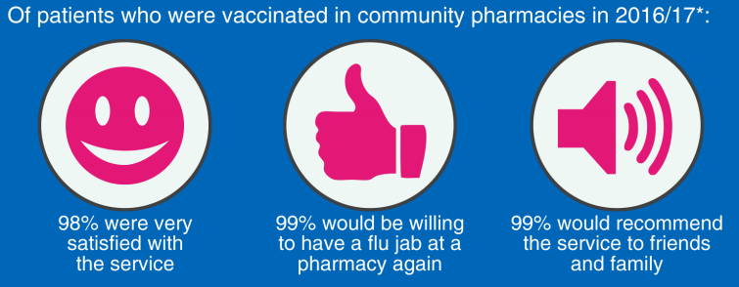
#pharmacywinter Community pharmacies made more than 150 million interventions through 12 services provided in 2015 psnc.org.uk/valueofpharmacy
#pharmacywinter In 2015, the NHS benefitted from £1,352m from pharmacy inc. savings from avoided treatment psnc.org.uk/valueofpharmacy
#pharmacywinter Pharmacies deliver more in benefits than they get in funding, providing excellent value psnc.org.uk/valueofpharmacy
#pharmacywinter Pharmacies provide significant value – how would your community be affected if they weren’t there? psnc.org.uk/valueofpharmacy

