#pharmacywinter tweet templates for pharmacy teams
The following tweets can be used by community pharmacy teams to help support the #pharmacywinter campaign. The highlighted sections should be amended as appropriate before use.
In the lead up to the action day on 21st November
Please support the #pharmacywinter campaign by adding a Twibbon to your social media profile http://ow.ly/aIDn30gakFT
@MP #pharmacywinter action day is 21st November – please attend the Parliamentary reception (12.30-2pm, Committee Room 18, Palace of Westminster)
@councillor/MP Why not visit our pharmacy to see how we support patients at this time of year? #pharmacywinter
@councillor/MP Find out about #pharmacywinter services in [local area/ constituency] by speaking to us and arranging a pharmacy visit
Feel free to add the below image to any of your tweets about the #pharmacywinter campaign
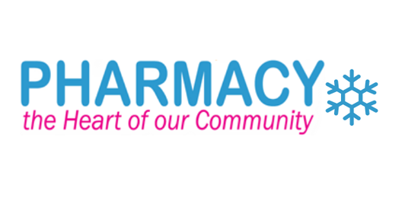
On the action day (21st November)
This morning/afternoon I helped a patient with [INSERT CONDITION] who couldn’t get an appointment with their GP #pharmacywinter
This morning/afternoon I helped a patient who was worried about their [INSERT MEDICINE/ MEDICAL CONDITION] who wanted face-to-face advice #pharmacywinter
This morning/afternoon I helped a patient who was worried about their [INSERT MEDICINE/ MEDICAL CONDITION] and didn’t know where else to go #pharmacywinter
I’ve just helped a patient who had run out of their medicine by providing an emergency supply, saving an urgent care appointment #pharmacywinter
I’ve just helped a patient with [INSERT NAME OF MINOR AILMENT] by advising them on how to treat it at home, saving a GP appointment #pharmacywinter
Today I gave self-care advice to xxx patients so they could look after themselves at home, reducing pressure on other services #pharmacywinter
Today I administered xxx NHS flu jabs to prevent vulnerable people from getting serious complications from flu #pharmacywinter
Today I carried out xxx Medicines Use Reviews to help patients get the most out of their medicines #pharmacywinter
Today I carried out xxx New Medicine Service consultations to help patients understand their new medicines #pharmacywinter
Today I showed a patient how to use their inhaler [OR OTHER MEDICINE/ APPLIANCE] correctly to help better manage their asthma [OR OTHER MEDICAL CONITION] #pharmacywinter
Today I carried out xxx [INSERT NAME OF LOCAL SERVICE] consultations to help patients [INSERT AIM OF SERVICE] #pharmacywinter
Today I provided emergency hormonal contraception and sexual health services for free because [LOCAL COMMISSIONER] has commissioned them #pharmacywinter
Today I provided stop smoking and alcohol advice services for free because [LOCAL COMMISSIONER] has commissioned them #pharmacywinter
Today we made xxx deliveries of medicines to those of our patients who are housebound #pharmacywinter
My day in the pharmacy: xxx prescriptions dispensed. xxx patient consultations. xxx MURs carried out. #pharmacywinter
@MP/other stakeholder Pharmacies offer vital services to vulnerable people in [local area/ constituency]. Please pledge your support #pharmacywinter http://ow.ly/aIDn30gakFT
@MP/councillor Pharmacies vaccinated nearly 1 million NHS patients against flu last year – why not visit one to see them in action? #pharmacywinter
@MP/councillor 99% of patients would recommend the NHS pharmacy flu jab service to others – why not visit one to see them in action? #pharmacywinter
The public, health commissioners and government all need to #thinkpharmacy and make us your first port of call #pharmacywinter
Our pharmacy provides NHS #flujabs – just pop in and ask us about eligibility #pharmacywinter
When flu strikes it can make you very ill, particularly if you are 65 or over. Ask your local pharmacist about #flujabs #pharmacywinter
#pharmacywinter When flu strikes it can make you very ill, particularly if you have a long term health condition. Ask your local pharmacist about #flujabs
#pharmacywinter We all know winter’s on the way, but what have you done to make sure you stay healthy this year? Ask your local pharmacist about #flujabs
#pharmacywinter Patients gave thumbs up to pharmacy’s 2016/17 NHS #flujabs service – why not experience it for yourself? Learn more: http://ow.ly/4hyD30foG5i [add below image]
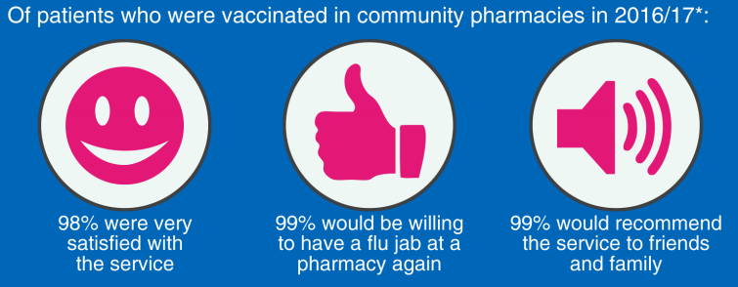
#pharmacywinter Community pharmacies made more than 150 million interventions through 12 services provided in 2015 psnc.org.uk/valueofpharmacy
#pharmacywinter In 2015, the NHS benefitted from £1,352m from pharmacy inc. savings from avoided treatment psnc.org.uk/valueofpharmacy
#pharmacywinter Pharmacies deliver more in benefits than they get in funding, providing excellent value psnc.org.uk/valueofpharmacy
#pharmacywinter Pharmacies provide significant value – how would your community be affected if they weren’t there? psnc.org.uk/valueofpharmacy

