How to Subscribe to Community Pharmacy Digital Group (CPDG) Using a Non-Gmail Email Address:

- Go to https://groups.google.com/group/cpdigitalpharmacygroup/subscribe

- Enter your preferred email address to subscribe to the group.

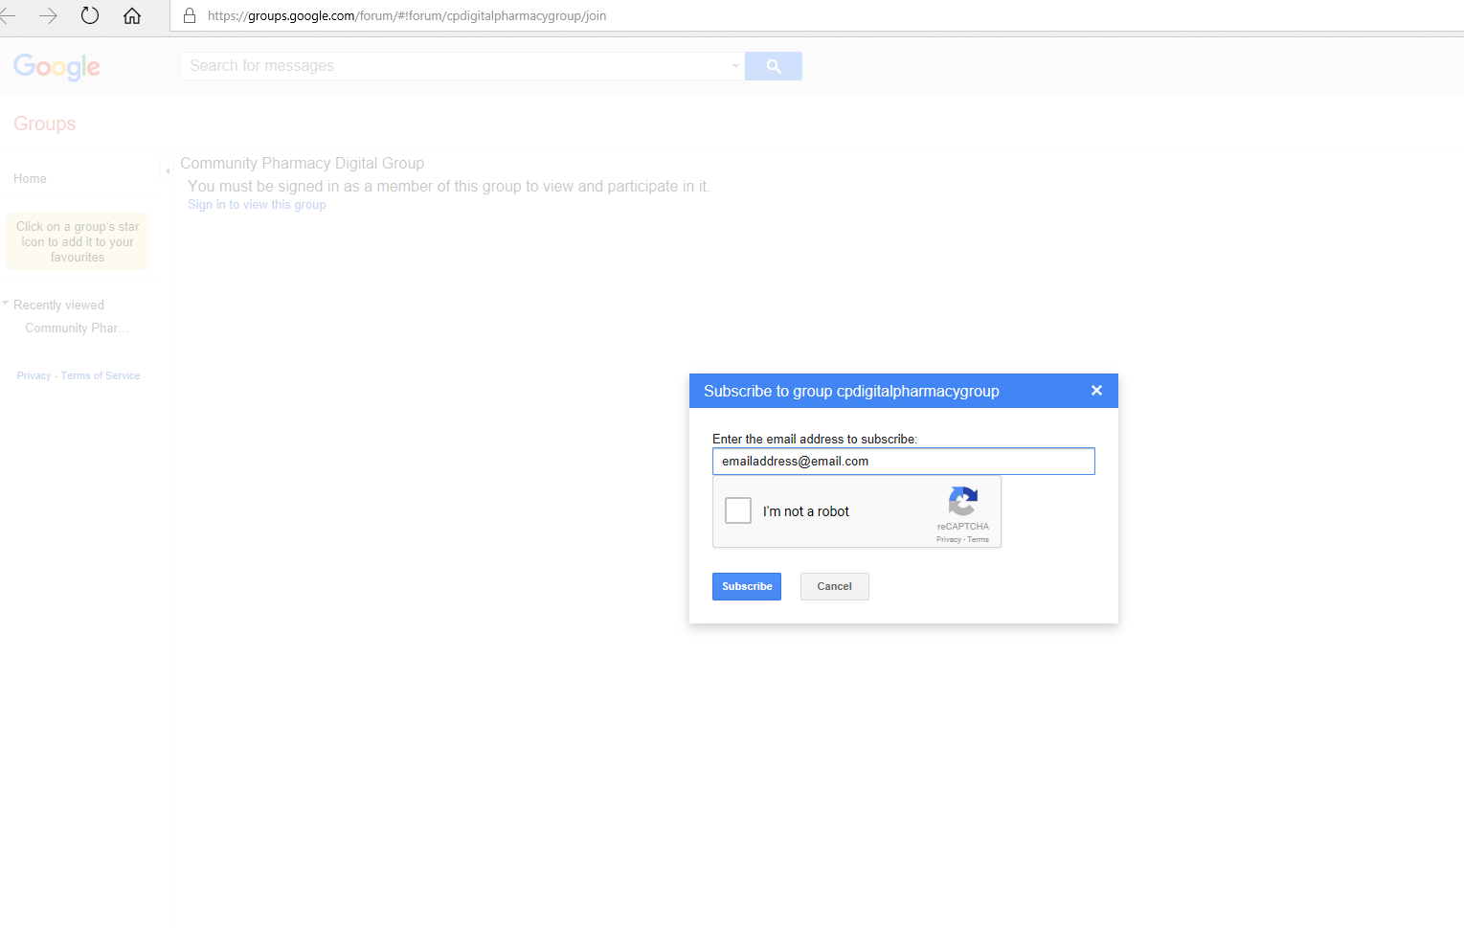
- You will receive a subscribe confirmation email to that email address. Click “Join this Group”.

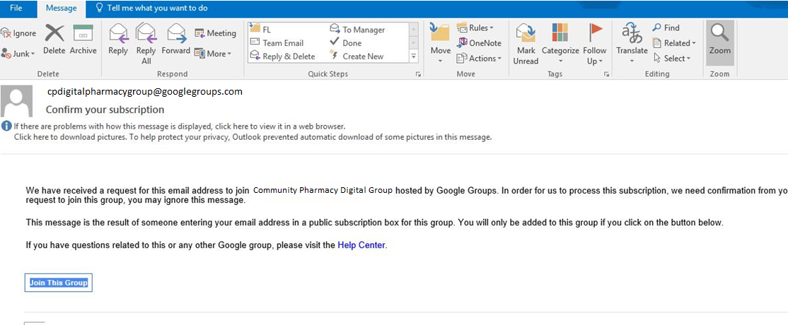

- If done correctly you will see a new message to confirm your approval is pending
- Your membership should be approved. You will now be able to receive emails or send comments to cpdigitalpharmacygroup@googlegroups.com

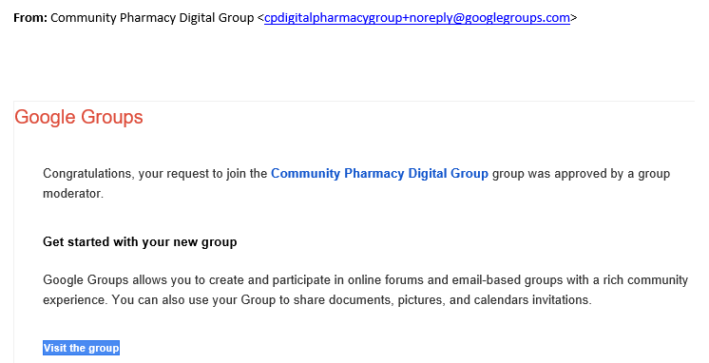

- Without a Google account you will be unable to view messages at the Google home page, but can receive and send emails directly using your usual email platform.

If you require assistance with the process above please email da@psnc.org.uk with subject title ‘join CPDG’

