Get your free NHS flu jab at your local pharmacy
A4 SIZE ADVERT – FULL COLOUR

Your local pharmacy will be giving NHS flu jabs to people aged 18 years and over who are eligible for a free jab.

You are eligible to receive an NHS flu jab if you:
- Are 65 years of age or over
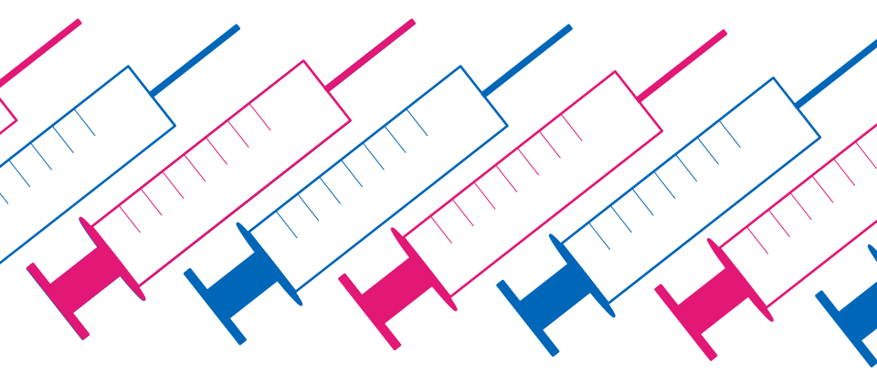
- Are pregnant*
- Are living in a long-stay residential care home or other long-stay care facility*
- Are a carer*
- Are a household contact of an immunocompromised individual*
- Are a social care worker or hospice worker^{Δ}
- Have certain medical conditions* including:
  - Asthma or COPD
  - Diabetes
  - Heart disease
  - Kidney disease
  - Liver disease
  - Neurological disease
  - Asplenia or splenic dysfunction
  - Morbid obesity
  - A weakened immune system due to disease or treatment

* patients must be 18 years of age or over
^{Δ} additional eligibility requirements apply

Ask the team at your local pharmacy today for more information about your eligibility for the NHS flu jab.

This free service is funded by NHS England.
Get your free NHS flu jab at your local pharmacy
A4 SIZE ADVERT – BLACK & WHITE

Your local pharmacy will be giving NHS flu jabs to people aged 18 years and over who are eligible for a free jab.

You are eligible to receive an NHS flu jab if you:
- Are 65 years of age or over
- Are pregnant*
- Are living in a long-stay residential care home or other long-stay care facility*
- Are a carer*
- Are a household contact of an immunocompromised individual*
- Are a social care worker or hospice worker^{Δ}
- Have certain medical conditions* including:
  - Asthma or COPD
  - Diabetes
  - Heart disease
  - Kidney disease
  - Liver disease
  - Neurological disease
  - Asplenia or splenic dysfunction
  - Morbid obesity
  - A weakened immune system due to disease or treatment

* patients must be 18 years of age or over
^{Δ} additional eligibility requirements apply

Ask the team at your local pharmacy today for more information about your eligibility for the NHS flu jab.

This free service is funded by NHS England.
Get your free NHS flu jab at your local pharmacy
A5 SIZE ADVERT – FULL COLOUR

Your local pharmacy will be giving NHS flu jabs to people aged 18 years and over who are eligible for a free jab.

You are eligible for an NHS flu jab if you:
- Are 65 years of age or over
- Are pregnant*
- Are living in a long-stay residential care home or other long-stay care facility*
- Are a carer*
- Are a household contact of an immunocompromised individual*
- Are a social care worker or hospice worker^{Δ}
- Have certain medical conditions* including:
- Asthma or COPD  - Kidney disease  - Morbid obesity  - Diabetes  - Asplenia or splenic dysfunction | - Heart disease  - Liver disease  - Neurological disease  - Weakened immune system due to disease or treatment

* patients must be 18 years of age or over
^{Δ} additional eligibility requirements apply
Ask the team at your local pharmacy today for more information on eligibility for the NHS flu jab.

This free service is funded by NHS England.
Get your free NHS flu jab at your local pharmacy
A5 SIZE ADVERT – BLACK & WHITE

Your local pharmacy will be giving NHS flu jabs to people aged 18 years and over who are eligible for a free jab.

You are eligible for an NHS flu jab if you:
- Are 65 years of age or over
- Are pregnant*
- Are living in a long-stay residential care home or other long-stay care facility*
- Are a carer*
- Are a household contact of an immunocompromised individual*
- Are a social care worker or hospice worker^{Δ}
- Have certain medical conditions* including:
- Asthma or COPD  - Kidney disease  - Morbid obesity  - Diabetes  - Asplenia or splenic dysfunction | - Heart disease  - Liver disease  - Neurological disease  - Weakened immune system due to disease or treatment

* patients must be 18 years of age or over
^{Δ} additional eligibility requirements apply
Ask the team at your local pharmacy today for more information on eligibility for the NHS flu jab.

This free service is funded by NHS England.

