**Pharmaceutical Services Negotiating Committee**

**Funding and Contract Subcommittee Agenda**

**Tuesday 9th October 2018 at 14.15**

**Swindon Marriott Hotel, Pipers Way, Swindon, SN3 1SH**

**Items are confidential where marked.**

**Members:** David Broome, Peter Cattee (Chairman), David Hamilton, Tricia Kennerley, Andrew Lane, Margaret MacRury, Garry Myers, Bharat Patel, Adrian Price, Anil Sharma

**In attendance:** Simon Dukes, Mike Dent

1. Welcome from Chair
2. Apologies for absence
3. Declarations or conflicts of interest
4. Minutes of last meeting **(Confidential Appendix FCS 01/10/18)** and Matters Arising

**ACTION**

1. Work plan for 2018 **(Confidential Appendix FCS 02/10/18)**
2. Remuneration
   1. 2017/18 out-turn **(Confidential Appendix FCS 03/10/18)**
   2. 2018/19 forecasts and fee rates **(Confidential Appendix FCS 04/10/18)**
3. Reimbursement
   1. Category M October 2018 **(Confidential Appendix FCS 05/10/18)**
   2. Retained Margins 2016/17 and 2017/18 **(Confidential Appendix FCS 06/10/18)**
   3. Margins survey methodology 2018/19 **(Confidential Appendix FCS 07/10/18)**
4. EPS implementation **(Confidential Appendix FCS 08/10/18)**
5. Specials **(Confidential Appendix FCS 09/10/18)**
6. DHSC proposals
   1. Electronic Drug Tariff **(Confidential Appendix FCS 10/10/18)**
   2. RiNN **(Confidential Appendix FCS 11/10/18)**
7. FMD **(Confidential Appendix FCS 12/10/18)**

**REPORT**

1. General funding update **(Appendix FCS 13/10/18)**
2. Statistics **(Appendix FCS 14/10/18)**
3. Any Other Business

**Appendix FCS 13/10/18**

|  |  |
| --- | --- |
| Subject | General funding update |
| Date of meeting | 9th October 2018 |
| Committee/Subcommittee | FunCon |
| Status | Confidential |
| Overview | General update on various issues including Cat M, closures, concessions and supply issues, branded generics, VAT |
| Proposed action(s) | No action required |
| Author(s) of the paper | PSNC Pharmacy Funding Team  PSNC Dispensing and Supply Team |

**Appendix FCS 13/10/18**

**General funding update**

The following items are matters of report:

**Category M August 2018**

Category M reimbursement prices were increased by £15 million a month from August 2018.

The increase is because DHSC agreed to cease the £15 million per month reduction in prices that had been in place to recover estimated excess margin delivered to pharmacies in 2015/16 and 2016/17.

These reductions had been in place since August 2017 and had been set to continue. This was because the latest Margins Survey results from 2016/17 suggest that there was over-delivery of margin in that financial year, with some excess yet to be recovered by DHSC.

The decision to cease the Category M price reductions to recover margin in August was a result of negotiations with PSNC in which we raised concerns about the impact of price reductions on contractors’ cash flow.

However, underlying Category M prices will continue to be based on manufacturers’ data, so prices will still reflect the lower purchase prices that led to the additional reduction in prices seen in the July Tariff.

Prices in August were uplifted by an average of 16% which equates to an increase in Average Item Value (AIV) of between 19 and 20 pence per item on all items. This tariff applied for September as well.

In October there will be a new Drug Tariff based on manufacturers’ data from the reference period Apr 18 to Jun 18. PSNC’s analysis indicates an average drop in Average Item Value of roughly 8p per item as a result of the October prices.

**Quality payments**

NHS BSA recently published on their website the latest Quality Payments declaration data for community pharmacies for the June 2018 claim period. We have audited the declaration data against payment data extracted from our payment audit system.

We found that all pharmacies’ June 2018 payments were in line with their declarations, and there appear to be no discrepancies in the June 2018 Quality Payments.

**Closures**

**Methodology**

We used pharmacy edispensary data from NHS Digital to analyse how many closures have occurred from October 2016 to July 2018.

The data contains a marker for any pharmacy which closes and gives the date of closure.

However, in a lot of cases we found that where a certain F-code was flagged as a closure, another pharmacy / F-code would then begin operating from the same address as the closed pharmacy. This indicates that those ‘closures’ are in reality sales of pharmacies, with a new F-code being granted when the new owner takes over.

We therefore scrutinised each pharmacy closure that occurred between October 2016 and July 2018, to identify where pharmacies closed but another pharmacy did not subsequently open in the same location. This will be much closer to the true number of closures.

The main characteristics of the closed pharmacies were then analysed.

**Results**

The graph below shows the number of closures that occurred each month between Oct 2016 and August 2018 (total 165)

The closures were spread out across the country but slightly more clustered in London and the North of England:

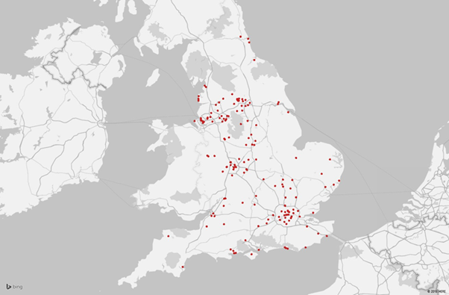

Not all closures were low volume pharmacies:

Blue = less than 5,000 items

Green = 5,000 - 10,000 items

Red = more than 10,000 items

Most were urban with a mixed ownership profile:

13 Rural pharmacies, 152 Urban

72 independent CPs, 93 multiples

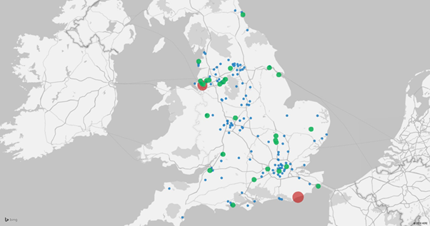

**Price concessions – July 2018**

* PSNC applied for a total of 64 price concessions in July 2018.
* A total of 43 price concession were granted by DHSC although 16 products had prices that were not agreed by PSNC. The applications for 2 lines were not granted. DHSC wrote to PSNC on 03/08/18 with the final prices.

**Price concessions – August 2018**

* PSNC applied for a total of 52 price concessions in August 2018.
* DHSC granted 40 granted price concessions in August 2018 and a further 8 products had prices that were not agreed by PSNC (including Buprenorphine tablets). Applications for 4 lines were not granted. DHSC wrote to PSNC on 31/08/18.
* The team applied for less concessions this month due to the prices of some products catching up and the suspension of the Cat M clawback.

**Price concessions – September 2018**

* PSNC applied for a total of 50 price concessions in September 2018.
* DHSC granted 33 granted price concessions in September 2018 and a further 14 products had prices that were not agreed by PSNC. Applications for 3 lines were not granted. DHSC wrote to PSNC on 28/09/18.
* Buprenorphine tablets were granted concessionary prices higher than those imposed for August but still lower than what was requested by the PSNC

**Buprenorphine tablets - price concessions**

* In September, PSNC received many calls and emails from frustrated, concerned and disappointed contractors, detailing the impact of the Buprenorphine price concession on their businesses, cashflow, ability to maintain supply of Buprenorphine under locally agreed services, and the consequences of delays in supply to this vulnerable patient group, which risked creating confrontational scenarios between pharmacy teams and substance misusers. On 18th September, PSNC wrote to DHSC with attached invoices detailing contractors concerns regarding Buprenorphine and to ensure a fair price could be agreed for September. On 28th September, the DHSC again imposed improved concessionary prices for Buprenorphine tablets compared to the prices imposed for August. The graphs below show the Buprenorphine pricing trends identified by PSNC for each strength:

Average CR = average price reported by contractors directly to us

Average PA = average price reported to us via PharmAssist (actual purchase prices not stock prices)

**Market movements with implications for supply**

* Epipen – There continues to be supply constraints of EpiPen Adrenaline Auto-Injectors in the UK according to DHSC’s latest update. This is due to Mylan having manufacturing issues through their contract manufacturer, Meridian Medical Technologies, a Pfizer company. An update has been posted on the availability of Epipen on the PSNC website.

**Submission webinar**

PSNC held an End of month submission Webinar on 25th September, hosted by Suraj Shah and Gemma Hackett from the Dispensing and Supply Team and Ben Tindale from NHSBSA presented the new ‘Manage Your Service’ application which provides pharmacies with a digital alternative to the current paper FP34C submission process. 308 people attended the webinar, out of 894 registered (a conversion rate of 35%*). 126 people completed the feedback survey (41% of attendees). The survey found that 95% of attendees thought the webinar was either very useful or useful and 83% would recommend watching it to others. 100% of respondents are very likely or likely to use what they had learned from the webinar in future. The on-demand version was made available two days after the live webinar, along with a copy of the slide packs. This can be watched at psnc.org.uk/webinar

Over 50 questions were sent in through the actual webinar platform and the survey feedback afterwards. The Dispensing and Supply team aim to respond to all question sent in by the participants. Some common questions will also be published in PSNC’s monthly publication, Community Pharmacy News (CPN) and on PSNC’s website.

The Dispensing and Supply team are looking at further webinars that would be useful to pharmacy contractors and their teams.

*Industry experts suggest that a conversion rate of anywhere between 35% and 45% is a strong result.

Below is some of the feedback from webinar participants:

* *“Found it very well presented and informative. lots of useful information”*
* *“It covered all the topics I was unsure of. As a locum I have limited practical experience but sometimes get asked advice This has helped a lot”*
* “very good, a difficult topic to explain via webinar”
* *“Thank you. Informative on some extra changes not aware of previously - mainly putting the bundle correctly”*
* *“very helpful one this month”*
* *“Thank you to all for an informative webinar”*
* *“I learnt so much from the webinar”*

**VAT**

* The latest position is that HMRC has been waiting for the outcome of the JR appeal before making a decision. Following the judgement, they have been chased up.

**Appendix FCS 14/10/18**

|  |  |
| --- | --- |
| Subject | Statistics |
| Date of meeting | 9th October 2018 |
| Committee/Subcommittee | FunCon |
| Status | Not confidential |
| Overview | Latest statistics for information |
| Proposed action(s) | No action required |
| Author(s) of the paper | PSNC Pharmacy Funding Team |

**Appendix FCS 14/10/18**

**Statistics**







