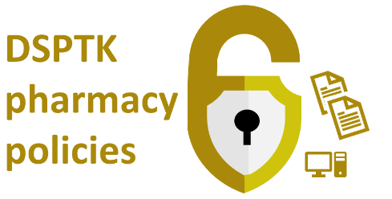

< Insert name of pharmacy>  Stand-alone staff confidentiality agreement |  |  |  | <Insert pharmacy logo>
Doc prepared by: | Doc approved by: | Date next review due:
Date prepared: | Date approved: | Date review takes place:

About the use of this document and related resources: This agreement should be reproduced on the pharmacy’s headed notepaper, photocopied and signed by each member of staff, as appropriate. One copy should be retained in the personnel file and one copy retained by the member of staff.

This data security document assists the pharmacy’s aligment with the Data Security and Protection Toolkit (DSPTK). Related pharmacy policies are at PSNC’s data security templates webpage. This document is based on a template updated during: Feb 2021

Staff confidentiality agreement

- I agree not to disclose, either during or after the termination of my employment, to anyone other than in the proper course of my employment any confidential information (e.g. personal data from within the organisation).
- In the event of the termination of my employment I accept I will not require being linked to pharmacy’s shared mailbox and I will not require the pharmacy’s ODS code to be listed on an NHS Smartcard I may hold.
- I understand that breach of this agreement may lead to dismissal without notice and may result in prosecution or an action for civil damages under data protection legislation.
- I agree to abide by the standards set out in the staff confidentiality code of conduct including maintaining good password practices.
- I have been informed and understand that my use (including personal use) of telephone (including mobile telephone), email, voicemail, internet and other communications may be monitored by automated software or otherwise, for business reasons, by my employer, to carry out their obligations and in order to monitor compliance with the standards set out in the staff confidentiality code of conduct.
- I have read, understand and agree to the terms and conditions set out above. This policy sets out the procedures and management accountability and structures that have been put in place within the pharmacy to safeguard the movement of personal data in the pharmacy.
- If any system administration responsibilities will apply to my work immediately or later, I will: respect the rights of the system users, respect the integrity of the systems and related physical resources, and comply with any relevant laws or regulations. I would also then have an obligation to keep myself informed of procedures, business practices, and operational guidelines pertaining to the system activities of the organisation.

Signature (electronic* or ink):
Name (printed):
Date:

*Note: Email or alternative remote confirmation that you have read and accept this confidentiality agreement is fine. Your employer may then file the email electronically as your confirmation.

