Community Pharmacy IT Group (CP ITG): NHS Service Finder communications

CP ITG was formed in 2017 by PSNC, NPA, RPS, CCA and AIMp. The meetings are attended by members representing the five organisations and representatives from pharmacy system suppliers, NHSBSA, NHS Digital, NHSE&I, and NHSX. Further information on the group can be found on the PSNC website.

Background about NHS Service Finder for healthcare professionals previously discussed by CP ITG

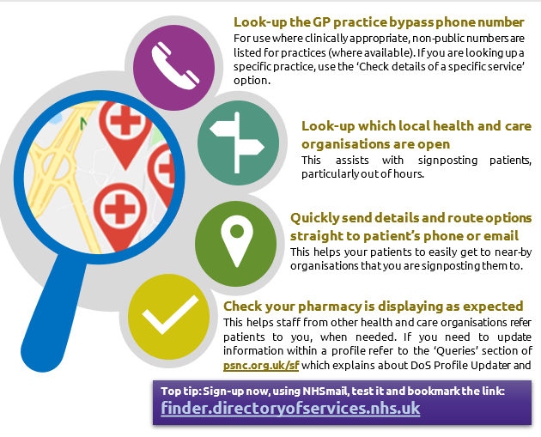
- NHS Service Finder is a free online search tool which provides access to information from the Directory of Services (DoS). It is not open to the public but it does allow pharmacy team members and other healthcare professionals to search for service information.
- It was discussed at the group’s March 2020 meeting and will by a CP ITG sub-group that approved of improvements and new comms. IT will also be discussed at the group’s 18th November 2020 meeting.

Long copy for communicating about it
Have you signed-up to use the NHS Service Finder?
NHS Service Finder is a free online search tool which provides access to information from the Directory of Services (DoS) and nhs.uk.
It is not accessible by the public, but it does allow pharmacy team members and other healthcare professionals to search for service information quickly, allowing a patient to be signposted to the most appropriate service for their needs. The system includes maps and directions to the services, plus the ability to email service information directly to your patient.
This tool also enables pharmacy teams to look-up non-public telephone numbers (where available) for listed services, such as general practices.
Top tip: Sign-up now and bookmark the webpage (https://finder.directoryofservices.nhs.uk/) so you can return to it quickly.
Find out more about NHS Service finder:
PSNC NHS Service Finder factsheet
PSNC's NHS Service Finder webpage
NHS Digital’s NHS Service Finder webpage

Short copy for communicating about it
Have you signed-up to use NHS Service Finder?
NHS Service Finder is for health care professionals. It is not open to the public but NHSmail users can speedily obtain login details.
The tool enables pharmacy teams to look-up non-public telephone numbers (where available) for listed services, such as general practices.
Sign-up now and bookmark the webpage (https://finder.directoryofservices.nhs.uk/) so you can return to it quickly.
Find out more about NHS Service Finder: PSNC NHS Service Finder factsheet

Example tweet
- Pharmacy teams: have you signed up and bookmarked NHS Service yet - finder.directoryofservices.nhs.uk/ #cpitg

Example news item
- https://psnc.org.uk/our-news/have-you-signed-up-to-use-nhs-service-finder/

