Pharmaceutical Services Negotiating Committee

Funding and Contract Subcommittee Agenda

Wednesday 26th August 2020
Zoom virtual meeting commencing at 10:30 am
Items are confidential where marked
Members: David Broome, Peter Cattee (Chairman), Jas Heer, Tricia Kennerley, Margaret MacRury, Has Modi, Garry Myers (Vice - Chair), Bharat Patel, Adrian Price, Anil Sharma

In attendance: Simon Dukes, Mike Dent, Jack Cresswell, Suraj Shah, Rob Thomas

- Welcome from Chair

- Apologies for absence

- Declarations or conflicts of interest

- Minutes of last meeting (Confidential Appendix FCS 01/08/20) and matters arising

REPORTS

- Remuneration
  - 2019/20 contract sum out-turn (Confidential Appendix FCS 02/08/20)
  - 2020/21 contract sum forecast out-turn (Confidential Appendix FCS 03/08/20)
  - HMT funding for C-19 related increased dispensing activity (Confidential Appendix FCS 04/08/20)
  - C-19 operating cost survey (Confidential Appendix FCS 05/08/20)

- Reimbursement
    - Category M July 2020 (Confidential Appendix FCS 06/08/20)
    - Margin update (Confidential Appendix FCS 07/08/20)
    - Special containers (Confidential Appendix FCS 08/08/20)
    - Quotas update (Confidential Appendix FCS 09/08/20)
    - Prescription switching during C-19 (Confidential Appendix FCS 10/08/20)
    - Original pack dispensing (verbal update)

- General funding update (Appendix FCS 11/08/20)

- Statistics (Appendix FCS 12/08/20)
- Any other business

Appendix FCS 11/08/20

Subject | General funding update
Date of meeting | 26th August 2020
Committee/Subcommittee | FunCon
Status | Not confidential
Overview | General update on various funding issues
Proposed action(s) | No action required
Author(s) of the paper | PSNC Pharmacy Funding Team

General funding update

The following items are matters of report:

Pharmacy closures & openings – estimates to May 2020
We used e-dispensary data published by NHS Digital to search for pharmacies which appeared to close or open in the months since the announcement of the funding cuts in October 2016. The latest data was published on 5th June 2020, so the full month of May data is included.
We defined a ‘period of interest’ for this analysis as any closure or opening occurring between “> or = 1 October 2016” and “< 1 June 2020”.
We also used location matching to filter out any closures or openings which appeared to be sales of pharmacy businesses. This leaves us with a count of ‘true openings and ‘true closures’ as shown in the charts below:
Overall, there appear to have been 453 ‘true closures’ from October 2016 until May 2020:
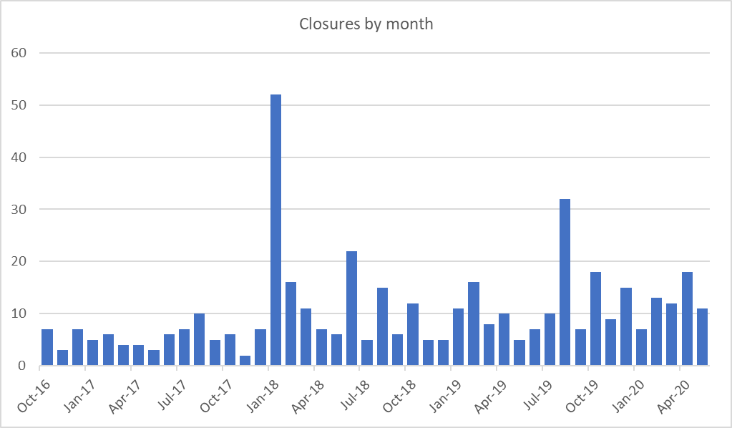
Of the 453 true closures:
- 7 were DSP’s
- 21 were PhAS pharmacies
- 177 were in urban areas
- 133 were independents

During the same time frame, there appear to have been 199 ‘true openings’:
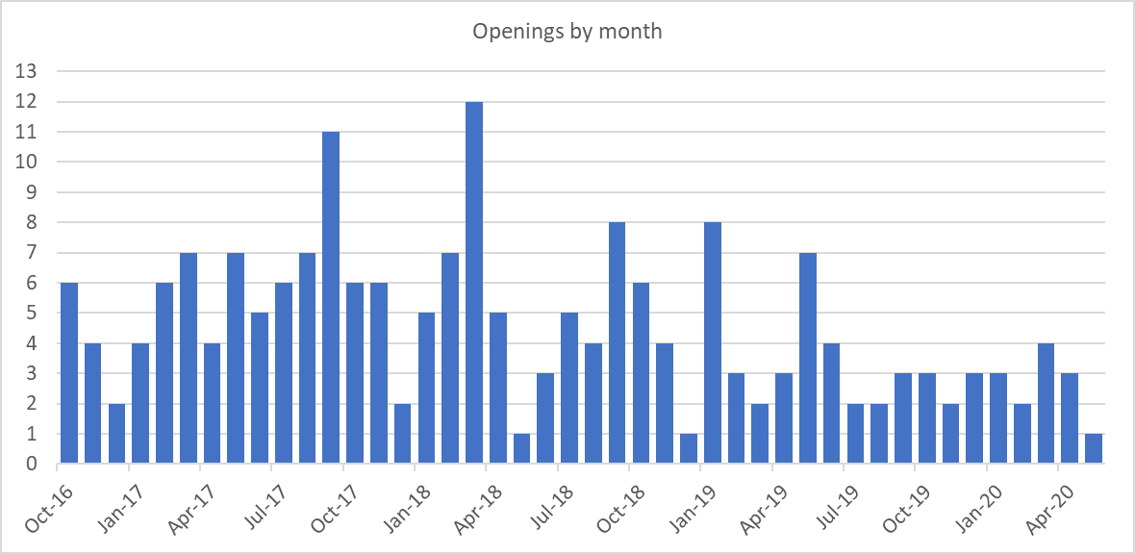
Of the 199 true openings:
- 120 were DSP’s
- 14 were bricks and mortar pharmacies in rural areas
- 10 were independent/multiples

A waterfall chart of net change in pharmacy numbers per month indicates a drop of 254 in the total number of pharmacies.
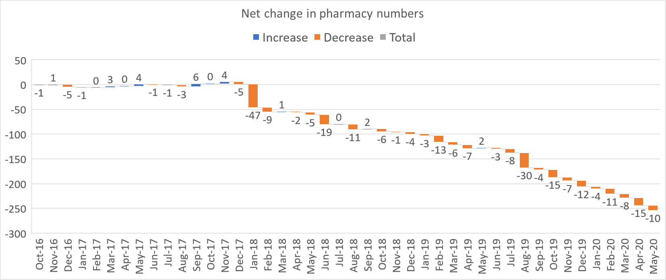

Price concessions
May 2020
- PSNC applied for a total of 94 price concessions in May 2020 and DHSC wrote to PSNC on 29 May 2020 with the list of final prices.
  - 68 price concessions were agreed between DHSC and PSNC
  - 8 products were agreed as no concession between DHSC and PSNC
  - 12 products had prices imposed as PSNC was unable to agree to the final prices proposed by DHSC
  - 6 products had a no concessionary price imposed by DHSC.
- Initially a no concession price was imposed for Ranitidine 150mg tablets despite DST providing anonymised copies of contractor invoices to DHSC
  - PSNC subsequently wrote to DHSC on 2 June 2020 seeking a retrospective price adjustment for Ranitidine 150mg tablets
  - DHSC were intent on receiving copies of invoices showing purchases made in May from multiple suppliers
  - PSNC were only able to gather invoices from multiple contractors who had all purchased stock from a single supplier
  - PSNC insisted that availability of stock from a single supplier should not be a barrier to granting of a price concession as contractors may not have had any other option but to purchase the limited stock from this remaining supplier
  - DHSC finally agreed to grant a retrospective May price concession of £7.32 on 10 June 2020 which is identical to the concession price granted in April
June 2020
- PSNC applied for a total of 59 price concessions in June 2020 and DHSC wrote to PSNC on 29 June 2020 with the list of final prices
  - 49 price concessions were agreed between DHSC and PSNC (this included 8 products where we agreed to no concession)
  - 8 products had prices imposed as PSNC was unable to agree to the final prices proposed by DHSC
  - 2 products had a no concessionary price imposed by DHSC
- There was a £15m Category M price increase which helped stabilise some of the drug prices
July 2020
- PSNC applied for a total of 46 price concessions in July 2020 and DHSC wrote to PSNC on 30 July 2020 with the list of final prices
  - 31 price concessions were agreed between DHSC and PSNC (this included 1 product where we agreed to no concession)
  - 13 products had prices imposed as PSNC was unable to agree to the final prices proposed by DHSC
  - 1 product had a no concessionary price imposed by DHSC
- The £15m Category M price increase which continued to help stabilise some of the drug prices
- Following contractor feedback, a late application for Prednisolone 2.5mg, 10mg and 20mg tablets was submitted by PSNC on 31st July based on contractor feedback. Prices were agreed with DHSC on 7th August 2020.
August 2020
- PSNC has applied for a total of 45 price concessions and currently 25 prices have been agreed. The first and second updates were published on 19 and 21 August 2020, respectively.
Price concession summary

Market movements with implications for supply
Supply disruption alerts (issued between May 2020 and 19 August 2020) for the following products were published by the Dispensing & Supply team on the PSNC website:
Date | Drug
10/08/2020 | Availability of Evorel products (Theramex) – Update
07/08/2020 | Sulfasalazine 250mg/5ml oral suspension sugar free (Rosemont) – Update
07/08/2020 | Pethidine 50mg tablets
03/08/2020 | Senna with ispaghula husk (Manevac) granules (Mylan)
03/08/2020 | Nabumetone 500mg tablets
03/08/2020 | H2-antagonists (Cimetidine, Famotidine and Nizatidine) – Update
24/07/2020 | Enalapril 20mg tablets (various suppliers)
24/07/2020 | Fluticasone propionate (Flixotide) 0.5mg/2ml and 2mg/2ml Nebules - Update
24/07/2020 | Promazine 25mg and 50mg tablets – Update
17/07/2020 | Oral contraceptive tablets (various brands)
17/07/2020 | Ketotifen 1mg/5ml elixir (Zaditen)
17/07/2020 | Metronidazole (Acea) 0.75% gel
17/07/2020 | Promazine 25mg and 50mg tablets – Update
17/07/2020 | Mirtazapine 15mg and 45mg orodispersible tablets – Update
17/07/2020 | Sodium Cromoglicate (Intal) CFC-free inhaler (Sanofi) – Update
17/07/2020 | H2-antagonists (Cimetidine, Famotidine and Nizatidine) – Update
08/07/2020 | Ferrous Fumarate 322mg/Folic Acid 350mcg (Pregaday) tablets (Recipharm)
03/07/2020 | Phenelzine Sulphate 15mg tablets (Nardil®) – Update
03/07/2020 | Availability of Evorel products (Theramex) – Update
30/06/2020 | Availability of Epipen 0.15mg and 0.3mg adrenaline auto-injectors – US labelled EpiPen 0.3mg
26/06/2020 | Fluticasone propionate (Flixotide) 0.5mg/2ml and 2mg/2ml Nebules
25/06/2020 | Isoniazid 50mg tablets
25/06/2020 | Phenelzine Sulphate 15mg tablets (Nardil®)
25/06/2020 | Lacosamide (Vimpat) 50mg tablets (UCB Pharma Ltd)
25/06/2020 | Mirtazapine 15mg and 45mg orodispersible tablets
25/06/2020 | Lodoxamide 0.1% (Alomide) eye drops (Novartis)
25/06/2020 | Imipramine 25mg tablets
25/06/2020 | Prednisolone 5mg suppositories (RPH Pharmaceuticals) – Update
25/06/2020 | Promazine 25mg and 50mg tablets – Update
25/06/2020 | Phenytoin Sodium NRIM 100mg capsules (Accord) – Update
25/06/2020 | H2-antagonists (Cimetidine, Famotidine and Nizatidine) – Update
23/06/2020 | Warticon 0.15% cream – Update
17/06/2020 | Stanek® and Sastravi® (levodopa/carbidopa/ entacapone) tablets
17/06/2020 | Ranitidine all formulations update
29/05/2020 | Stanek® (levodopa/ carbidopa/ entacapone) tablets – various strengths – Update
29/05/2020 | Salazopyrin® (sulfasalazine) 500mg suppositories – Update
29/05/2020 | Phytomenadione (Konakion MM Paediatric) 2mg/0.2ml ampoules (Cheplapharm) – Update
29/05/2020 | Valproate semisodium (Depakote) 250mg and 500mg tablets (Sanofi) – Update
29/05/2020 | Zyban (bupropion hydrochloride) 150mg prolonged release tablets (GlaxoSmithKline UK)
29/05/2020 | Danazol 100mg and 200mg capsules
29/05/2020 | Nardil (Phenelzine sulfate) 15mg tablets
12/05/2020 | Clenil Modulite 100mcg – additional batches released
Serious Shortage Protocol SSP06 Fluoxetine 40mg capsules
In response to significant ongoing disruption to the supply of Fluoxetine 40mg capsules, a Serious Shortage Protocol (SSP) was issued by the Department of Health and Social Care (DHSC). Introduced on Wednesday 20 May 2020, SSP06 was developed by clinicians and provides pharmacists with procedures to follow in providing a suitable alternative product, two Fluoxetine 20mg capsules in response to the serious shortage affecting the 40 mg capsules. DST issued communications and produced a briefing with example endorsements to show contractors how to endorse and claim for supplies made against this SSP. SSP06 for Fluoxetine 40mg capsules were previously expected to expire on the 10 August but the end date has been further extended to the 4 September 2020.

Other active SSPs
SSP05 for Fluoxetine 10mg capsules is due to expire on 11 September 2020.

C-19 payments and claiming deadlines
DST has issued regular updates via PSNC website, CPN and Twitter reminding contractors of the importance of their end of month submission process, methods and deadlines for claiming any C-19 related payments, and timing of these payments to ensure that contractors do not lose out on these. The payment table below was published to inform contractors how and when certain payments would be made.

Payment type | Claim method | Payment amount | Payment due | How payment will appear on your Schedule of Payments
Early May Bank Holiday Friday 8th May* | MYS portal | £250 per hour  (maximum £750 for opening of at least 3 hours) | Payment due on 1 July if claimed using MYS by the 22 June | This payment will not appear on the Schedule of Payment. NHSBSA will issue individual letters to contractors who claimed via MYS informing them of payment.
Pandemic Delivery Service (Essential Service)** | Automatic payment by NHSBSA | 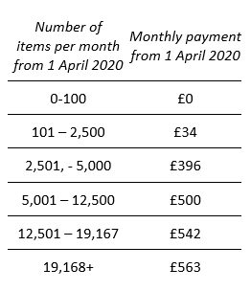 | Monthly – with first payment due on 1 July | Paid on the same line as Transitional Payment. It will show as a total figure.
Pandemic Delivery Service  (Advanced Service)** | MYS portal | £6 (including VAT) per delivery | Monthly – with first payment due on 1 July for deliveries made in April and claimed using MYS by the 5 May | Payment will be listed as ‘Additional advance payment’ under section titled ‘Summary of Payment Amounts’
Adjustments to support social distancing e.g for installation of protective screens** | NHSBSA claim form for contractors who did not automatically receive the £300 payment in May because they had to temporarily close their pharmacy for more than 2 weeks since 31 March and had made adjustments for social distancing prior to or after the closure. | £300 | Contractors will be paid at the earliest opportunity if claimed using the appropriate claim form by the 5 August  0)** | This payment will not appear on the Schedule of Payment. NHSBSA will issue individual letters to contractors who claimed informing them of payment.
Recently opened pharmacies to receive share of C-19 advance sums
Following representations from PSNC, community pharmacies that newly opened (including any changes to ownership, consolidations, mergers etc.) between 1 March 2020 and 30 June 2020 can receive advance funding to help mitigate cashflow issues due to C-19.

DHSC announced that, as long as these recently opened pharmacies provided NHS pharmaceutical services during these months, they will be eligible to receive a share of the total uplift of circa £370m in advance funding given to pharmacy contractors. The arrangements for new pharmacies allow contractors who opened in June 2020, for example, and provided NHS pharmaceutical services during this month to receive their share of the average each prescription got from £20m for each prescription they dispensed in June. NHSBSA will be sending a letter to affected contractors outlining their uplift.

Different arrangements to calculate uplift payments were needed for new pharmacies that opened between 1 March 2020 and 30 June 2020 because of the method use for calculation of the advance payments. For example, pharmacies that opened in June did not receive any uplift payments that were made to existing pharmacies on the 1 July because this payment was calculated as an uplift of the May advance payment.
Those pharmacies that opened between March 2020 and June 2020, and did not receive an uplift by 1 August 2020 or think that their uplift was lower than it should have been when they compare to what is outlined in the determination, have an opportunity until 5 November 2020 to make representations as to why they think they should have received the uplift or a top-up to the uplift they received. Forms put forward by contractors will be considered by the Secretary of State on a monthly basis to the following schedule. For example, if a form is submitted by 5 August it will be considered during the month of August for payment to be made on 1 September, if appropriate. Any missing information on the form may cause delay to the process / payment by a month.
Table showing different scenarios for each claim month
Month pharmacy opened | Timing of FP34C submission | How the uplift payments will be calculated
Mar-20 | FP34C submitted in March 2020 | Contractors will receive uplift based on the average each prescription got from £300 million for each prescription they dispensed in March
Mar-20 | No FP34C submitted for March but submitted for April 2020 | Contractors will receive uplift based on the average each prescription got from £100 million for each prescription they dispensed in April.
 |  | However, if you provided NHS pharmaceutical services in March but failed to submit the batch you can make representations to access the uplift based on £300 million using the appropriate form (see the full determination on the NHSBSA website for more details).
Mar-20 | No FP34C submitted for March and April but submitted for May 2020 | No uplift.
 |  | However, if you provided NHS pharmaceutical services in March and/or April but failed to submit the batch you can make representations to access the uplift based on £300 million or £100 million using the appropriate form (see the full determination on the NHSBSA website for more details).
Apr-20 | FP34C submitted for April 2020 | Contractors will receive uplift based on the average each prescription got from £100 million for each prescription they dispensed in April.
Apr-20 | No FP34C submitted for April but submitted for May 2020 | No uplift.
 |  | However, if you provided NHS pharmaceutical services in April but failed to submit the batch you can make representations to access the uplift based on £100 million using the appropriate form (see the full determination on the NHSBSA website for more details).
May-20 | FP34C submitted for May 2020 | Contractors will receive uplift based on the average each prescription got from £50 million for each prescription they dispensed in May.
May-20 | No FP34C submitted for May but submitted for June 2020 | No uplift.
 |  | However, If you provided NHS pharmaceutical services in May but failed to submit the batch you can make representations to access the uplift based on £50 million using the appropriate form (see the full determination on the NHSBSA website for more details).
Jun-20 | FP34C submitted for June 2020 | Contractors will receive uplift based on the average each prescription got from £20 million for each prescription they dispensed in June.
Jun-20 | No FP34C submitted for June but submitted for July 2020 | No uplift.
 |  | However, if you provided NHS pharmaceutical services in June but failed to submit the batch you can make representations to access the uplift based on £20 million using the appropriate form (see the full determination on the NHSBSA website for more details).

Changes to PEPS
From 1 July 2020 the Pharmacy Earlier Payment Scheme (PEPS) has been updated to provide contractors even earlier access to their monthly Advance payment. Under the new scheme, pharmacy contractors can receive an estimated early payment, based on their submission history, before the NHS Business Services Authority (NHSBSA) receives their FP34C submission document. This means pharmacy contractors can access funds up to 60 days earlier.

NHSBSA calculates an average estimated early payment based on your individual dispensing history over the last 12 months. There will be one payment date at the beginning of the dispensing month. Contractors actual monthly submission will be offset against the estimated early payment they receive, and this payment will be reconciled against the actual payment when it is due. It is important that the prescription batches and accompanying FP34C are submitted to the NHSBSA within the normal submission deadlines i.e. by the 5th day of the month following that in which the supply was made.

The previous PEPS terms will no longer apply from 1 July 2020. Pharmacy contractors who were previously signed up to PEPS who wished to continue with the new scheme should have sent a completed revised terms and conditions form the NHSBSA by 31 May 2020. Existing pharmacy contractors who did not send in their revised terms and conditions revert to the normal payment timetable.

PEPS was first introduced in April 2013. It is a privately financed, voluntary arrangement, as part of a broader initiative by the UK Government, to allow community pharmacies early access to their monthly advance payment for the provision of NHS pharmaceutical services. The voluntary arrangement is financed by Taulia and is facilitated by NHSBSA.

Updated PEPS payment timings
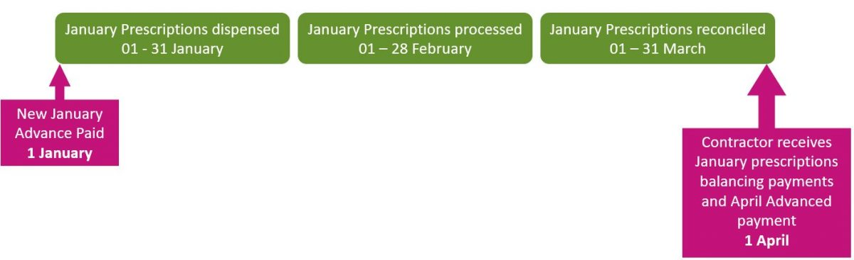

Additions to Discount Not Deducted (DND) list
Since January 2020, following contractor feedback and through internal DST checks, applications for Discount Not Deducted (DND) status were submitted to the NHSBSA and DHSC for 58 products. Of these, 40 products have been agreed to by DHSC and added to the Drug Tariff DND list.

The following applications to the DND list were successfully made to the Drug Tariff between January and September 2020:
Month | Product name
Sep-20 | Rybelsus 14mg tablets
 | Rybelsus 3mg tablets
 | Rybelsus 7mg tablets
Aug-20 | Prednisolone 20mg/application foam enema
 | Abilify Maintena 400mg powder and solvent for prolonged-release suspension for injection pre-filled syringes
 | Abilify Maintena 400mg powder and solvent for prolonged-release suspension for injection vials
 | Aripiprazole 400mg powder and solvent for suspension for injection pre-filled syringes
 | Aripiprazole 400mg powder and solvent for suspension for injection vials
Jul-20 | Acetylsalicylic acid (Aspirin powder)
 | Ammonium bicarb
 | Zinc Oxide
 | Emtricitabine 200mg / Tenofovir alafenamide 10mg tablets
 | Emtricitabine 200mg / Tenofovir alafenamide 25mg tablets
Jun-20 | Acetone liquid
 | Borax powder
 | Boric Acid powder
 | Peppermint oil liquid
 | Potassium iodide powder
 | Rose water liquid
 | Sulfur precipitated powder
 | Sulfur sublimed powder
 | Tartaric acid powder
May-20 | Posaconazole 40mg/ml oral suspension
Apr-20 | Alprostadil 20microgram powder and solvent for solution for injection cartridges
 | Alprostadil 40microgram powder and solvent for solution for injection cartridges
 | Darunavir 800mg tablets
 | Nutrison 800 Complete Multi Fibre liquid
Mar-20 | Esmya 5mg tablets
 | Liothyronine 10microgram tablets
 | Similac Alimentum powder
 | Ulipristal 5mg tablets
 | Valcyte 50mg/ml oral solution
 | Valganciclovir 50mg/ml oral solution sugar free
Feb-20 | Follitropin alfa 75unit powder and solvent for solution for injection vials
 | Follitropin alfa 450unit powder and solvent for solution for injection vials
Jan-20 | Fortini Compact Multi Fibre liquid
 | Nutrini Peptisorb Energy liquid
 | PaediaSure Compact liquid
 | PKU sphere15 oral powder
 | SMA Alfamino powder

In July 2020, PSNC submitted applications to the NHSBSA for an additional 120 drugs (mainly ACBS products) to be added to the DND list as these products appear to meet the individual drugs DND criteria PSNC is currently awaiting a decision from DHSC on these applications. Further checks of over 900 products are under way to determine if they meet the individual drug DND criteria.

Dm+d special order product listings
Recent ‘Supply Disruption Alerts’ and ‘Medicine Supply Notification’ updates issued by DHSC for drugs affected by supply issues make recommendations for prescribers to consider unlicensed imported alternatives. However, for majority of these recommended unlicensed alternatives, there are no ‘Special Order’ or ‘Imported’ Actual Medicinal Product (AMP) listings on dm+d for prescribers to select using their prescribing systems. Due to this, prescribers are only able to issue paper FP10 prescriptions for these drugs. However, ,any GPs have completely stopped issuing paper prescriptions for their patients and given that nearly 90% of all items are now prescribed using EPS in primary care, it is impractical and unreasonable for pharmacies to request paper prescriptions for any unlicensed products without a listing on dm+d.

Additionally, with the EPS Phase 4 roll out, most paper prescriptions will be replaced by Phase 4 tokens. As more practices go live with Phase 4, pharmacies will see the majority of paper prescriptions replaced by Phase 4 tokens. To avoid pharmacy teams having to request paper prescriptions or refer patients back to their GP for a new prescription, PSNC has urged the Department and NHSBSA to add to dm+d, as 'Special Order' or 'Imported' AMPs, every missing unlicensed product recommended by DHSC in order to facilitate electronic prescribing of these products. This would allow prescribers to select the unlicensed version, where appropriate, so that pharmacists can dispense the required product and be reimbursed accordingly. This would prevent any unnecessary delays in getting medicines to patients and better utilise resources of GPs and pharmacy teams at a time where they are needed most to support the NHS and its patients through the pandemic.

List of products requested for addition to dm+d
Date request sent | Drug name
18/08/2020 | Desmopressin 150micrograms/dose nasal spray (Special Order)
18/08/2020 | Enalapril 20mg tablets (Special Order)
18/08/2020 | Phenelzine 15mg capsules (Special Order)
07/08/2020 | Pethidine 50mg tablets (Special Order)
07/08/2020 | Nabumetone 500mg tablets (Special Order)
23/07/2020 | Cimetidine 200mg tablets (Special Order)
23/07/2020 | Cimetidine 400mg tablets (Special Order)
23/07/2020 | Cimetidine 800mg tablets (Special Order)
23/07/2020 | Sodium cromoglicate 5mg CFC free inhaler (Special Order)
23/07/2020 | Ketotifen 1mg/5ml elixir (Special Order)
23/07/2020 | Ethinylestradiol/norethisterone/35microgram/1mg tablets and Ethinylestradiol/norethisterone/35microgram/500microgram tablets (Special Order)
01/07/2020 | Fluticasone propionate 0.5mg/2ml nebules (Special Order)
01/07/2020 | Fluticasone propionate 2mg/2ml nebules (Special Order)
01/07/2020 | Mirtazapine 15mg orodisperible tablets (Special Order)
01/07/2020 | Mirtazapine 45mg orodispersible tablets (Special Order)
01/07/2020 | Imipramine 25mg tablets (Special Order)
01/07/2020 | Prednsiolone 5mg suppositories (Special Order) - (Please reinstate dm+d entry)
03/06/2020 | Propantheline 15mg tablets (Special Order) - (Please reinstate dm+d entry)
03/06/2020 | Bupropion 150mg prolonged release tablets (Special Order)
03/06/2020 | Danazol 100mg capsules (Special Order)
03/06/2020 | Danazol 200mg capsules (Special Order)
14/04/2020 | Phytomenadione 2mg/0.2ml ampoules (Special Order)
14/04/2020 | Acetazolamide 250mg SR capsules (Special Order)
03/04/2020 | Cycloserine 250mg capsules (Special Order)
03/04/2020 | Promazine 25mg tablets (Special Order) - (Please reinstate dm+d entry)
03/04/2020 | Promazine 50mg tablets (Special Order)
25/02/2020 | Phenytoin 30mg/5ml Oral Suspension (Special Order)
17/01/2020 | Moclobemide 300mg tablets (Special Order)
16/09/2019 | Mianserin 10mg tablets (Special Order)
16/09/2019 | Mianserin 30mg tablets (Special Order)

Pharmacy factsheets for Community Pharmacy News (CPN)
Each month DST produces factsheets with latest information and reminders on various dispensing and supply-related topics for pharmacy teams to refer to. Below is a table of the recent factsheets published in the monthly Community Pharmacy News (CPN) magazine:

CPN Month | Factsheet title
Aug-20 | Exemptions from prescription charges
Jul-20 | New prescriber endorsement ‘FS’ for free supply of sexual health treatment
Jun-20 | All you need to know about: Special containers and products requiring reconstitution
May-20 | C-19 related payments in June/July
Apr-20 | C-19 related payments in April/May
Mar-20 | Dispensing Factsheet: Prescription endorsements
Feb-20 | Dispensing and endorsing FP10MDA instalment forms correctly
Jan-20 | Changes to FP10 NHS Prescription forms and EPS Tokens

Appendix FCS 12/08/20

Subject | Statistics
Date of meeting | 26th August 2020
Committee/Subcommittee | FunCon
Status | Not confidential
Overview | Latest statistics for information
Proposed action(s) | No action required
Author(s) of the paper | PSNC Pharmacy Funding Team

Statistics

