Pharmaceutical Services Negotiating Committee Funding and Contract Subcommittee Agenda

Wednesday 5th February 2020 at 10.30
Aylesbury room, 14 Hosier Lane, London, EC1A9LQ
Items are confidential where marked
Members: David Broome, Peter Cattee (Chairman), Tricia Kennerley, Andrew Lane, Margaret MacRury, Has Modi, Garry Myers (Vice - Chair), Bharat Patel, Adrian Price, Anil Sharma

In attendance: Simon Dukes, Mike Dent, Jack Cresswell, Suraj Shah, Rob Thomas

- Welcome from Chair

- Apologies for absence

- Declarations or conflicts of interest

- Minutes of last meeting (Confidential Appendix FCS 01/02/20) (pages 3-5) and matters arising

ACTION

- Remuneration

  - Forecast 2019/20 contract sum out-turn (Confidential Appendix FCS 02/02/20) (pages 6-7)
  - VAT

- Reimbursement

  - Category M January 2020 (Confidential Appendix FCS 03/02/20) (pages 8-12)
  - Quarterly margins survey (Confidential Appendix FCS 04/02/20) (pages 13-15)
  - Retained margins forecasts (Confidential Appendix FCS 05/02/20) (pages 16-19)
  - Cat C additional margin methodology (Confidential Appendix FCS 06/02/20) (pages 20-23)

- CPCF

  - Reimbursement changes
  - New funding models
  - Evaluation and Annual review

REPORT

- General funding update (Appendix FCS 07/02/20) (pages 24-29)

- Statistics (Appendix FCS 08/02/20) (pages 30-35)

- Any other business
Appendix FCS 07/02/20

Subject | General funding update
Date of meeting | 5th February 2020
Committee/Subcommittee | FunCon
Status | Not confidential
Overview | General update on various funding issues
Proposed action(s) | No action required
Author(s) of the paper | PSNC Pharmacy Funding Team PSNC Dispensing and Supply Team

General funding update

The following items are matters of report:

Pharmacy Quality Scheme
The deadline to claim the Aspiration payment for the 2019/20 Pharmacy Quality Scheme has now passed. Contractors were able to claim up to 70% of what was paid in the previous year’s QPS by indicating which criteria they intend to meet this year. The aspiration payments were paid at the end of November, and there will be a final declaration and reconciliation at the end of 2019/20.

NHSBSA provided a list of ODS codes who had submitted an aspiration payment claim and the total points they aspired to claim for. We have audited the list and cross referenced against payments received by contractors, and subsequently liaised with NHSBSA to clarify a small number of unexpected findings. These have been cleared up and consequently our checks indicate that all aspiration payments have been made correctly.

Pharmacy closures & openings – estimates to November 2019
We used e-dispensary data published by NHS Digital to search for pharmacies which appeared to close or open in the months since the announcement of the funding cuts in October 2016. The latest data was published on 29th November 2019, meaning that any November data within is likely to be incomplete.
We defined a ‘period of interest’ for this analysis as any closure or opening occurring between “> or = 1 October 2016” and “< 29 November 2019”.
We also used location matching to filter out any closures or openings which appeared to be sales of pharmacy businesses. This leaves us with a count of ‘true openings and ‘true closures’ as shown in the charts below:
Overall there appear to have been 364 ‘true closures’ from October 2016 until Nov 2019:

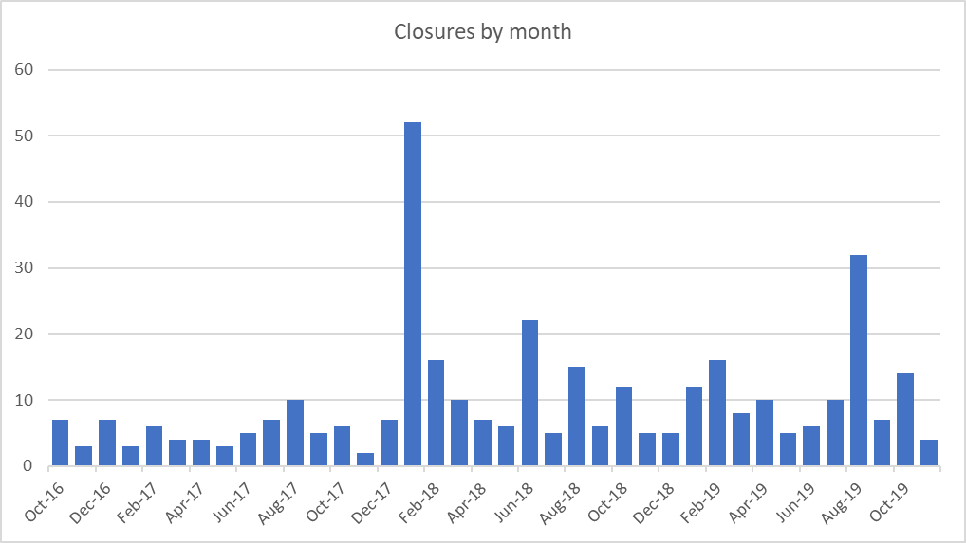

During the same time frame, there appear to have been 180 ‘true openings’:
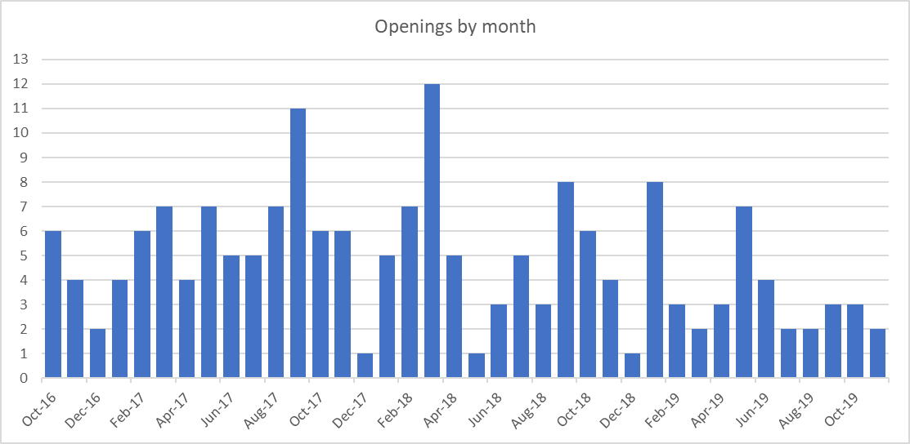

A waterfall chart of net change in pharmacy numbers per month indicates a drop of 184 in the total number of pharmacies.

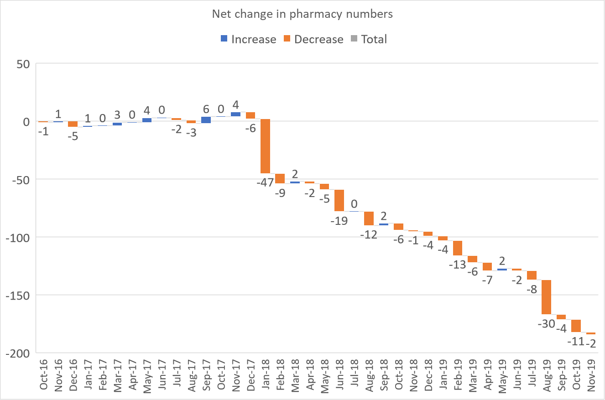

Price concessions – November 2019
- PSNC applied for a total of 55 price concessions in November 2019.
- 39 price concessions were agreed between DHSC and PSNC. 15 products had prices imposed as PSNC was unable to agree to the final prices proposed by DHSC. DHSC wrote to PSNC on 03/12/19 with the final prices.
Price concessions – December 2019
- PSNC applied for a total of 65 price concessions in December 2019.
- 48 price concessions were agreed between DHSC and PSNC. 14 products had prices imposed as PSNC was unable to agree to the final prices proposed by DHSC. DHSC wrote to PSNC on 20/12/19 with the final prices.
Price concessions – January 2020
- PSNC have currently applied for 58 price concessions in January 2020.
- 45 price concessions have been agreed between DHSC and PSNC. 13 products are still under consideration

Price concession summary

Market movements with implications for supply
Supply disruption alerts (issued between November 2019 and January 2020) for the following products were published by the Dispensing & Supply team on the PSNC website
Date | Drug
17/01/2019 | Salofalk (mesalazine) suppositories (500mg and 1g) – Update
17/01/2019 | Seroxat (paroxetine) 20mg/10ml oral solution – Update
17/01/2019 | Mianserin 10mg and 30mg tablets – Update
17/01/2019 | Sayana Press (medroxyprogesterone acetate) injection supply issue – Update
17/01/2019 | Supply Disruption: Azathioprine 25mg tablets
08/01/2020 | FreeStyle Libre Supply Update
23/12/2019 | Valproic acid 150mg, 300mg and 500mg capsules (Convulex®)
22/12/2019 | SSP issued for Haloperidol
20/12/2019 | Ranitidine all formulations update
20/12/2019 | H2-antagonists (Cimetidine, Famotidine and Nizatidine)
20/12/2019 | Clonidine 25mcg tablets (updated 17/01/2019)
19/12/2019 | Sinemet – Update
18/12/2019 | Haloperidol (Serenace) 500 microgram capsules (Teva)
11/12/2019 | Berinert (Human C1 Esterase Inhibitor) 500units Powder And Solvent For Injection (Csl Behring UK)
28/11/2019 | Reboxetine (Edronax) 4mg tablets
28/11/2019 | Fluorouracil 5% (Efudix) cream
27/11/2019 | Ranitidine all formulations update
14/11/2019 | Synphase (Ethinylestradiol and Norethisterone) tablets (updated 17/01/2019)
14/11/2019 | Disopyramide 150mg capsules (updated 17/01/2019)
14/11/2019 | Provera (medroxyprogesterone acetate) 100mg & 200mg tablets update
14/11/2019 | Pethidine 50mg tablets
14/11/2019 | Minims Phenylephrine 2.5% & 10% w/v eye drops

Metformin – supply update
MHRA released an update on metformin medicines on 6th December 2019. This update indicated that outside the UK very low amounts of an impurity, N-nitrosodimethylamine (NDMA) have been found in some metformin-containing medicines. MHRA advised that patients should continue to take their metformin containing medicines as usual whilst further investigations continue.

PSNC has received reports from some contractors who were unable to source any metformin products and also some reports that stock available in market cannot be purchased at or below the Drug Tariff prices. DST is in regular contact with the Medicines Supply Team at DHSC and MHRA’s Defective Medicines Centre regarding this issue. Both DHSC and MHRA recognise that metformin is a critical medicine with no direct alternative, and they will be taking a pragmatic stance to consider the best course of action, if any, for patients in the UK.

FreeStyle Libre sensors

Some pharmacy contractors have reported delays in obtaining FreeStyle Libre sensors for orders placed around the end of December 2019 and into January 2020. DST contacted Abbott who advised that this was due to temporary shipment delays and there could be delays of up to 2 to 3 weeks in fulfilling orders of the FreeStyle Libre sensors to some pharmacies in the UK. DST is in regular contact with Abbott to discuss supply issues affecting this product.
SSPs
The following fluoxetine SSP’s expired in November and December:
SSP | Date expired
SSP02: Fluoxetine 30mg capsules | 18th December 2019
SSP03: Fluoxetine 40mg capsules | 20th November 2019
NHSBSA and DHSC confidentially updated PSNC that as of 24th October less than 5% of EPS Fluoxetine prescriptions had claimed for SSPs. NHSBSA and PSNC are investigating this further to see how contractors are endorsing SSPs.
SSP04 - Haloperidol 500mcg capsules (Serenace®) was issued on 22 December 2019. DST issued a revised briefing along with endorsement examples for this SSP.
Changes to the reverse of FP10 prescription form/token
DHSC informed PSNC that the reverse of the prescription form/token has been finalised. DST has created a CPN factsheet and detailed briefing on the changes. NHSBSA requested PSNC to jointly release materials on 21st January 2020.
The main changes are as follows:

- A new exemption box U for patients who are in receipt of Universal Credit and meet the criteria for free help with health costs.
- Removal of box X "was prescribed free-of-charge contraceptives" from the paper FP10 form/Token.
- Introduction of a new prescriber endorsement ‘FS’ for 'free supply of sexual health treatment' to enable prescribers to endorse prescriptions for the treatment of sexually transmitted infections (STIs) to indicate to dispensers that the patient should not be charged.
- Combination of age exemption categories, A "is under 16 years of age" and C "is 60 years of age or over" into a single age exemption category, A "is 60 years of age or over or is under 16 years of age".
- Exemption box G 'has a War Pension exemption certificate’ has been re-worded to read ‘Prescription exemption certificate issued by the Ministry of Defence’. This is to better represent the exemption certificates issued by Veterans UK and those entitled to an award under the Armed Forces Compensation Scheme (AFCS).

Appendix FCS 08/02/20

Subject | Statistics
Date of meeting | 5th February 2020
Committee/Subcommittee | FunCon
Status | Not confidential
Overview | Latest statistics for information
Proposed action(s) | No action required
Author(s) of the paper | PSNC Pharmacy Funding Team

Statistics
