Pharmaceutical Services Negotiating Committee

Funding and Contract Subcommittee Agenda

Wednesday 20th May 2020
Zoom virtual meeting commencing at 10:00 am
Items are confidential where marked
Members: David Broome, Peter Cattee (Chairman), Tricia Kennerley, Andrew Lane, Margaret MacRury, Has Modi, Garry Myers (Vice - Chair), Bharat Patel, Adrian Price, Anil Sharma

In attendance: Simon Dukes, Mike Dent, Jack Cresswell, Suraj Shah, Rob Thomas

- Welcome from Chair

- Apologies for absence

- Declarations or conflicts of interest

- Minutes of last meeting (Confidential Appendix FCS 01/05/20) (pages 2-5) and matters arising

REPORTS

- Remuneration
  - Forecast 2019/20 contract sum out-turn (Confidential Appendix FCS 02/05/20) (pages 6-8)
  - Forecast 2020/21 contract sum out-turn (Confidential Appendix FCS 03/05/20) (pages 9-12)
  - C-19 operating cost survey (Confidential Appendix FCS 04/05/20) (pages 13-20)
  - PoT proposals – C-19 (Confidential Appendix FCS 05/05/20) (pages 21-23)

- Reimbursement
- Category M April 2020 (Confidential Appendix FCS 06/05/20) (pages 24-28)
- Retained margins forecasts (Confidential Appendix FCS 07/05/20) (pages 29-33)
- Original pack dispensing (Confidential Appendix FCS 08/05/20) (pages 34-41)
- Quotas (Confidential Appendix FCS 09/05/20) (pages 42-45)
- Reimbursement changes (Confidential Appendix FCS 10/02/20) (pages 46-48)
- Price concessions analysis (Confidential Appendix FCS 11/05/20) (pages 49-52)

- CPCF
- PoT discussion document (Confidential Appendix FCS 12/05/20) (pages 53-56)

- General funding update (Appendix FCS 13/05/20) (pages 57-65)

- Statistics (Appendix FCS 14/05/20) (pages 66-71)

- Any other business
Appendix FCS 13/05/20

Subject | General funding update
Date of meeting | 20th May 2020
Committee/Subcommittee | FunCon
Status | Not confidential
Overview | General update on various funding issues
Proposed action(s) | No action required
Author(s) of the paper | PSNC Pharmacy Funding Team

General funding update

The following items are matters of report:

Pharmacy closures & openings – estimates to February 2020
We used e-dispensary data published by NHS Digital to search for pharmacies which appeared to close or open in the months since the announcement of the funding cuts in October 2016. The latest data was published on 28th February 2020, meaning that any February data within is likely to be incomplete.
We defined a ‘period of interest’ for this analysis as any closure or opening occurring between “> or = 1 October 2016” and “< 28 February 2020”.
We also used location matching to filter out any closures or openings which appeared to be sales of pharmacy businesses. This leaves us with a count of ‘true openings and ‘true closures’ as shown in the charts below:
Overall, there appear to have been 401 ‘true closures’ from October 2016 until Feb 2020:
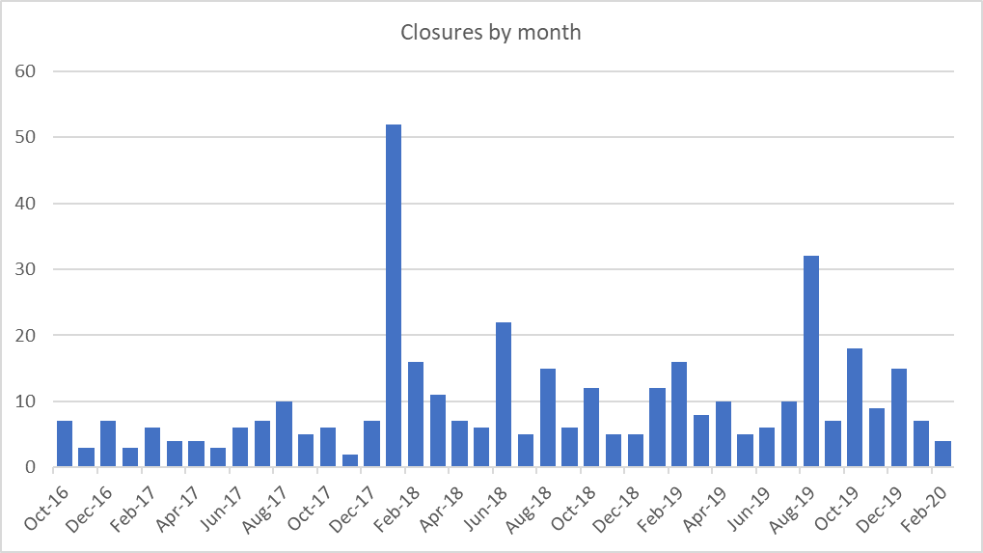

Of the 401 true closures:
- 369 were in urban areas
- 127 were independents
- 116 were independent bricks and mortar pharmacies
- 59 were independent bricks and mortar pharmacies with a monthly item volume greater than 2,500
- 237 were in rural areas
- 40 had a monthly item volume greater than 7,000
- 16 were independents with a monthly item volume greater than 7,000
- 13 were DSP’s
- 18 were PhAS pharmacies

We were able to identify 329 of the true closures in previous pharmacy distance analysis. Of the 329, 294 had their nearest pharmacy still open.
The average distance from the closed pharmacies to their next nearest bricks and mortar pharmacy was 704 metres:
Frequency for 0-200m distance: 99
Frequency for 201-500m distance: 80
Frequency for 501-750m distance: 28
Frequency for 751-1000m distance: 28
Frequency for 1001-2000m distance: 46
Frequency for 2001-10000m distance: 13
Looking at frequency, we can see that most closed pharmacies had another pharmacy operating within 500 metres.
During the same time frame, there appear to have been 191 ‘true openings’:
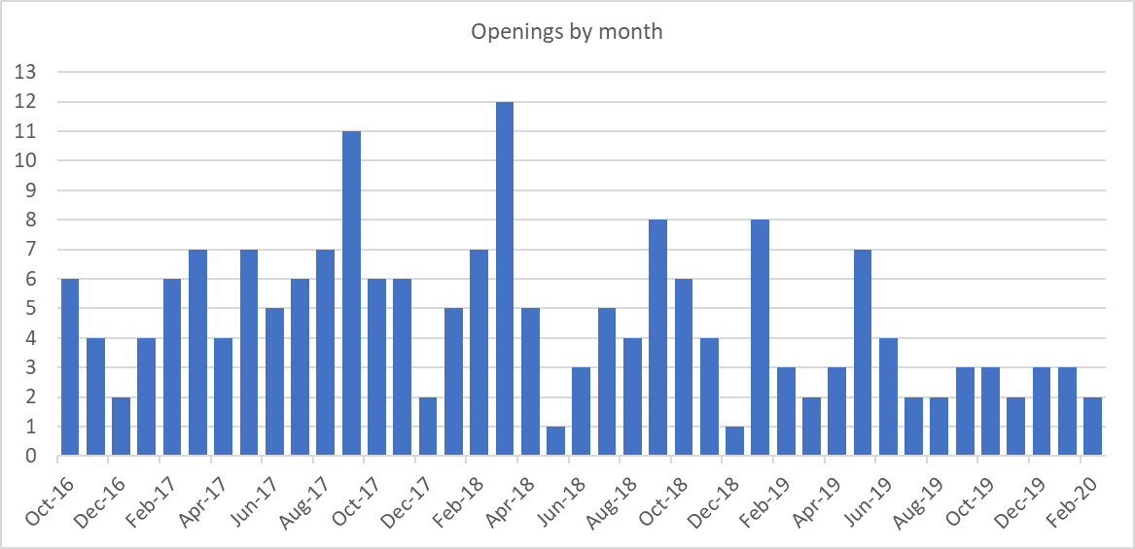
Of the 191 true openings;
- 110 were DSP’s
- 37 were DSP’s with a monthly item volume greater than 2,500
- 6 were DSP’s with a monthly item volume greater than 7,000
- 35 were bricks and mortar pharmacies with a monthly item volume greater than 2,500
- 19 were bricks and mortar pharmacies in rural areas
- 11 were independent bricks and mortar pharmacies in rural areas

A waterfall chart of net change in pharmacy numbers per month indicates a drop of 210 in the total number of pharmacies.
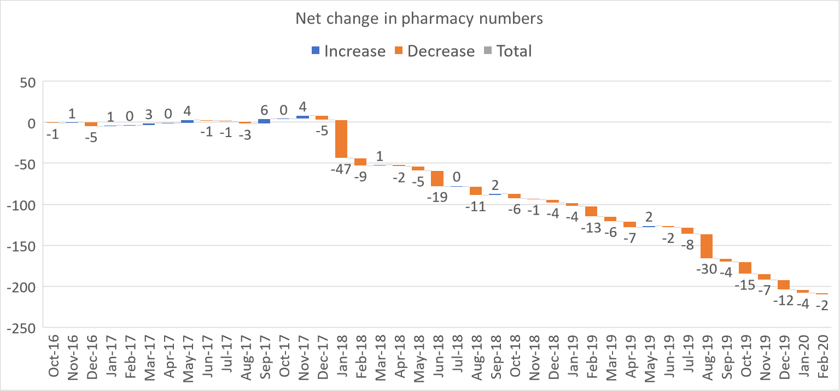

Price concessions – February 2020
- PSNC applied for a total of 57 price concessions in February 2020.
- 45 price concessions were agreed between DHSC and PSNC. 9 products had prices imposed as PSNC was unable to agree to the final prices proposed by DHSC and 3 products had a no concessionary price imposed by DHSC. DHSC wrote to PSNC on 28/02/20 with the final prices.
Price concessions – March 2020
- PSNC applied for a total of 79 price concessions in March 2020.
- 57 price concessions were agreed between DHSC and PSNC. 22 products had prices imposed as PSNC was unable to agree to the final prices proposed by DHSC and 3 products had a no concessionary price imposed by DHSC. DHSC wrote to PSNC on 30/03/20 with the final prices.
- Sertraline 50mg, and 100mg tablets had large price increases and although PSNC had supporting data, DHSC imposed the prices for March 2020.
- The spike in the number of price concession applied for was due to increased pressure arising from the COVID-19 pandemic.
Price concessions – April 2020
- PSNC applied for a total of 80 price concessions in April 2020.
- 65 price concessions were agreed between DHSC and PSNC. 12 products had prices imposed as PSNC was unable to agree to the final prices proposed by DHSC and 3 products had a no concessionary price imposed by DHSC. DHSC wrote to PSNC on 28/04/20 with the final prices.
- Both Sertraline strengths continued to be an issue in April with generic stock of the 100mg tablets slowly being depleted due to an API issue. PSNC pushed for quicker and more responsive prices and managed to get prices agreed (100mg - £15.07 and 50mg - £8.95).

Price concession summary

Market movements with implications for supply
Supply disruption alerts (issued between February 2020 and May 2020) for the following products were published by the Dispensing & Supply team on the PSNC website
Date | Drug
07/05/2020 | Ranitidine all formulations update
29/04/2020 | Sulfasalazine 250mg/5ml oral suspension sugar free (Rosemont)
28/04/2020 | Salofalk (mesalazine) suppositories (500mg and 1g) – Update
28/04/2020 | Disopyramide 150mg capsules – Update
28/04/2020 | Valproic acid 150mg, 300mg and 500mg capsules (Convulex®) – Update
28/04/2020 | Valproate semisodium (Depakote) 250mg and 500mg tablets (Sanofi) – Update
28/04/2020 | Promazine 25mg and 50mg tablets – Update
28/04/2020 | Lorazepam (Ativan®) 4mg/ml injection (Pfizer) – Update
28/04/2020 | Propantheline bromide (Pro-Banthine) 15mg tablets (Kyowa Kirin
09/04/2020 | Acetazolamide SR 250mg capsules
09/04/2020 | Phytomenadione (Konakion MM Paediatric) 2mg/0.2ml ampoules (Cheplapharm)
30/03/2020 | Penicillamine 125mg and 250mg tablets – Update
25/03/2020 | Diamorphine Hydrochloride powder for reconstitution and injection 5mg and 10mg ampoules – update
13/03/2020 | Clonidine 25mcg tablets – Update
13/03/2020 | Lorazepam (Ativan®) 4mg/ml injection (Pfizer) – Update
20/02/2020 | Seroxat (paroxetine) 20mg/10ml oral solution – Update
12/02/2020 | Levomepromazine 25mg/1ml solution for injection

Supply Issues with inhalers
During March and April, DST were made aware of supply issues affecting many commonly dispensed inhalers such as Clenil and Fostair due to a sudden spike in demand. PSNC has been in regular contact with DHSC Medicines Supply team and manufacturers to highlight the concerns that were raised by contractors unable to source stock and to better understand the reasons behind the supply issues and any contingency plans that were in place. The team released updates to reiterate NHSE&I and BTS guidance around managing prescription duration and issuing of monthly repeat prescriptions instead to manage supply issues. The team is in regular contact with DHSC to share and receive updates on reported supply issues affecting contractors and their patients.

COVID-19 Comms

DST has issued regular updates via PSNC website, CPN and Twitter reminding contractors of the importance of their end of month submission process, methods and deadlines for claiming any Coivd-19 related payments, and timing of these payments to ensure that contractors do not lose out on these. The payment table below was published to inform contractors how and when certain payments would be made.

Payment type | Claim method | Payment amount | Payment due | How payment will appear on your Schedule of payments
Easter Bank Holiday opening hours (Good Friday and Easter Monday)* | MYS portal | £250 per hour  (maximum £750/day for opening of at least 3 hours per day) | Payment due on 1st June if claimed using MYS by the 5th May | This payment will not appear on the Schedule of Payment. NHSBSA will issue individual letters to contractors who claimed via MYS informing them of payment.
Pandemic Delivery Service (Essential Service)** | Automatic payment by NHSBSA | 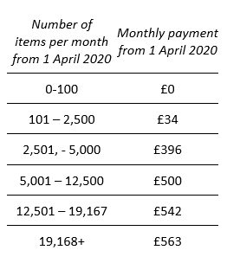 | Monthly – with first payment due on 1st July | Paid under same line as Transitional payment
Pandemic Delivery Service  (Advanced Service)** | MYS portal | £6 (including VAT) per delivery | Monthly – with first payment due on 1st July for deliveries made in April and claimed using MYS by the 5th May | ‘Additional Advance Payment’
Payment for installation of physical barriers e.g. screens** | Automatic payment by NHSBSA | £300 | End of April/early May | This payment will not appear on the Schedule of Payment. NHSBSA will issue individual letters to contractors informing them of payment.
£300 for adjustments to support social distancing within pharmacy premises

A change to Part VIA confirms a £300 payment from NHSE&I to help community pharmacy contractors adapt their premises to keep their staff and the public safe. As stated in Chief Pharmaceutical Officer Keith Ridge’s preparedness letter for community pharmacy on 31st March, the money is intended to be a contribution towards the installation of physical barriers and other measures to help encourage social distancing. As distance-selling pharmacies do not provide Essential services face-to-face, they are excluded from this payment.

The majority of contractors will have received this payment on 1st May 2020. Whilst it was not itemised on the FP34 Schedule of Payments, the NHSBSA has sent letters to contractors confirming the payment. Any contractors who have temporarily closed their pharmacy for more than two weeks since 31st March 2020 but made adjustments for social distancing prior to or shortly after the closure, will need to claim the £300 payment by 5th August 2020 using the appropriate NHSBSA claim form.
Although PSNC welcomes the £300 contribution, we are continuing to press NHSE&I to fully recognise the costs of introducing these important protective measures for pharmacy staff and patients.
Submission of COC/COA no longer required

From May 2020, the Drug Tariff no longer has a requirement for contractors to submit copies of the Certificate of Analysis (COA) or Certificate of Conformity (COC) to the local NHSE&I team of the prescriber after dispensing unlicensed specials or imports not listed in Part VIIIB. As contractors are still required to keep the necessary records of unlicensed specials or imports they dispense for a period of five years, any COAs and COCs obtained can be retained by the pharmacy for this purpose.

Individual Patient Supply products

It has come to our attention that approximately 30 products labelled as ‘Individual Patient Supply’ on the NHSBSA dm+d browser are unlicensed specials but are not being reimbursed accordingly by the NHSBSA. DST has obtained confirmation of the product licensing status from respective manufacturers and suppliers and has submitted a request for the licensing status of these products to be re-determined to allow payment of the £20 ‘SP’ fee where endorsed as a non-Part VIIIB special.

‘Special Order’ Products

Products reported to have supply issues are regularly communicated to contractors by DHSC through Supply Disruption Alerts or Medicine Supply Notifications. Often DHSC may recommend prescribers to consider available alternatives which may include unlicensed or imported equivalents. Where prescribing of an unlicensed import is considered appropriate by the prescriber, a prescription must be issued with the wording ‘Special Order’ or ‘Drug Tariff Special Order’ or ‘Imported (Country)’ next to the prescribed product to ensure that a pharmacy can dispense and be correctly reimbursed for a special. Many of the recommended unlicensed alternatives are not listed on dm+d for prescribers to select electronically using their prescribing systems. To ensure contractors are reimbursed correctly, PSNC has been advising contractors to obtain paper prescriptions for these items. DST has raised with both DHSC and NHSBSA that it would be both impractical and unreasonable for pharmacies to request paper prescriptions for products that do not have a listing on dm+d as many GPs have moved to EPS fully and have completely stopped issuing paper prescriptions for their patients.

To avoid pharmacy teams having to request paper prescriptions or refer patients back to their GP for other alternatives, PSNC has requested that where a drug becomes temporarily unavailable or is discontinued, and DHSC or SPS make a recommendation for prescribers to consider an alternative unlicensed product, these should be reflected in dm+d at the same time so electronic prescriptions can be promptly issued by prescribers using EPS to avoid delays in getting the correct medication to patients. This would allow prescribers to select the unlicensed version, where appropriate, so that pharmacists can dispense the required product and be reimbursed accordingly. This will allow better resource utilisation of GPs and pharmacy teams at a time where they are needed most to support the NHS and its patients through the pandemic. In PSNCs latest request, we have submitted an application for over 30 products to be added to dm+d as ‘(Special Order)’ or ‘Imported (Country)’.

Special Containers
DST has identified hundreds of products on dm+d which appear to fulfil the special container (SC) criteria but have not been classified as such in the Drug Tariff. Between December 2019 and May 2020, DST has submitted applications to the NHSBSA for nearly 400 products for re-evaluation of their SC status. DST is continuing its checks and is submitting new applications on an almost weekly basis for products that are deemed special containers. The table below provides latest information on the number of products that have been checked and submitted to DHSC and NHSBSA for further investigation and the current status of the applications.

Special container criteria under which application is submitted | Number of products checked by DST | Number of products applied for SC status (Dec 19 – May 20) | Number of products currently under active discussion with DHSC | Number of products agreed by DHSC as meeting SC criteria
Effervescent or hygroscopic | 47 | 47 | 39 | 12
Viscous external preparations | 861 | 78 | x | x
Impractical to dispense exact quantity due to packaging | 2654 | 245 | 7 | 6

Addition of DND products

DST has identified a number of products that meet the Discount Not Deducted criteria for eligibility and has submitted applications for 32 products between February 2020 and May 2020. 18 products have been added (or will be added) to the Drug Tariff and 14 are still under discussion.

Retrospective price adjustment for Omeprazole 10mg/5ml and 20mg/5ml oral suspension SF and Melatonin 1mg/ml oral solution AF

Omeprazole

Two Omeprazole licensed liquid preparations became available on the market in March 2020. Following representations from PSNC to account for the licensed products now on market, Department of Health and Social Care (DHSC) and the National Assembly of Wales have retrospectively determined from March 2020:

The addition of (with special container status applied):

- Omeprazole 10mg/5ml oral suspension sugar free (75ml) to Category C based on Rosemont Pharmaceuticals Ltd, and
- Omeprazole 20mg/5ml oral suspension sugar free (75ml) to Category C based on Rosemont Pharmaceuticals Ltd;

the deletion from Part VIIIB of:

- Omeprazole 10mg/5ml oral suspension (STD, SF, LF, CF, NSF, FF, AF, BP)
- Omeprazole 20mg/5ml oral suspension (STD, SF, LF, CF, NSF, FF, AF, BP)
Payment for March and April’s prescriptions will reflect the above retrospective determination and hence will not be as per the published Drug Tariff prices for March and April, respectively. Payments for Omeprazole 10mg/5ml oral suspension and Omeprazole 20mg/5ml oral suspension will be based on the licensed Omeprazole 10mg/5ml oral suspension sugar free (Rosemont Pharmaceuticals Ltd) and Omeprazole 20mg/5ml oral suspension sugar free (Rosemont Pharmaceuticals Ltd), respectively.

Melatonin
In March 2020, Colonis Pharma relaunched Melatonin 1mg/ml oral solution sugar free (currently listed in Part VIIIA of the Drug Tariff) as an alcohol-free formulation.
Following representation from PSNC to account for the reformulated product now on market, DHSC and the National Assembly of Wales have retrospectively determined from March 2020:
the deletion from Part VIIIB of:
- Melatonin 5mg/5ml oral solution alcohol free
- Melatonin 5mg/5ml oral suspension alcohol free
Payment for March and April’s prescriptions will reflect the above retrospective determination and hence will not be as per the published Drug Tariff prices for March and April, respectively. Payments for Melatonin 5mg/5ml oral solution alcohol free will be based on Melatonin 1mg/ml oral solution sugar free as listed in Part VIIIA of the Drug Tariff.

Appendix FCS 14/05/20

Subject | Statistics
Date of meeting | 20th May 2020
Committee/Subcommittee | FunCon
Status | Not confidential
Overview | Latest statistics for information
Proposed action(s) | No action required
Author(s) of the paper | PSNC Pharmacy Funding Team

Statistics

