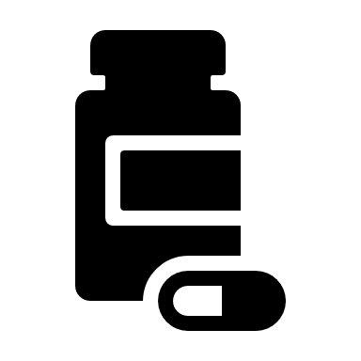 | Lockdown medicines deliveries end | 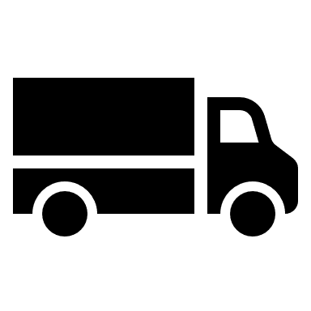

During the national restrictions for coronavirus, the Government funded all community pharmacies to provide a medicines delivery service. These medicines deliveries were for those patients who needed it most, i.e. those who were shielding and had no-one to collect medicines for them.

As the restrictions ease and people can go outside more, the Government’s shielding support package has now ended. This also brings the national pharmacy medicines delivery service to a close.

With the end of the national delivery service, pharmacies will no longer receive any Government or NHS funding to help them continue to offer such a service.*

What should I do now?
If you still need help to get your medicines, please:
- ask a friend or relative to collect them for you,
- call NHS Volunteer Responders on 0808 196 3646 (8am to 8pm) to arrange support, or
- contact us or your council to find a local volunteer.
OR We have arranged to keep providing deliveries for some of our most vulnerable patients. Please call XXXXXXXXXXXX to ask a member of the pharmacy team about the terms and conditions.

*However, pharmacies are funded by the NHS to deliver a small number of specified appliances to patients’ homes (e.g. catheters).
Lockdown medicines deliveries end

During the national restrictions for coronavirus, the Government funded all community pharmacies to provide a medicines delivery service. These medicines deliveries were for those patients who needed it most, i.e. those who were shielding and had no-one to collect medicines for them.

As the restrictions ease and people can go outside more, the Government’s shielding support package has now ended. This also brings the national pharmacy medicines delivery service to a close.

With the end of the national delivery service, pharmacies will no longer receive any Government or NHS funding to help them continue to offer such a service.*

What should I do now?
If you still need help to get your medicines, please:
- ask a friend or relative to collect them for you,
- call NHS Volunteer Responders on 0808 196 3646 (8am to 8pm) to arrange support, or
- contact us or your council to find a local volunteer.
OR We have arranged to keep providing deliveries for some of our most vulnerable patients. Please call XXXXXXXXXXXX to ask a member of the pharmacy team about the terms and conditions.

*However, pharmacies are funded by the NHS to deliver a small number of specified appliances to patients’ homes (e.g. catheters).

