Staff training analysis  (data security and IG) | 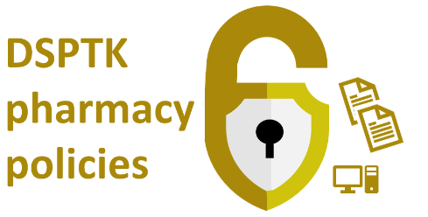

About the use of this document and related resources: This data security document assists the pharmacy’s aligment with the Data Security and Protection Toolkit (DSPTK). Related pharmacy policies are at PSNC’s data security templates webpage.

This document is for the pharmacy IG lead(s) to help them consider what training is necessary for themselves and for other staff. It will assist with their DSPTK-related work to perform a staff training analysis. New staff should receive induction training about pharmacy data security. All staff should also receive refresher training at least annually.

Standard training options for pharmacy staff (excluding IG leads)

A standard data security training specifically for pharmacy staff is available within one or both of the below:
- Pharmacy data security and IG training (for induction or refreshment) DSPTK Template series doc 03B)
- GDPR guidance for Community Pharmacy (short version) (Part 2) training booklet for staff;

These are also listed at psnc.org.uk/dstraining alongside other options.

Non-pharmacy specific training options

A range of free or commercial options will be available. Several free options include those listed below:

Resources:
- National Cyber Security Centre (NCSC)
- Little Book of Cyber Scams guidance (Met Police)
- NHSX IG portal

Videos
- Keep I.T. confidential NHS campaign videos (NHS Digital)

Interactive courses (free)
- NHS Digital Online IG Training Tool “Data Security Awareness Level 1.
- BT Skills for Tomorrow – courses including data security ones.

Pharmacy IG leads require deeper training and expertise (see section below).

Standard training options for pharmacy IG leads

Pharmacy specific guidance includes that below:
- GDPR Guidance for Community Pharmacy (Part 1) for pharmacy IG leads.

Commercial or equivalent in-house training may also be available to pharmacy contractors and teams.

Ways to increase data and cyber security awareness

Whatever options are decided upon, within your role as IG lead, consider how the training resources and messages will help reinforce good data security lessons.
Top tips:
- Focus on the most important areas and target key staff
- Ask your staff – what worries them?
- Do they know how to spot emails from phishing scammers?
- Consider an annual training session on the topic in which staff are invited to comment about risk areas and how to mitigate risk of incidents in the year ahead.
- Repeat key messages in different ways, e.g. through posters.
- Make it visual by using pictures and posters.
- Use your IT system to convey key messages, such as via ‘pop ups’ on log in.
- Make data security a key component of any induction process.

Further info

See: psnc.org.uk/dstraining

This data security document assists the pharmacy’s aligment with the Data Security and Protection Toolkit (DSPTK). Related pharmacy policies and more can be found at:
- psnc.org.uk/ds; psnc.org.uk/dsptk; and
- psnc.org.uk/dstemplates.
Pharmacy contractors with queries about the original template or questions about DSPTK may contact it@psnc.org.uk.
This document is based on a template updated during: Feb 2021

