#Pharmacy24 templates for pharmacy teams
The following social media posts can be used by community pharmacy teams to join in with #Pharmacy24, either using a pharmacy social media account or their own individual ones. The highlighted sections should be amended as appropriate before use. You may wish to use some images of your pharmacy or pharmacy team to go with the tweets.

@councillor/MP Would you like to learn more about pharmacy’s role in the #pandemic2020 response? Follow #Pharmacy24 today or get in touch with me/us directly. #pharmacyheroes #patientcare #patientsafety

@local press contact A year in #lockdown: my/our pharmacy has been supporting people in [location] throughout the #COVID19 pandemic. Follow #Pharmacy24 today or get in touch with me/us directly to find out how. #pharmacyheroes #patientcare #patientsafety #nhs

@stakeholder [local Healthwatch or charity/organisation the LPC has worked with recently] My/our pharmacy has been supporting people in [location] throughout the #COVID19 pandemic. Follow #Pharmacy24 today or get in touch with me/us directly to find out how. #pharmacyheroes #patientcare #patientsafety #nhs

My/our pharmacy has remained open throughout the #COVID19 pandemic, adapting COVID-secure practices so I/we could continue to offer face-to-face healthcare advice. #Pharmacy24 #pharmacyheroes #patientcare #patientsafety #nhs
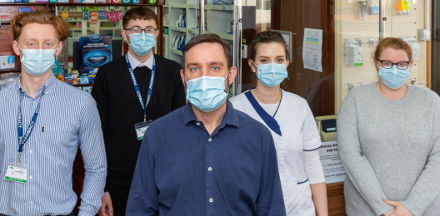

My/our pharmacy worked very hard to keep staff and patients safe during the #pandemic. Safety measures such as social distancing were quickly put in place. #Pharmacy24 #pharmacyheroes #patientcare #patientsafety #nhs
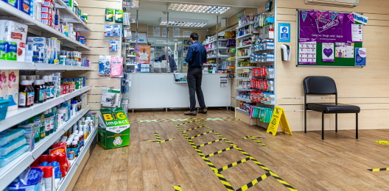

Throughout the pandemic, I/we ensured that all of my/our patients continued to have safe and convenient access to their medicines. #Pharmacy24 #pharmacyheroes #patientcare #patientsafety #nhs #lockdown

@DHSCgovuk My/our pharmacy is supporting the #NHS pandemic response: I/we/our pharmacist administered [approximate number] flu jabs in a COVID-safe way this winter. #Pharmacy24 #pharmacyheroes #patientcare #patientsafety #nhs
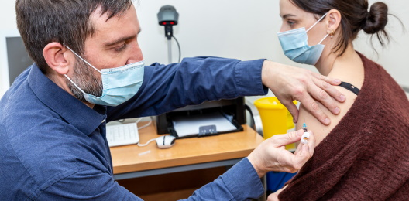

My/our pharmacy is supporting the #NHS pandemic response: we stayed open on bank holidays during the initial #COVID19 peak. #Pharmacy24 #pharmacyheroes #patientcare #patientsafety

My/our pharmacy is playing a key role in the #COVID19 vaccination programme: I/we/our pharmacist have/has administered [approximate number] coronavirus jabs far. #Pharmacy24 #pharmacyheroes #patientcare #patientsafety #nhs

#Pharmacy24 Future goals: learning lessons from #COVID19, my/our pharmacy is already working to help address health inequalities for people in [location].
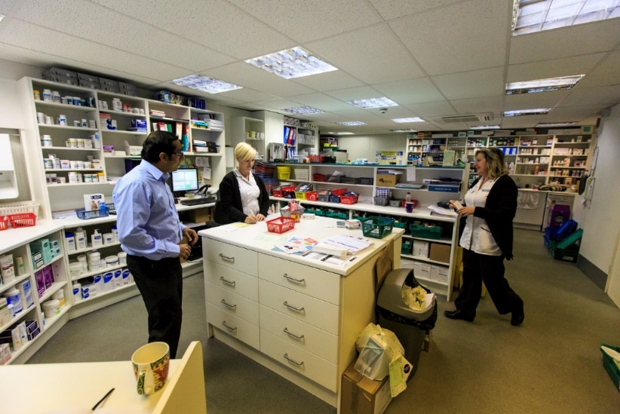

NATIONAL STATISTICS
These posts contain national statistics and graphics taken from PSNC’s Pharmacy Advice Audit. Pharmacy teams are free to use them but may wish to reference the data they collected instead.

Pharmacy hasn’t stopped during the #pandemic: community pharmacies in England continue to have 600,000 informal healthcare consultations a week. #Pharmacy24 #pharmacyheroes #patientcare #patientsafety #nhs
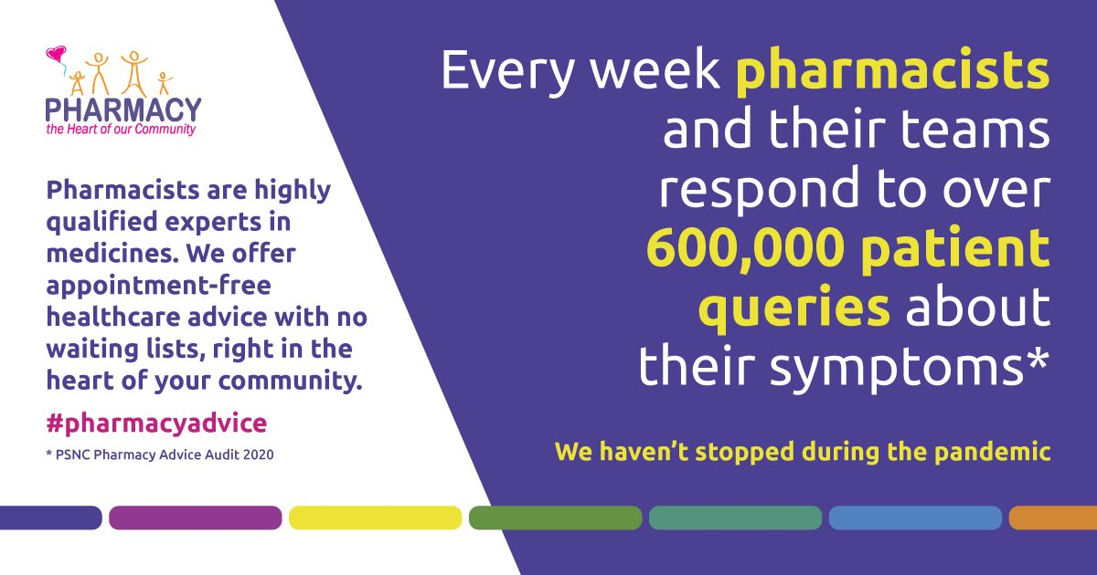

Pharmacy hasn’t stopped during the pandemic: community pharmacies in England continue to prevent nearly 500,000 GP appointments a week. #Pharmacy24 #pharmacyheroes #patientcare #patientsafety #nhs
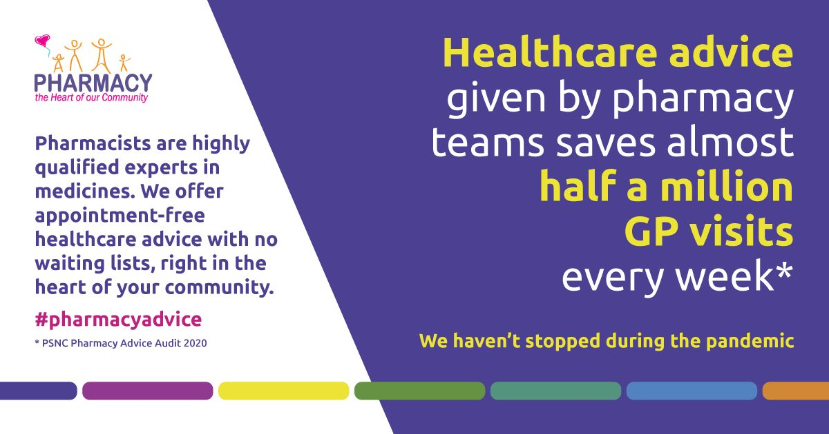

Pharmacy hasn’t stopped during the pandemic: community pharmacies in England continue to prevent 57,000 weekly A&E and walk-in centre visits a week. #Pharmacy24 #pharmacyheroes #patientcare #patientsafety #nhs
