Will information about me be shared with others?
You will be asked to give your consent for your pharmacist to share information from your New Medicine Service discussions with:
- your GP, if necessary (for example if they need to change your medicine because you are having a problem with it)
- NHS England, to make sure the service is being provided properly by your pharmacist
- NHS England and the NHS Business Services Authority, to make sure your pharmacy is being paid the correct amount by the NHS for the service they have provided you.

If you do not give your consent, you will not be able to use the service. However, when you first receive your medicines, your pharmacist will still give you advice about them.

How can you prepare for your discussions with the pharmacist?
- Read the leaflet that comes with your new medicine.
- Make a note of questions you want to ask about your new medicine.
- Make a note of any concerns about your new medicine that you may want to discuss with your pharmacist.
- Bring your new medicine to the meeting with your pharmacist or have it in front of you if you speak to the pharmacist by telephone.

What happens after the two discussions?
- Everything may be okay with your new medicine and nothing else will need to happen.
- If you have had problems with the medicine, you may agree with your pharmacist to change the way you take it.
- Your pharmacist may recommend that your doctor reviews your new medicine. If this is needed your pharmacist will send a note to your doctor explaining the issues raised. You can have a copy of this note.
The NHS New Medicine Service:
helping you with your new medicine

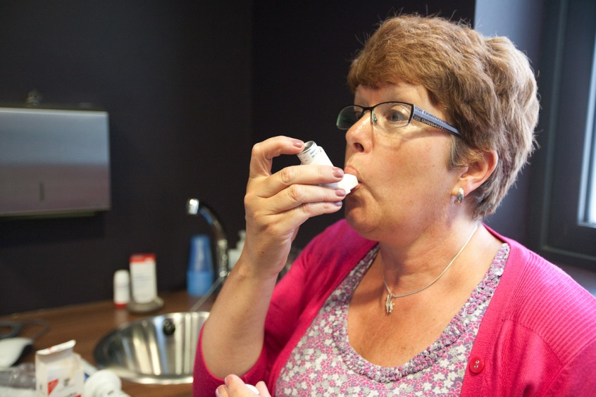



Dear Patient
You have been prescribed a new medicine and we would like to provide you with extra help to make sure you can use it properly.
We would like to do this by inviting you to use the New Medicine Service; this leaflet will give you the information you need to know about this service.
If you would like to receive the service, contact the pharmacy and we will arrange to provide the service at a time that suits you.
What is the New Medicine Service?
The New Medicine Service is a free NHS service, offered through your pharmacy, to help you understand your condition and get the most out of your new medicine.
Who is it for?
The service is for people who have received their first prescription for a medicine to treat one of a range of conditions which have been chosen by the NHS.
How will it help me?
Between 30% and 50% of prescribed medicines are not taken as recommended. This means that a lot of medicines are wasted or are not as effective as they could be.
The service will:
- help you to find out more about the new medicine you are taking
- help to sort out any problems you are having with your new medicine
- give you a chance to ask questions about your medicine and discuss any concerns
- help to improve the effectiveness of your new medicine, for example, there may be an easier or better way to take it
- help you to make your own decisions about managing your condition
- help you to improve your health, which could lead to fewer GP and hospital visits.
The New Medicine Service will help provide better value for you and the NHS by making sure that your medicines are right for you.
How does the service work?
When you are given your new medicine, we will ask if you want to be supported by the service, which will be provided in three parts.
If you agree, your consent will be recorded on your pharmacy clinical record to allow your pharmacist to share your information with other parts of the NHS (see over the page).

Step 1 | Your pharmacist will give you information about your new medicine.
Step 2 | You will be invited to a consultation with your pharmacist between 7 and 14 days after you first receive your new medicine. You will be able to choose a time that suits you.  This is a confidential conversation and it will be provided in a private area within the pharmacy or if you prefer, you could choose to have the discussion over the telephone or via a video consultation.  Your pharmacist will ask you questions about how you are getting on with your new medicine, find out if you are having any problems and give you any information and support you need. You may have concerns or questions that you want to ask. You can ask anything at all about your new medicine.
Step 3 | Your pharmacist will arrange a follow-up discussion with you 14 to 21 days after step 2.  You will be able to talk about how things are going with your medicine and ask for more advice if you need it.

