Your NHS blood pressure check

Thank you for having your blood pressure checked at the pharmacy.

Why get your blood pressure checked?

- High blood pressure, also called hypertension, is a condition which can be controlled to reduce your risk of a heart attack, stroke or other cardiovascular disease.
- In the UK there are about five million adults (one in every nine) who have high blood pressure without even knowing it, since high blood pressure itself rarely causes symptoms.
- The British Heart Foundation estimates that high blood pressure causes over 50% of heart attacks and strokes.

High blood pressure – know your numbers

Blood pressure is the force of your blood moving against the walls of your arteries. It is expressed as two numbers, one above the other:

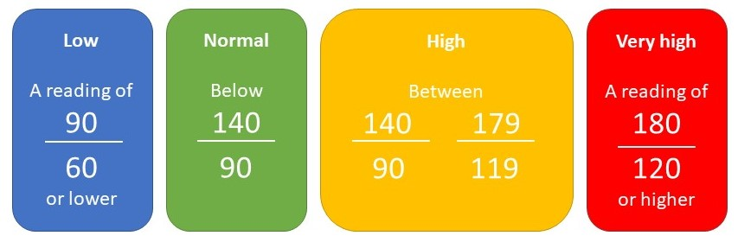
Your blood pressure reading:

Date:

For general healthy living and high blood pressure information visit:

www.nhs.uk/conditions/high-blood-pressure-hypertension/
Pharmacy details:
www.bloodpressureuk.org/
www.bhf.org.uk/informationsupport/risk-factors

